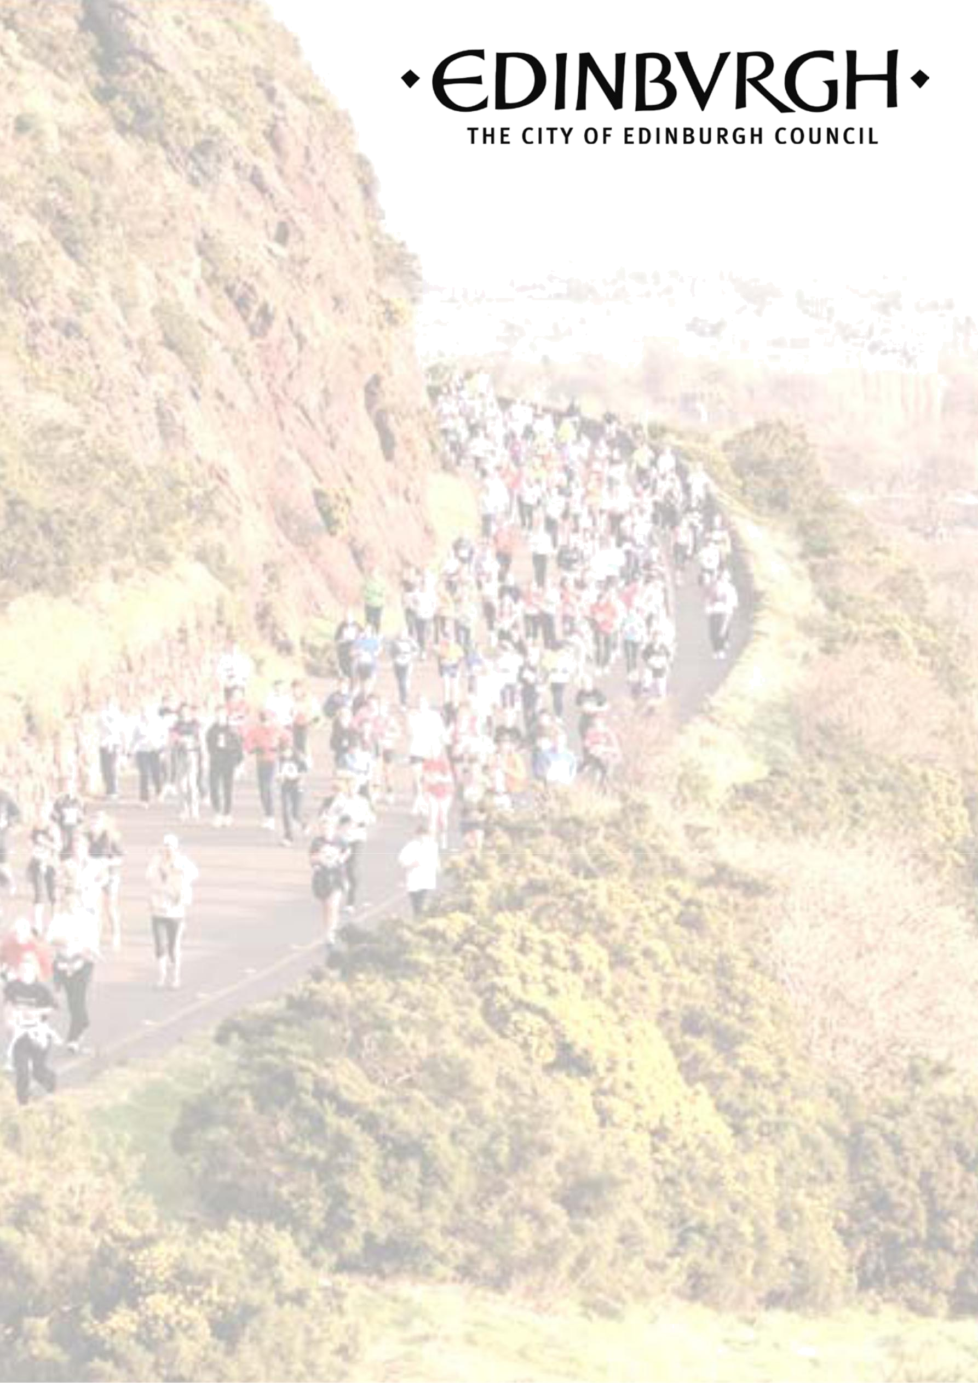

COVID-19 Physical Activity and Sport Fund –Return to sport recovery grants
2021

Guidance Notes

1

Information about the COVID-19 Physical Activity and Sport Fund –Return to sport recovery grants 2021

In response the effect of COVID-19 on sports clubs and organisations we are encouraging applications which are aimed at helping clubs return to activity when they can do so. This funding is targeted at voluntary led organisations based in the sport and physical activity sector who have a role in enabling and supporting the communities of Edinburgh to take part in sport and to get and stay active. This fund will support sports organisations for costs for sports organisations planning the restart or delivery of activities. Examples of items we will fund include additional or different equipment, signage, storage solutions, PPE or associated costs with any changes required to your delivery.

Please note the normal range of awards are from £500 to £1000. Funding up to a maximum of £1,000 may be considered but this shall only be awarded to applications that target people living in the identified ‘Small Areas’ in the local improvement plans (see appendix 1), target girls into sport, or those with a disability.

Your Organisation’s Eligibility
We offer grants to a range of constituted organisation, including voluntary and community sector organisations, sports clubs and national governing bodies of sport. The fund will not support individuals, sole traders or profit-making organisations. Only constituted organisations can apply for a grant.

Grant Applications Closing Date/ Notifications
The closing date for this round of applications is Friday 26th February 2021. You will be notified of the progress of your application by email. This may include asking for more information/revisions or suggesting that you seek partners to help deliver your project.

Contact Us

For more information about the COVID-19 Physical Activity and Sport Fund –Return to sport recovery grants 2021 please contact Sean Webster at sean.webster@edinburgh.gov.uk or 07718 250 834

Physical Activity & Sport Fund – Support for Completing the Application
The following guidance will give you support to complete the Physical Activity & Sport Fund Application.

Organisation Details
Detail the organisation which is leading the project in this section. You may wish to include: its purpose, achievements, structure and history. Grants will only fund constituted organisations; please confirm that you are constituted by ticking the appropriate box.

Funding and Finance
In the space provided, you should detail the total funding you are requesting from the Council. Funding up to £500 or £1,000 is available. In the income section detail other sources of secured/ pending funding that you expect for the project. This may include income from participant fees etc. In the expenditure section you should give an overview of your proposed project spend.

You should also provide bank details of your organisation in this section.

Declaration

Please read the statements in the declaration and check the box confirming that you adhere to the statements.

Appendix 1 – Small areas identified in the local improvement plans

