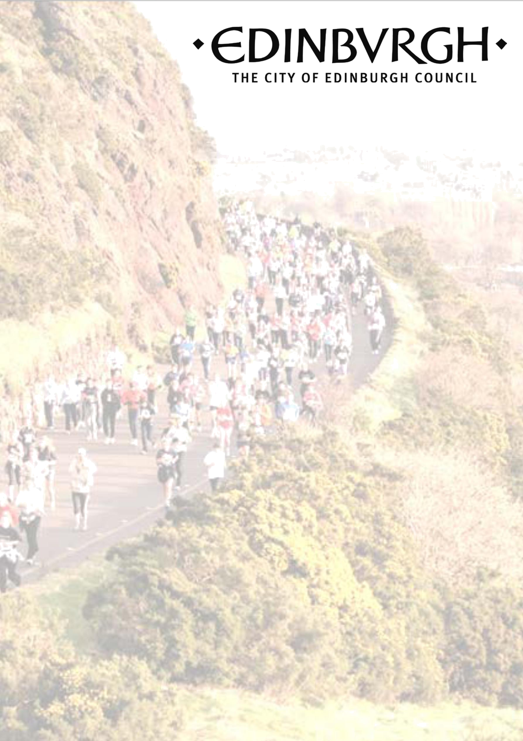

COVID-19 Physical Activity and Sport Fund – Return to sport recovery grants

2021


Section 1: Organisation Details

Organisation

Organisation’s website

Contact Name

Position

Phone

Contact E-mail

Contact Address

Postcode

Overview of Organisation (including main aims and objectives)

Are you a constituted organisation? Yes/No

Page | 2

Section 2: Your Application

Name purpose of the funding requested

Who will benefit from your proposal?

Has your organisation received grants/funding from the Council previously Yes/No

If yes, please give details

Page | 3

Please give details of your proposals for this application (300 words max)

How many people may benefit from your proposal?

Participants

Volunteers

Total

Page | 4

Section 3: Funding and Finance

Funding requested £

Approximate costs

Item | Cost
(name) | (£)
Total £

What bank account should we pay your grant into if your application is successful?

Name of Bank

Bank Address

Account Name

Bank Sort Code

Account Number

Page | 5

Section 4: Declaration

All applications must be confirmed by two people who are recognised as representatives of your organisation. One of these people must be a board/management committee member. Please list the contact details below and tick the appropriate declaration box to illustrate that your organisation will comply with the funding criteria.

Please check this box to confirm that you have read and will comply with all funding criteria below:

- Have an open and non-discriminatory constitution

- Be affiliated to the appropriate governing body of sport and adhere to their disciplinary procedures

- Employ and/or deploy suitably qualified coaches, in accordance with governing body guidelines within the junior club

- Have adopted a suitable Safeguarding/Child Protection Policy and be compliant with the associated procedures in accordance with governing body requirements

- Ensure that all coaches and volunteers in contact with children and young people are subject to safe recruiting procedures that include checks via the Disclosure Scotland PVG Scheme

- Hold adequate public liability insurance for all activities undertaken

- Will supply a progress report within six months of grant being awarded

- You are authorised to complete this application on behalf of your organisation

- To the best of your knowledge, the information contained in the application, including supporting documentation, is accurate

Principal Contact

Name

Position

Secondary Contact

Name

Position

e-mail

phone

Email completed application forms and enquiries to
SportsAnd.OutdoorLearning@edinburgh.gov.uk

Sports and Outdoor Learning Unit
Schools and Lifelong Learning
City of Edinburgh Council
Waverley Court

Page | 6

