1. Install and open app

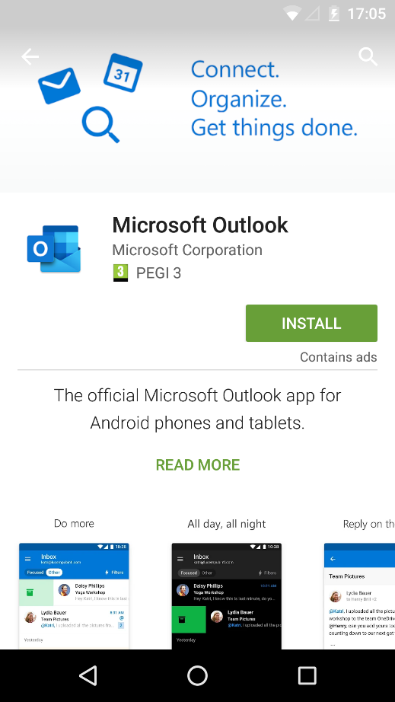

1. Press ‘Get Started’

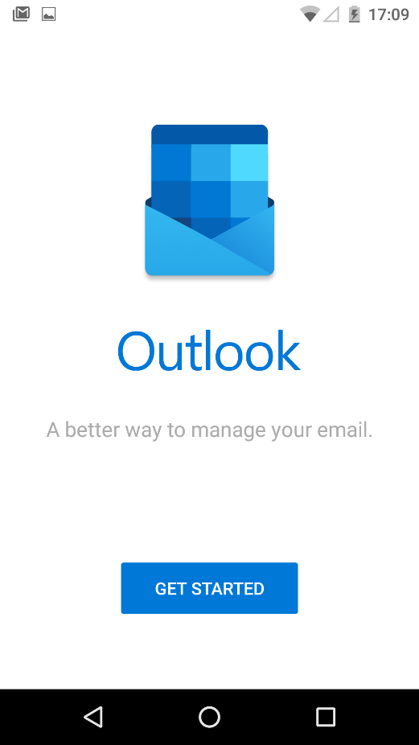

1. Enter email address (payroll number instead of name) and password you use when you log in in the morning.

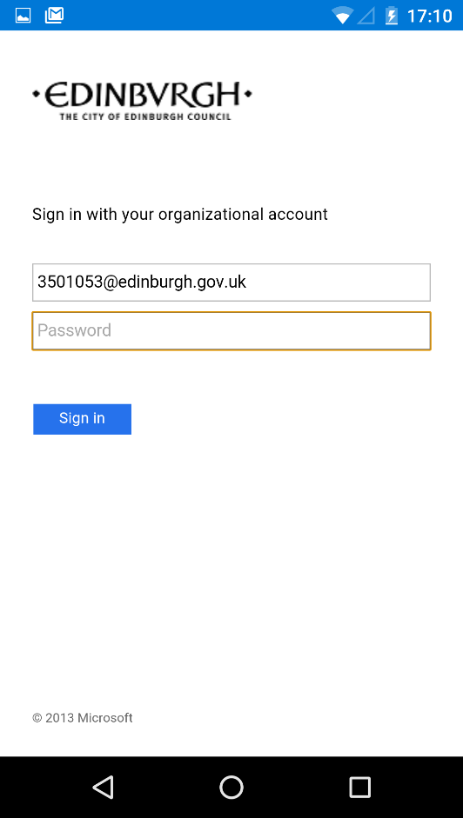

1. Approve MFA. If you have not set this up please do that now using the [MFA set up guide.](https://www.edinburgh.gov.uk/downloads/file/27095/set-up-multi-factor-authentication-mfa-for-office-365)

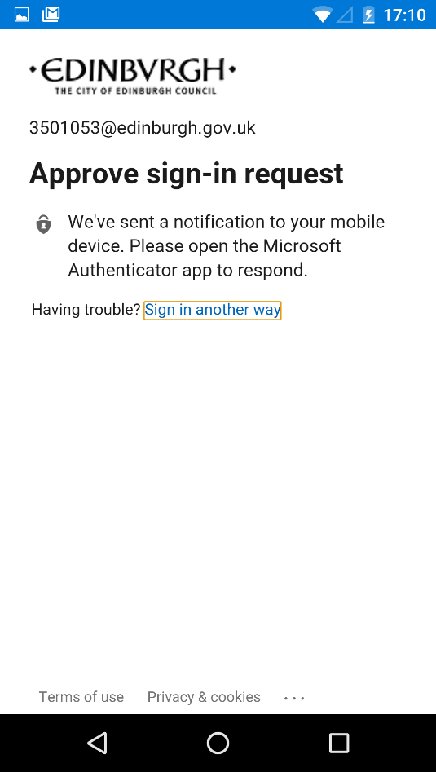

1. On Android devices you will be asked to add the ‘Company Portal’ app (but not on Apple). Press ‘Get the app’

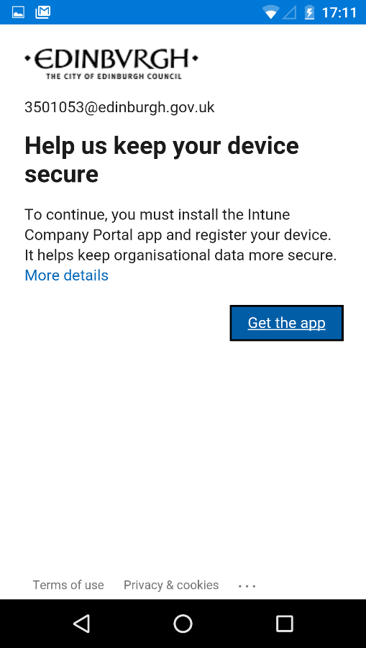

1. Install and open

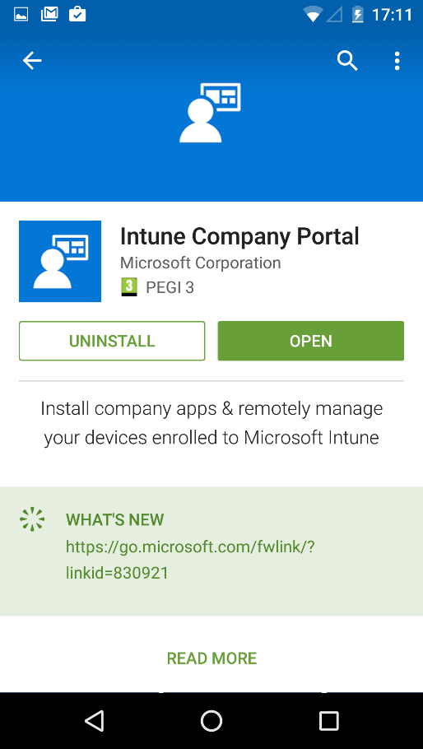

1. DO NOT SIGN IN! Just press the home button to close.

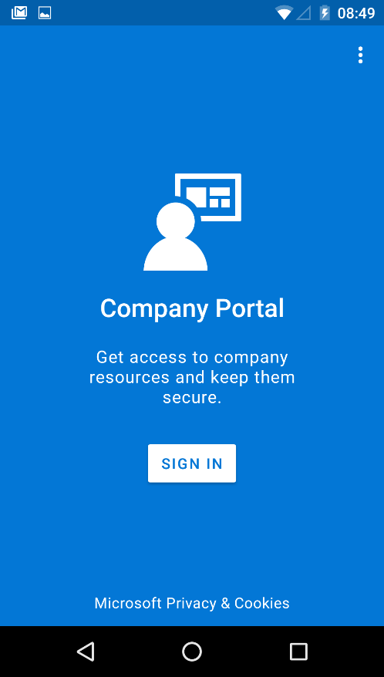

1. You’ll see your home screen. Open Outlook by pressing the icon.

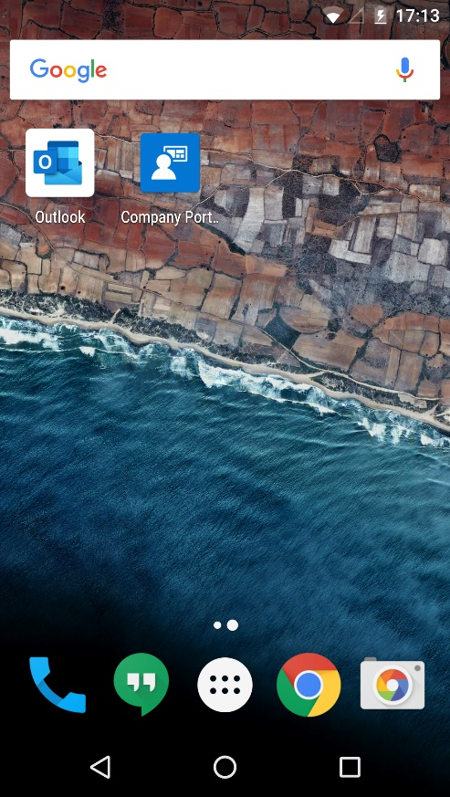

1. Press get started (You may be asked to log in again please just do this. You may also be sked to ‘Register’ please also do this).

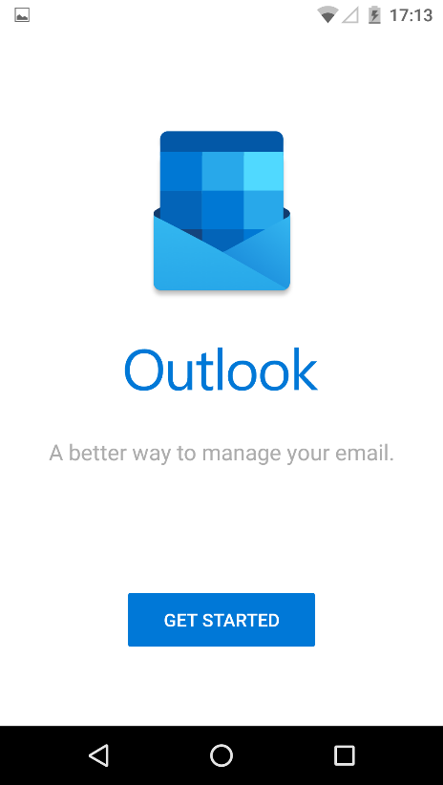

1. You’ll be asked to add another account. Press ‘Maybe later’

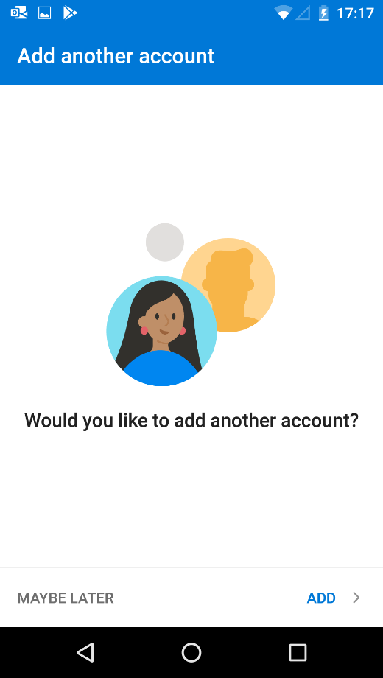

1. Press skip

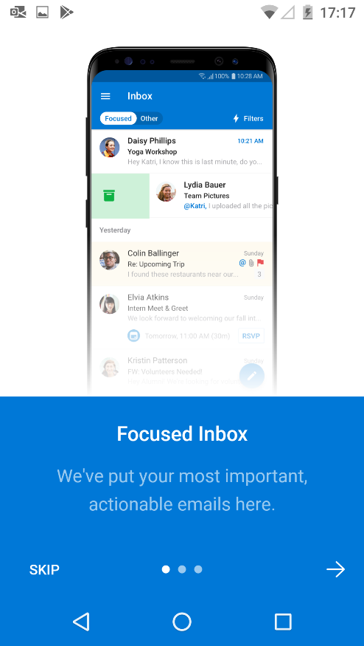

1. You’ll now be asked to set up a PIN – press continue at this screen.

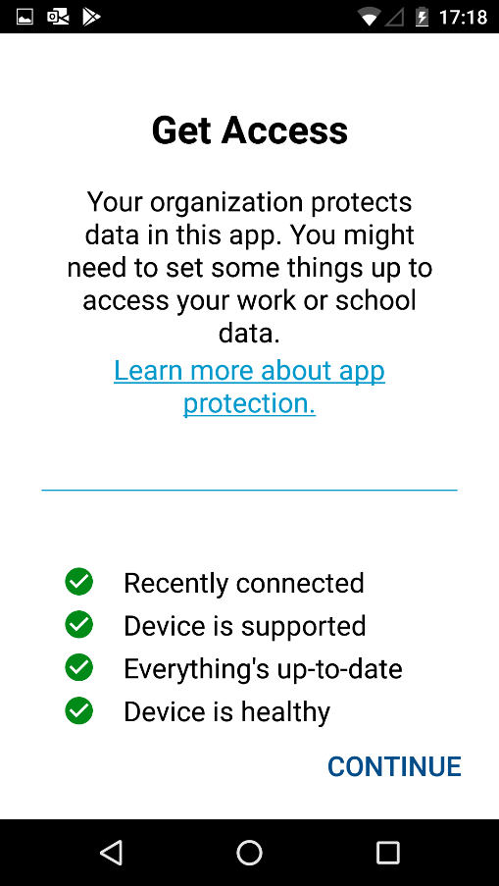

1. Finally, set a PIN that you’ll remember. And that’s it!

