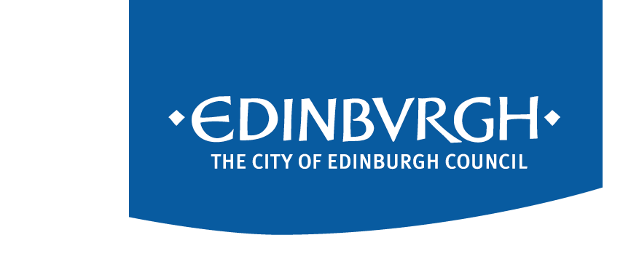


Mediation

How can community mediation help?
Community Mediation helps neighbours deal with various issues including;
- noise
- clash of lifestyles
- noise of children.

Community Mediation is a practical, free and quick way of helping you settle a dispute with your neighbour. It is confidential* except for information relating to child/adult protection, fraudulent or criminal activity. It also:
- allows you to get a clearer idea of what the problem is
- is impartial - we don’t take sides
- is realistic and practical outcomes can be agreed
- is voluntary
- avoids the stress and financial aspects of employing a solicitor and going to court.

What are the benefits of mediation?
You are in control - the mediators will help you to make your own decisions about your dispute. You can withdraw at any time during the process and nothing will be done without your agreement.
Also, because as neighbours, YOU have agreed to a resolution, you are far more likely to stick to it. It might not end up with you becoming great friends with your neighbour, but mediation can help you reach a point where you can live amicably alongside each other.

Does mediation always work?
There is every chance it could help however mediation is not a guarantee of success.

How long will mediation take?
Each mediation session is different. Some might be completed in one session which normally takes around one hour, however in consultation with both parties it might be decided that more than one joint meeting would need to take place in order to reach an agreement.

Do mediators take sides?
No. They are trained, impartial people who are skilled in helping establish common ground in even the trickiest of situations. They will listen to both sides before helping you come to a mutually acceptable agreement.

How do I get someone to help me?
To find out if mediation can help, you can contact your local office and ask to speak to someone in Family and Household Support about mediation.
North East 0131 529 7168
Email:northeastFHS@edinburgh.gov.uk
South East 0131 529 5123
Email:southeastFHS@edinburgh.gov.uk
South West 0131 469 5150
Email:southwestFHS@edinburgh.gov.uk
North West Telephone:0131 529 5014
Email:northwestFHS@edinburgh.gov.uk

A support worker will talk to you about your current situation and assess if mediation might be able to help. If they think it would and you would be keen to give it a try then they would contact your neighbour to speak to them and assess if they were also prepared to get involved. If both households agree, then a referral will be made to a trained Mediator.

I’ve agreed to take part in mediation – what happens next?
A mediator will contact you to find out more about your circumstances and discuss with you further whether mediation is right for your situation and if so, explore what you would view as a positive outcome and explain what you can expect and how they will help you prepare. They will then do the same with your neighbour.
With agreement on both sides, the mediator will then arrange a meeting between both parties in a neutral place, such as a room in a local library to work out a way forward.
During COVID 19 restrictions however we will provide telephone mediation. When both parties are ready to mediate the mediator will telephone each party separately and talk through what the other party wants to relay, whilst helping them to work out their own solutions.

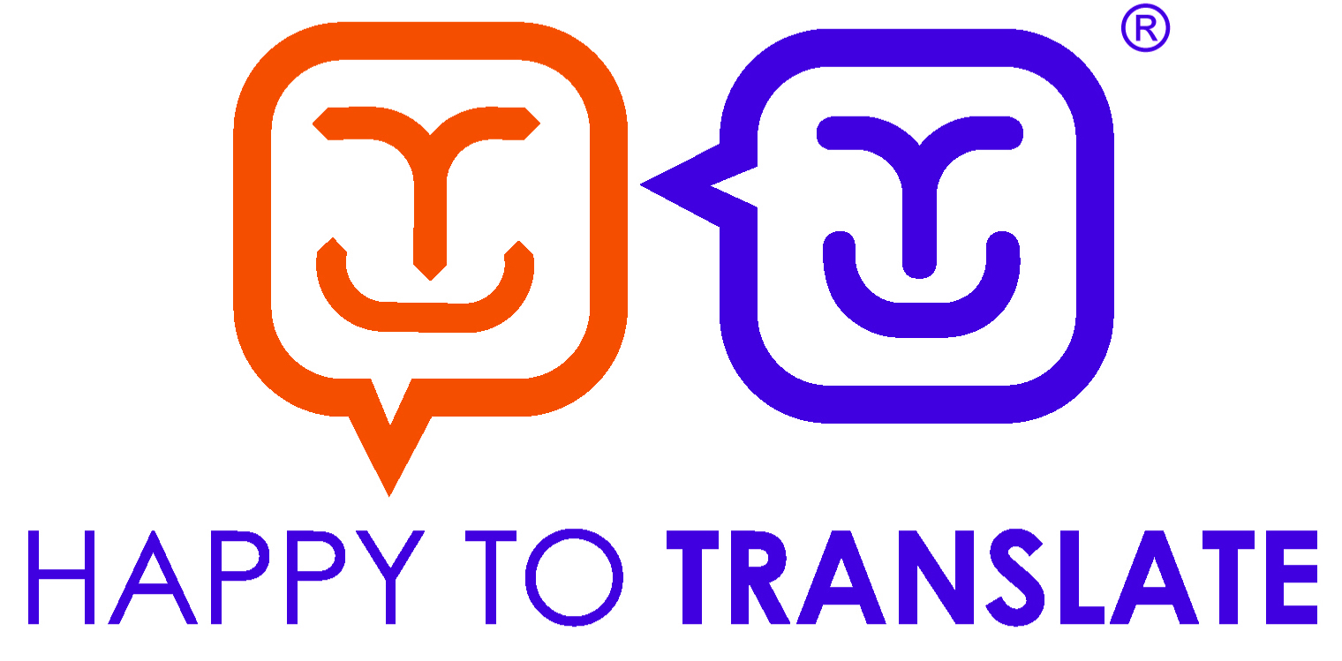

You can get this document on tape, in Braille, large print and various computer formats if you ask us. Please contact ITS on 0131 242 8181 and quote reference number XXXXX. ITS can also give information on community language translations.

