**Edinburgh’s Promise - Framework and Principles of Involvement and Voice**

**Purpose of this document**

This document is for all organisations and services across all sectors in Edinburgh who work with children, young people and their families – schools, social work services, youth and children’s work health, police and others. It outlines the principles which we should all follow in the development, delivery and evaluation of services. It also provides examples of how the voice of children, young people and families may be incorporated into practice and how we might think about the quality of our work in this area.

The document is underpinned by the national commitment to keeping The Promise (LINK) and our local commitment that Edinburgh’s children will be loved, safe and respected. Whilst this work arose from the Independent Care Review which focussed on children and young people who have experience of the “care system”, it is recognised that children do not fit neatly into boxes – for example, many children may benefit from a level of support within their birth family, whilst some may have past experience of care or indeed be living with extended family, foster carers or group living.  And, of course, many children and young people will have had no contact at all with the ‘care system’.

The primary focus of this document is **listening and responding to children, young people and families.** Listening is one of the fundamentals which underpin Edinburgh’s Promise.

***What it means***

To keep the Promise, Edinburgh’s children need to know that when they have shared something, it will be heard and acted upon. Individually and collectively, children and young people’s voice must be listened to and acted upon.

***What it looks like***

People, teams, services and organisations will show they are **listening** by:

* Making changes and improvements when they are told these are needed.
* Using every conversation and interaction with children and their families as an opportunity to be curious and learn what works and what is needed
* Actively gathering and acting upon the views, wishes and asks from children and their families that we receive through our listening
* Providing support for as long as it is needed

In the rest of this document, we will detail both the principles and values which underpin our common approach, as well as practical considerations which you can considering both as individuals and within your own team or organisation.

**Principles and Values**

*“Listening to and, crucially, making sense of what is heard from children and families will be embedded into all practices and processes that engage with children and families to ensure their voices are heard and they are involved in every decision that affects them.*

*Where support is required for children and families to have their voices heard and to participate in decision making, this will be identified and provided immediately, with the support remaining for as long as it is needed.*

*Regardless of how children and families’ voices are heard, there must be a full and considered exploration of how listening, shared sense-making and shared decision-making will be embedded into practice and mechanisms to actively use what is heard…”*

– The Promise Plan 21-24

The following shared principles and values apply both individually and collectively, both in terms of individual practitioners and wider organisations or partnerships.

In line with The Promise, these principles should underpin all of our work:

* It is everyone’s responsibility to listen and respond.
* Children and families must be actively included in all decisions about them or which affect them.
* If support to participate is needed, this should be provided for as long as required
* Every interaction is an opportunity to listen; we should not be limited only to “formal” methods of seeking feedback.
* Listening must be accompanied by action; if we are told something needs to change or improve, we should try to do this.

The graphic on the next page shows the different levels of participation which exist within organisations:

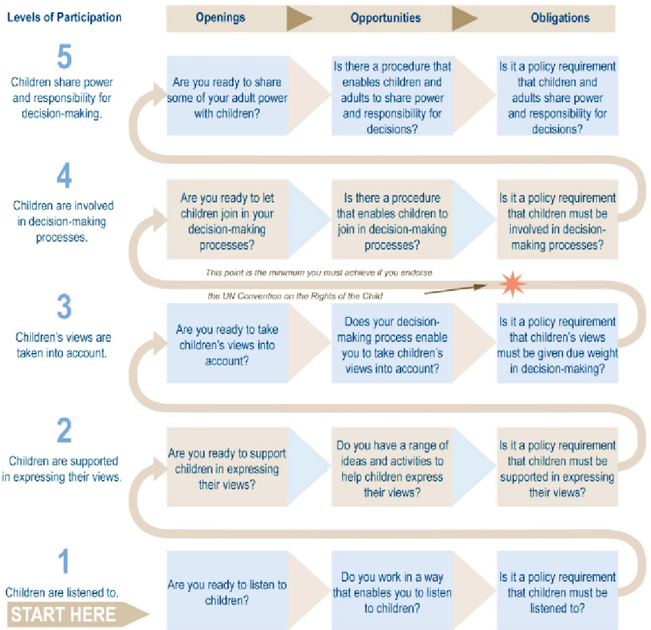

Shier’s Pathway to participation (2001)

|  |  |
| --- | --- |
| **Level of participation** | **What needs to be in place** |
| 5 | Clear expectations throughout the organisation, backed up by policies and procedures that facilitate the sharing of power.  Supports for children and young people to share power and participate in decision making, contribute to debates and discussions.  A collective understanding, at all levels of the organisation, about how shared power and decision making operates on a day to day basis. |
| 4 | A commitment to sharing power and responsibility from senior leaders, backed up with behaviours which evidence this.  Procedures that allow for children and young people to be involved in decision making, not simply for their views to be heard.  An understanding within the organisation of the type of behaviours which are required to promote effective participation. |
| 3 | Organisational policy which requires views to be taken into account.  Procedures that enable children and young people’s views to be heard by decision makers.  Senior leaders are open to the idea of participation and shared decision making. |
| 2 | Supports are available to children and young people who wish to express their views. This is proactive and based on individual needs.  Organisational policy requires children and young people to be supported to express their views. |
| 1 | Senior leaders have stated their commitment to listening to the voices of children and young people.  Adults are able to demonstrate how they listen to children and young people as part of their work. |
| **At all levels of participation:**  Do not have hidden agendas – be authentic and transparent regarding choices, options, and complexities.  Do not dismiss views and opinions being shared, especially when they are uncomfortable or conflict with your own understanding.  Work in a way which is inclusive, supportive and open to ideas and improvement. | |

**Framework**

**Practice examples**

In this section, we will describe how the principles and values may be put into practice. The below examples are not exhaustive but are intended to give an illustration of the range of ways which listening to the voices of children and families, and their involvement in decision making, might be achieved in different settings.

* **It is everyone’s responsibility to listen and respond.**

This means that:

* *Whatever your role, if a child chooses to tell you that something needs to change, you must take this seriously and think about what you can do to help.*
* *Listening should be a priority for staff in all organisations.*
* *There is no “wrong person” in a team or organisation for a child to give feedback to or share their views with*
* **Children and families must be actively included in all decisions about them or which affect them.**

This means that:

* *Reports should be shared with families before meetings and their views listened to*
* *Families should be included in meetings at school to discuss what’s best for that child*
* *Any professional language should be fully explained and its understanding checked out*
* **If support to participate is needed, this should be provided for as long as required**

This means that:

* *Children and young people should be offered advocacy support for formal meetings, regardless of where they are in the “care system”.*
* *Communication aids should be actively considered wherever needed*
* *There should be no arbitrary cut-off for access to such support.*

* **Every interaction is an opportunity to listen; we should not be limited only to “formal” methods of seeking feedback.**

This means that:

* *When we transport a child to or from family time, they may want to talk about what went well or what they want done differently. This should be heard and acted upon; they should not have to repeat their views in another setting.*
* *Children in a class or youth group may give feedback before or after activities. This should be listened to and acted upon*
* *If a child dislikes the forms or apps used to gather their views for formal meetings, we should ensure they have other opportunities to give feedback in a way that is comfortable for them.*
* **Listening must be accompanied by action; if we are told something needs to change or improve, we should make efforts to address this.**

This means that:

* *When young people are telling us something needs to change, we should hear this and act. We do not need to wait or ask them again.*
* *If a child or young person gives you feedback about their plan, this should be taken forward with the relevant person.*
* *Children and young people may not know about formal routes for making complaints or giving feedback. If a young person tells us something that raises concern about a person or organisation, we have a responsibility to pass this on without placing the burden on the young person.*

*Example – Scottish Youth Parliament*

***Principles:***

**Children and families must be actively included in all decisions about them or which affect them.**

*The Scottish Youth Parliament (SYP) represents Scotland’s young people. Democratically elected members listen to and recognise the issues that are most important to young people, ensuring that their voices are heard by decision-makers. All young people aged between 14 and 25 can stand for election to the SYP and all young people aged 12 to 25 are able to vote.*

*SYP elections were held in November 2021. Eleven candidates were successfully elected and a twelfth MSYP has recently been added.*

*The MSYPs engage with young people and decision-makers in their constituencies and across the city and campaign at a national level including, successfully, on free public transport for young people, free period products, marriage equality and votes at 16.*

*Example: What Kind of Edinburgh?*

***Principles:***

**Listening must be accompanied by action; if we are told something needs to change or improve, we should make efforts to address this.**

**It is everyone’s responsibility to listen and respond.**

*The ‘What Kind of Edinburgh?’ project has given children and young people across Edinburgh the chance to influence how adults plan and run the city’s services.*

*‘What Kind of Edinburgh?’ worked with 40 children and young people to find out what matters to them and what they would like to see improve. Decision-makers from the Council, NHS Lothian, voluntary sector and Police Scotland met with the children and young people and heard their views on several strategic priorities. The decision-makers made pledges in response to the suggestions which were followed up in the sessions.*

*What Kind of Edinburgh? provided a model of strategic engagement for adult stakeholders, children and young people. It supported the public bodies who form Edinburgh Children’s Partnership to meet obligations defined in the Children and Young People (Scotland) Act (2014).*

[*Read about What Kind of Edinburgh?*](https://www.childrensparliament.org.uk/our-work/what-kind-of-edinburgh/)*on the Children’s Parliament website.*

*Example – Young people and COVID*

**Principles:**

**It is everyone’s responsibility to listen and respond.**

**If support to participate is needed, this should be provided for as long as required**

*In November 2020, 21 senior phase students from 14 high schools took part in an online consultation about COVID. The purpose was to find out from them what had been the good and bad things about 2020, how effective COVID messaging had been and how we could improve compliance with infection control measures.*

*From this consultation, the following main points/next steps emerged:*

*All those consulted expressed anxiety about the future and its uncertainties.*

*Compliance is generally good in school but less so, especially amongst younger students, at break times and before and after school.*

*Mask exemption system needs to be reviewed and applied more consistently*

*Hand sanitisers should be checked regularly. A more pleasant- smelling product might encourage greater use.*

*Make greater use of social media and ‘influencers’ that young people respect.*

*There is a risk of ‘Covid Fatigue’ setting in. There was a sense that, for some, safety routines were maybe becoming a bit more relaxed and taken less seriously.*

*These findings were fed back to senior management and to the School Risk Timeline Review Group. Some of the young people also worked with Screen Education Edinburgh to make short videos highlighting the key points and these were shared widely with pupils across the city.*

*Example: Foster Carer Support through Family Based Care*

**Principles:**

**Every interaction is an opportunity to listen;**

Social workers in the Family Based Care team meet regularly with the foster carers that they support. Primarily these meetings are in place to support and supervise the work of the foster carer, but often become opportunities to interact with several members of a household, including any care experienced children who live there.

Often these visits provided informal opportunities to listen to the young person. These interactions would often allow for discussions about the child’s support and care needs. At times these interactions could lead to links and connections being made.

On one such occasion, the young person receiving care popped in to say hello to me towards the end of my visit to the home. We chatted about school, friends and family and this led to discussions about her love for doing hair and make-up. The following week information was shared around the team about an opportunity linked to the hair and beauty industry. On the back of this informal interaction, and having taken the time to get to know and listen to this young person, I was able to direct the carer towards this opportunity. The young person went on to join the course that was on offer, and furthered her knowledge of hair and beauty.

*Example: Edinburgh Champion’s Board*

**Principles:**

**We should not be limited only to “formal” methods of seeking feedback**

Edinburgh Champions Board is a group of Care Experienced Young People that meet with selected Ambassadors from the City of Edinburgh Council and other Corporate Parenting Partner Agencies. They work together to improve the care received by Children and young People in Care. They challenge perceptions of what it is to be ‘Care Experienced’, push to change practice across agencies and strive to make Edinburgh the best place to grow up, for all of Edinburgh’s children, especially for those in care.

The Champions Board is set up and designed so that the voices of children and young people are at the heart of what we do, but there are always opportunities to capture views and feedback informally as well. For example, meetings were previously held once per month and had all the Champions and Ambassadors along at the same time. This included occasional opportunities for the Champions and Ambassadors to go on joint outings to spend time together in an informal atmosphere.

During one of these outings some of our Champions suggested that more frequent meetings would help them to feel more involved in the changes that were being designed. They also said that they would like some sessions where it was just the young people and their Participation Officers, to allow them to speak more frankly than they might otherwise do.

We changed to fortnightly meetings for the Champions with the Ambassadors joining every third meeting for a Full Board meeting. The feedback from Champions and Ambassadors has been very positive. All parties have spoken positively about how much more involved they feel in the work that is happening.

**Continuous Evaluation**

It is important that this method of working is not static, allowing for changes and adaptations to practice overtime. The voices of the service users must always be used to evaluate how our services are meeting the needs of our children, young people and families. As such a feedback loop model has been suggested rather than more static evaluation models. The following model is one example of such a feedback loop –

Gather – This can be formal feedback through a piece of consultation work, but more often should be the gathering of insights from service users, as they interact with staff and services. These insights should be collated in a manner that suits your organisation or team.

Analyse – Information should be collated with commonalities and themes being identified. Go back to the service users to check you have understood the feedback – have you interpreted their thoughts and views correctly? Then begin to look at how to address these views and opinions, is it about doing more of what is already on offer, changing practice to better meet service need, or creating something new to ‘fill a gap’?

Act – put into action the above identified changes, again checking in with service users that the suggested actions are appropriate, proportionate and timely. Where possible, allow service users the opportunity to help design the changes and allow opportunities for collaborative working between staff and service users.

Gather – once implemented begin gathering information about how the changes have been received, repeating the cycle. Remember that the cycle is just that – a series of stages repeated regularly.

**Next steps**

Keeping Edinburgh’s Promise requires a collective effort across all agencies and sectors.

This document should be used to inform the continuous improvement of practice, service design and delivery. The principles above apply whether we are working on an individual basis with children, or with groups, or at a management or strategic level.

If we are to ensure that Edinburgh’s children are loved, safe and respected, the principles above must be integrated into everything we do.

Further information and resources about Edinburgh’s can be found here:

<https://www.edinburgh.gov.uk/edinburghspromise>