CORSTORPHINE COMMUNITY CENTRE STRATEGIC PLAN
AREA OF BENEFIT (WEST)
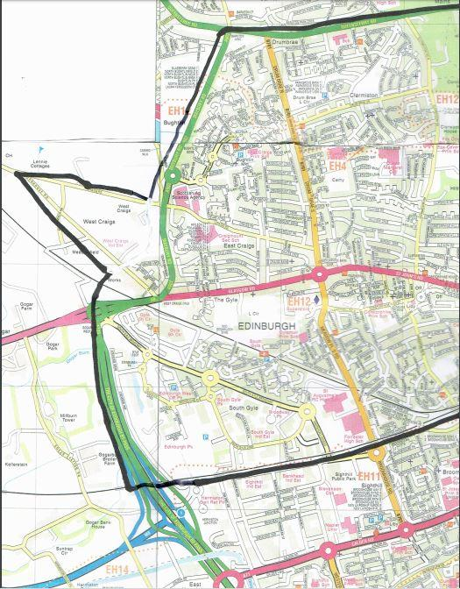
26 April 2018

AREA OF BENEFIT (EAST)
