Edinburgh Union Canal Strategy 2024-2029
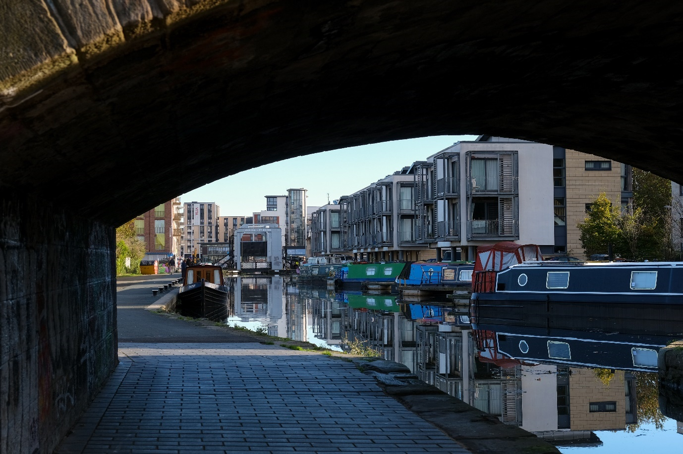
Caption: Towpath under Viewforth bridge showing Canal boats and buildings
Edinburgh City Council and Scottish Canals
Introduction
The Union Canal continues to be one of Edinburgh’s most important heritage, leisure, and community assets. Recent years have seen the canal corridor busier than ever, offering outdoor space to residents and visitors and alike.
Since the original Edinburgh Union Canal Strategy was published in 2011, many neighbourhoods along the Union Canal have seen changes such as the development of replacement schools, housing, and public realm.
This refreshed strategy was developed by the Edinburgh Union Canal Partnership, comprising Scottish Canals and the City of Edinburgh Council. It recognises and tracks the progress that has been made since the publication of the previous strategy in 2011 whilst seeking to map out the ongoing challenges and opportunities and how we can work with our canalside partners to deliver on future ambitions.
This process has included:
- A series of stakeholder meetings and learnings carried out along the Union Canal including meetings with social enterprises, sports club, and community councils.
- An online survey carried out via the Council’s Consultation Hub from early June till mid-July 2023.
- The formation of an Edinburgh Union Canal Partnership Working Group consisting of Council and Scottish Canal officers with relevant expertise.
- A review of the actions developed in the original 2011 strategy and its accompanying action plan to determine progress.
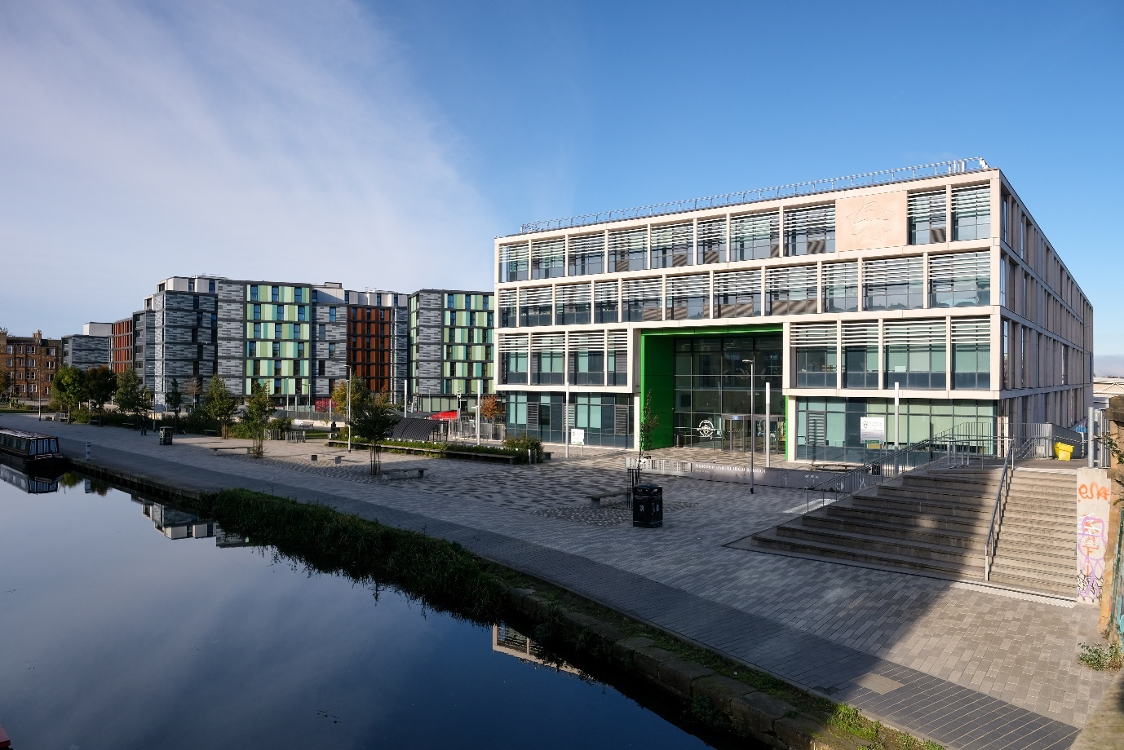
Caption: Outside Boroughmuir High School and Fountainbridge Green
Partner's foreword
Cllr Cammy Day
Council Leader
I am pleased to introduce the 2024 refresh of Edinburgh’s Union Canal Strategy. This updated strategy highlights the key opportunities for the Edinburgh stretch of the Union Canal. Since the original strategy was published in 2011, the route has continued to develop as a green-blue active travel corridor from the outskirts of Edinburgh into the city centre, free from vehicular traffic. Sites along the Union Canal have proven a popular location for new homes due to the benefits to people’s mental and physical health from living nearby. Highlights have included: completion of the Canalside Boroughmuir High School in 2018 with space to exercise and relax; ongoing access and maintenance improvements; and a £1 million sports centre was opened at Meggetland in 2022 offering rowing for all. The Edinburgh Union Canal Partnership will work with stakeholders to deliver this strategy, building upon the work that has been done since 2011 and taking forward projects to further enhance the Union Canal for everyone to enjoy.

John Paterson
CEO, Scottish Canals
I am delighted to have worked in partnership with the City of Edinburgh Council’s to update the Edinburgh Union Canal Strategy, reporting on progress since the original strategy was published in 2011 and allowing us to refocus our priorities for the coming years. The priorities for Edinburgh naturally reflect the Scottish Canal values as we will work in partnership to care, create and collaborate to enhance, conserve and improve our canals and their surrounds to provide benefits for local communities. Edinburgh’s stretch of the Union Canal is popular, vibrant and very busy, arguably much more so in recent years, so we fully recognise the need to support all users of our towpaths and waterway, to have the space and experience they expect. We will also continue to support all our canalside organisations and community groups to build on the wealth of projects and activities that rely on the Union Canal as their foundation.

Aims of the strategy refresh
- Complement wider area improvements and support a community wealth building approach
- Improve the health and wellbeing of canalside communities
- Support the delivery of the Scottish Canals Corporate Plan 2023-2028
- Increase connections to, and knowledge, around the Union Canal
- Recognise the Union Canal towpath’s role as an active travel corridor
- Support the status of the Union Canal as a Local Nature Conservation Site and Edinburgh’s Nature Network aspirations
- Support the Council’s wider regeneration work
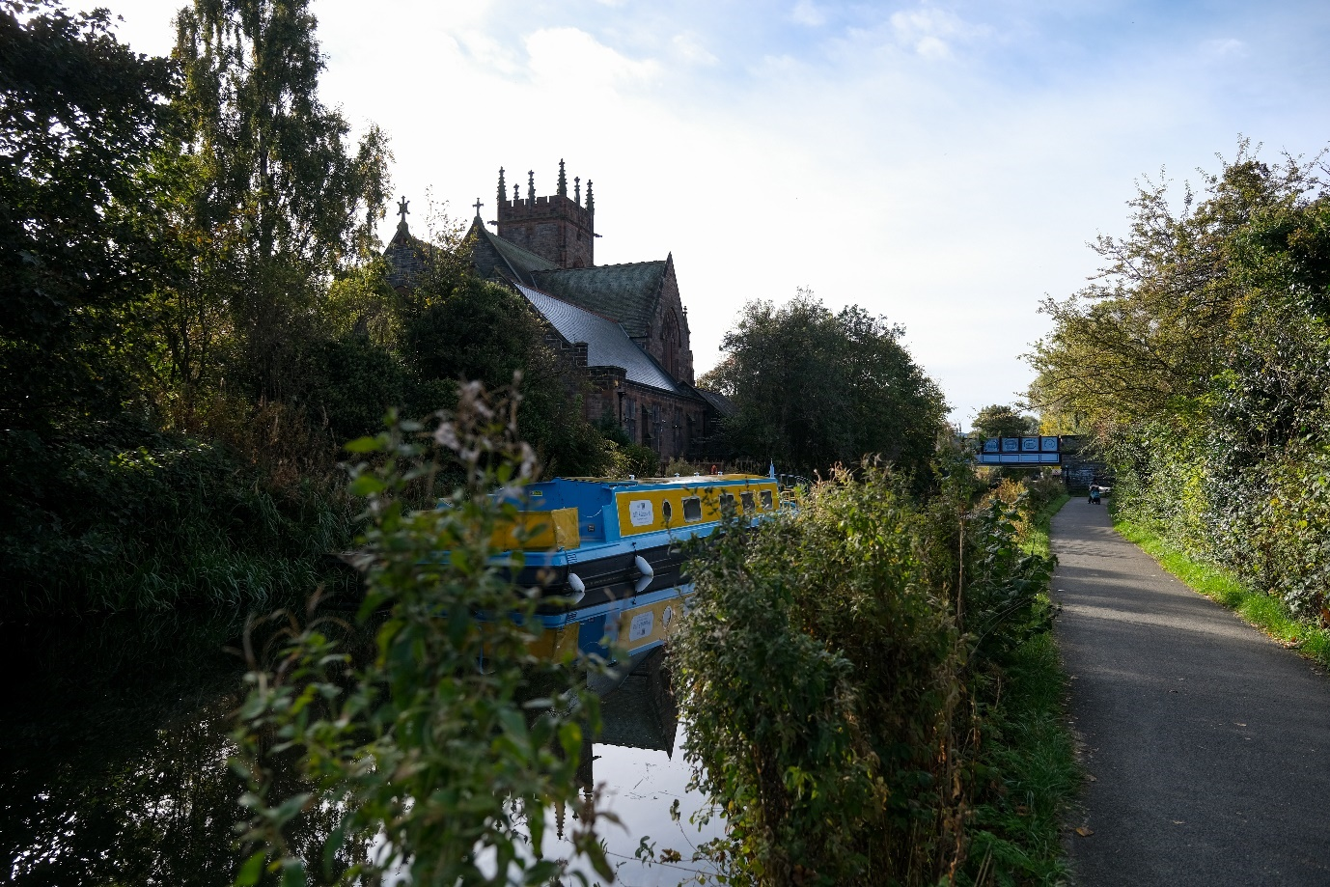
Caption: Canal towpath with All Aboard Boat and Polwarth Church in background
History
The Union Canal, the last of Scotland’s major canals, was created between 1818 and 1822. Day-to-day, the Union Canal was principally used to transport goods, and later to transport people. Travelling by canal was far more comfortable, and often safer, than along rutted roads. However, as railways developed, passenger services along the Union Canal were stopped in 1848 as railways offered faster transportation and by 1965 the Union Canal was closed to all boat traffic.
In 2002, the UK’s largest canal restoration project, the Millennium Link, restored navigation, and with a link with the Forth & Clyde Canal through the Falkirk Wheel, boats were once more able to travel between Edinburgh and Glasgow. The Union Canal is a significant industrial heritage asset not just for the city, but nationally and internationally and is recognised as such by its status as a Scheduled Ancient Monument. As one travels along the Union Canal, the heritage of the area is apparent via artefacts such as the kick stones along the towpath which would have guided horses and the massive aqueducts which served as an alternative to locks along the Union Canal.
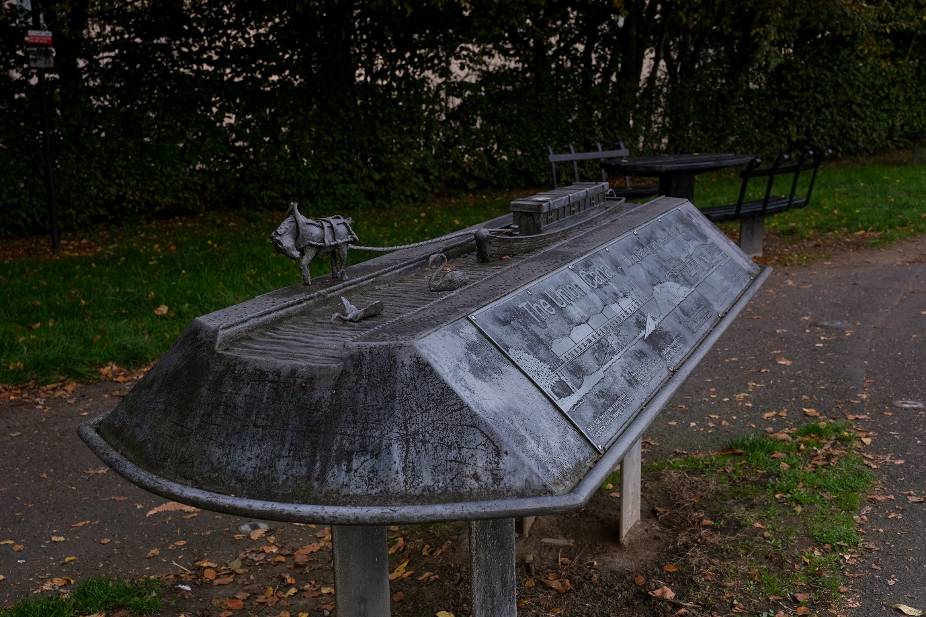
Caption: Union Canal information board on decorative structure at Ratho with bench in background
Recent Achievements
In Edinburgh, the restoration of the Union Canal has been vital in linking up communities; allowing for boating communities to flourish; providing a car-free active travel route; and offering a gateway to the outdoors with nature on people’s doorstep. There has been a lot of progress since the Edinburgh Union Canal Strategy was published in 2011 with increased traffic both along the Canal and in neighbouring communities. This has included:
- In 2018, the completion of the canalside Boroughmuir High School replacement with open space including seating and outdoor exercise equipment and the new school completely integrated into its waterside surroundings.
- The celebration of the Bicentenary of the Union Canal in 2022, including a special event at the Edinburgh Canal Festival in June that year.
- Opening of a new £1 million rowing facility at Meggetland for the St Andrew Boat Club in 2022.
- New housing-led mixed-use developments in Fountainbridge including New Fountainbridge, Lower Gilmore Place, and the former Fountain Brewery site.
- Completion of the community-led Local Place Plan in Wester Hailes which - outlined how the community would like to see future projects be developed including their aspirations for the Union Canal in that area.
- Start of construction on the Roseburn to Union Canal active travel route, which will establish a new green corridor linking Fountainbridge and the North Edinburgh Path network.
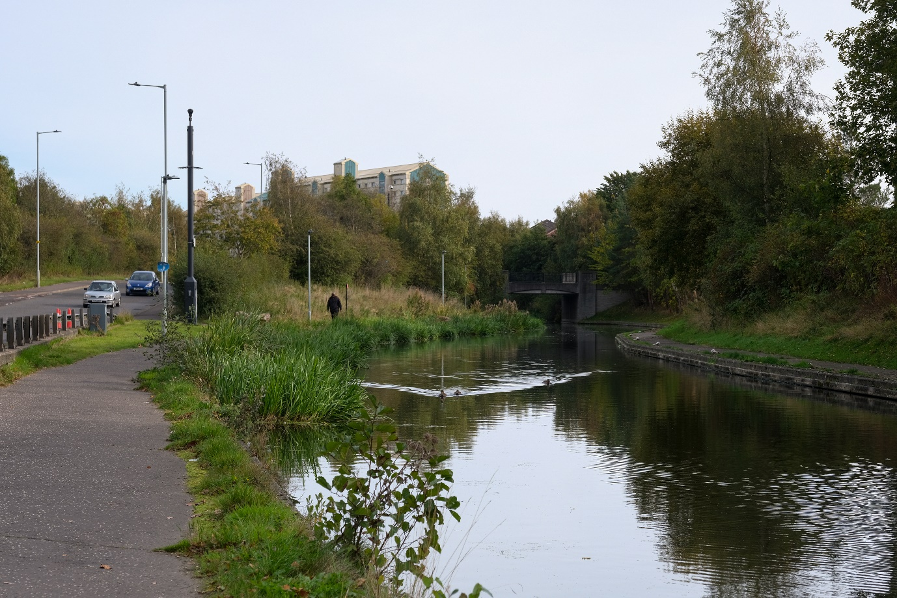
Caption: Union Canal and adjacent towpath at Wester Hailes
Education and heritage
The Union Canal provides an opportunity for schools and residents to connect to nature in a local setting. The curriculum developed by teachers can help pupils see opportunities in familiar places. This can encourage an update in local’s utilising the canal and volunteering nearby.
The Union Canal is being incorporated into education resources at various levels:
- Scottish Vocational Qualifications (SVQs)
- School lessons
- Supporting teacher training
- Supporting water-based sports lessons
- Lessons and social groups on social enterprise canal boats
Canals can be used to teach about a wide range of topics including biodiversity, visitor tourism, and architecture. The Union Canal can also be used as a resource in geography, biology, and biodiversity lessons. The water can be used to understand stream velocity and flow, comparing artificial watercourses to natural rivers. The water can also provide testing for water quality and depths, which could be linked up with Citizen Science, with volunteering and local input via mobile apps taking a key role, and data collection.
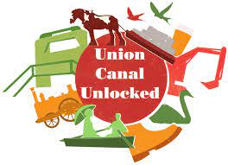
Caption: Union Canal Unlocked Logo (an app and website used to highlight the heritage of the Union Canal)
Biodiversity and landscape
The Union Canal continues to be an important wildlife corridor and a Local Nature Conservation Site, which are a connected network of protected sites for nature across Edinburgh. The Union Canal offers access to a diverse range of plant and animal species, and car-free connections to green and blue spaces across the city.
The Union Canal stretches through both rural and urban areas, linking adjacent woodlands, species rich grasslands and other watercourses, and allowing relatively easy movement through often otherwise hostile and more intensively managed surrounding land. The waterway supports fauna in the water, including fish species and invertebrates, as well as supporting birds, otters, bats and badgers who utilise the towpath’s varied grass vegetation. Having one side of the canal as space for nature, and one side for access, is important to maintain the connected space for wildlife to move along the canal corridor. Bats are well supported by the Union Canal, due to its aqueducts and bridges providing covered habitats, and the darkness along the Union Canal is crucial for bat populations to forage at night.
Scottish Canal’s Environment Strategy 2015-2025 supports protecting biodiversity and provide environmental benefits along the wider canal network, and this strategy is in line with these wider outcomes.
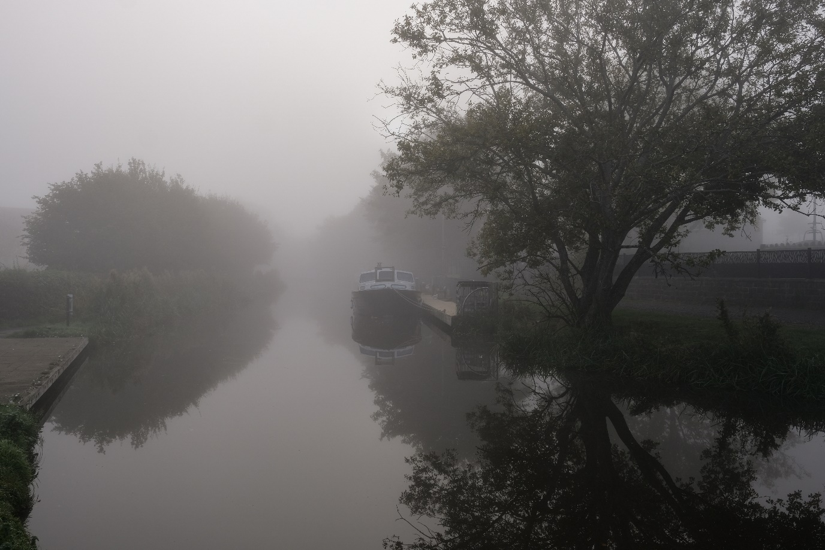
Caption: Mist along the Union Canal at Ratho
The Union Canal is highlighted in the Blue Networks section of the Edinburgh Local Biodiversity Action Plan (ELBAP). The Union Canal is identified for its important function in Edinburgh, providing semi-natural habitat and commuting corridors for wildlife, as well as green travel routes for people. The ELBAP aims to manage biologically important places and recognise difference spaces as opportunities for wildlife. Looking ahead at the vision for 2050, the ELBAP aims to develop a species-rich network across the whole network which will increase the city’s resilience to climate change, create a good foundation of ecosystem services, and support healthy lifestyles.
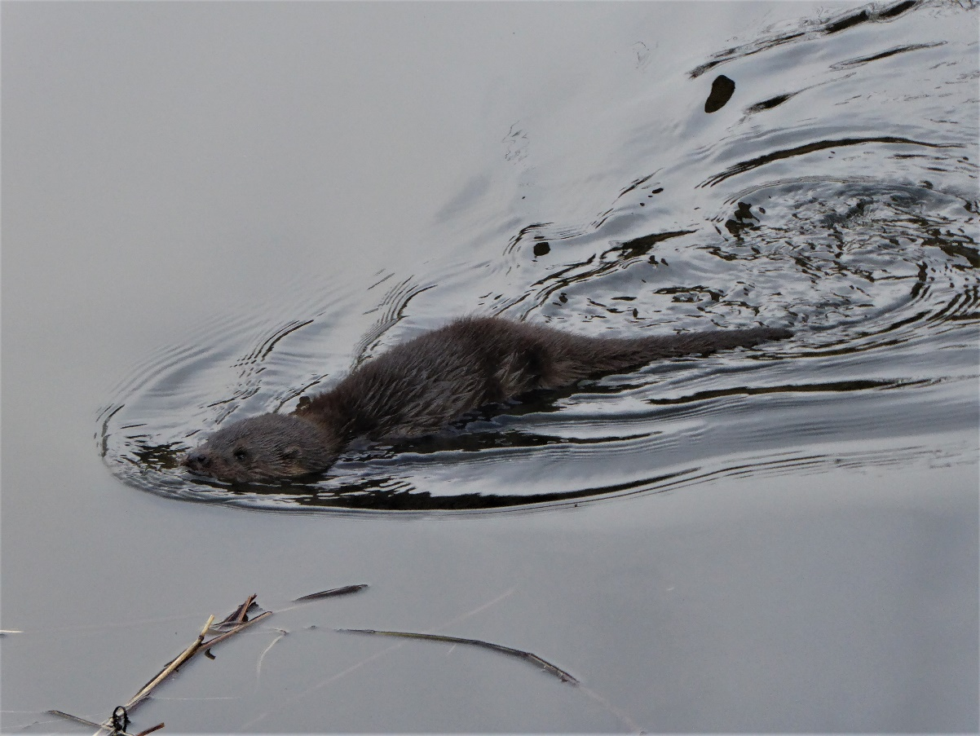
Image: An otter swimming in Union Canal water (Source: miketransreal on Flickr)
Otters are a good news story for Edinburgh – just a few decades ago there were no otters on Edinburgh’s watercourses. As water quality has improved, otters have returned and are now found on all of Edinburgh’s watercourses, including the Union Canal and the nearby Water of Leith.
Case Study: Recording Wildlife on the Union Canal
The Wildlife Information Centre, in partnership with the Council, carry out survey work to provide information about Local Nature Conservation Sites. These wildlife recording visits, by volunteer experts, provide important information which can support future citizen science projects. These visits will primarily survey plants, but other species will also be recorded.
At the most recent survey day, almost 200 species were recorded on the section of the Union Canal between Slateford and Harrison Park. Most of these were plants, birds, and a small number of insects. A species of sponge (Spongilla lacustris) was also seen growing on concrete under the water. Citizen science activities, including surveying, can help understand and protect the important wildlife along the Union Canal network.
Survey respondents who have spotted species along the Union Canal:
Species | Number of people who spotted this species
Pollinators (Bumble Bees, Solitary Bees, Hoverflies and Honey Bees) | 440
Butterflies | 403
Birds (e.g., Sparrowhawk, Swift, Common Tern) | 367
Fish | 199
Bats | 129

Partner Case Studies
There are several organisations carrying out vital work utilising the Union Canal to carry out activities ranging from boat trips to educational programmes.
George Heriot’s School Rowing Club operates with over 100 pupils aged 14-18. They use the Union Canal six times through a week. They also involve parents who sometimes volunteer their time to help maintain the stretch of water under the direction of Scottish Canals.
Polwarth Parish Church offer several activities during the week where everyone is welcome. This includes a pop-up café, a Scrabble group, tea and cake get-togethers, and other events for people to socialise. On Wednesdays, an adults group meet to learn new skills, make new friends, and connect with the local community. Skills include baking, crafts, gardening, and learning computer skills.
Edinburgh Union Canal Society operate out of the Ashley Terrace Boathouse, near Harrison Park. They encourage public use of those stretches of the Union Canal and its towpath for educational, sporting, leisure and recreational purposes. They have recently refurbished rowing boats and offering popular boat hire along the Union Canal.
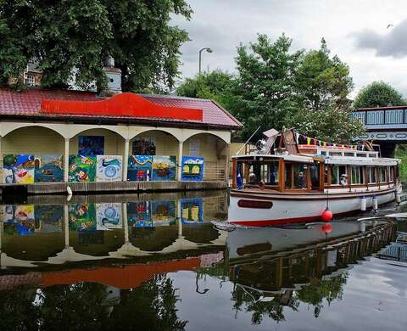
Caption: Edinburgh Union Canal Society’s Ashley Terrace Boathouse
The Sorted Project is an Edinburgh-based charity supporting people with complex health issues including substance dependency and mental health. They have a purpose-built canal boat, the Panacea, which they use to bring people in recovery together to a safe and unique space on water. They regularly support more than 150 people per year and offer a range of opportunities including Royal Yachting Association training; employability training; and litter picks. The group and wider volunteers also support the Union Canal’s environment through projects including litter picks, tidying, and gardening and composting projects.
One of the volunteers at The Sorted Project has had an amazing experience with the Sorted Project and has progressed from attendee to paid employee. Their confidence has grown over time from making tea and coffee to getting their helmsman certification and becoming a sessional worker. They advocate for getting along and enjoying the magic of the Panacea.
Another volunteer found the organisation organically. They were fishing along the Union Canal and had their lure stuck in a tree. After those on the Panacea rescued the lure, they had ongoing conversations as the boat passed, and they ended up deciding to join as a volunteer. They have developed from a valuable volunteer crew member, to gaining three major qualifications, and now being a paid member of a nearby organisation.
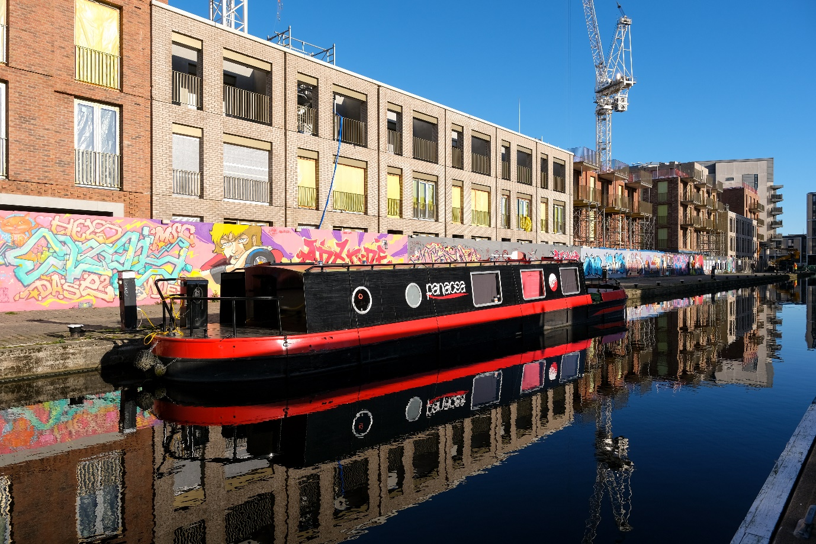
Caption: The Sorted Project’s Panacea Canal Boat moored along the Union Canal towpath
Fountainbridge Canalside Community Trust (FCCT) aims to make their local area a better place to live, work, do business and visit. All their projects and activities promote social inclusion, sustainability, and well-being. Their current projects include: the operation of Re-union Canal boats offering a variety of social inclusion trips; a canalside wellbeing walking group; running the annual Edinburgh Canal Festival; and organising various volunteering opportunities.
They have recently completed a 12-week pilot of a Canalside Greenside Group which delivered three small greenspace improvements for people and nature on the Union Canal in Edinburgh and nearby park. The project aims to boost urban biodiversity, increase participation in the outdoors, and improve the health and wellbeing of volunteers, event attendees and people living in the local area.
FCCT have a range of long-standing volunteers who have had the opportunity to help with a range of activities, and many have received training which has allowed them to go on to other volunteering and work pathways. All the volunteers advocate for just going for it, trying new things, and note that volunteering along the Union Canal is important to maintaining a sense of community.
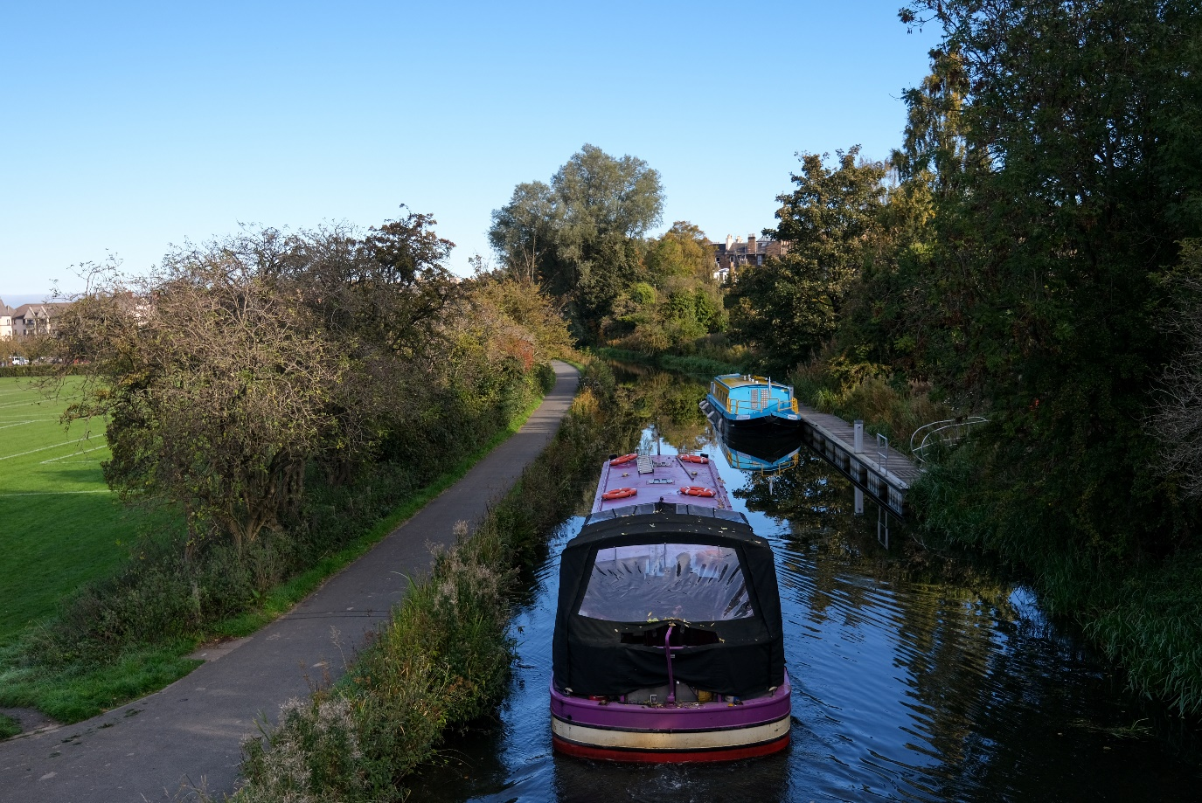
Caption: Lochrin Belle, Fountainbridge Canalside Community Trust’s Canal Boat, cruising along the Union Canal passing Harrison Park
Next Steps: Key priorities and action plans
Six key priorities have been identified through consultation and partnership working. These are followed by individual action plans breaking down the work required to support these six priorities. The action plan will be tracked and monitored as part of the Edinburgh Union Canal Partnership by the relevant project owner.
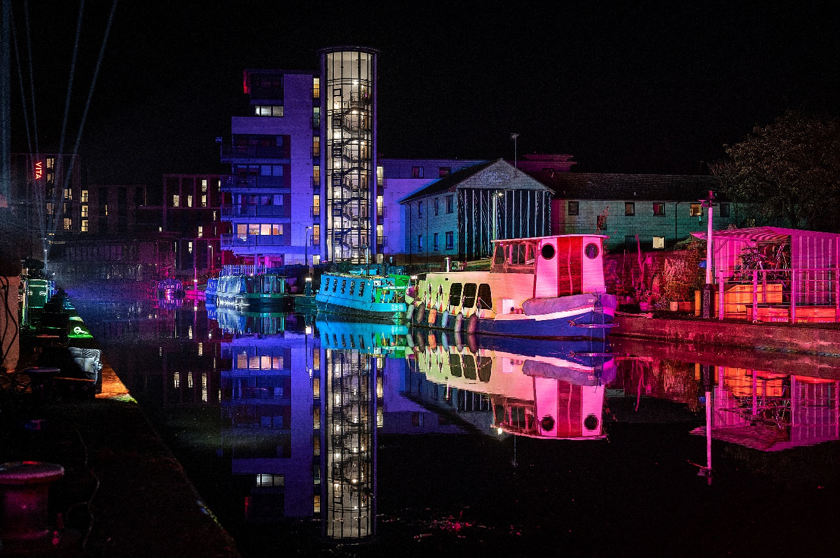
Caption: Canal boats moored along the Union Canal at night with lighting
Key Priorities
User behaviour | Support positive relationships between different users of the Union Canal and its adjacent towpath through signage and campaigning.
Improving access | Continue to ensure the towpath is accessible for users through access and surface improvements.
Placemaking and safety | Prioritise safety along the Union Canal by looking at solutions to support lighting, seating, and facilities.
Partnership working | Work with partners to support and grow volunteering, education, and skills-based training opportunities.
Enhancing biodiversity and climate resilience | Ensure the Union Canal’s biodiversity is protected and enhanced through education and volunteering.
Building upon developments | Work with developers and other stakeholders to ensure new opportunities enhance the Union Canal and contribute to a resilient and inclusive canal community.

Action Plans 2024-2029
Action Plan 1: User behaviour
Aim | Action Required | Project Owner
Installing educational signage promoting responsible and courteous behaviour by towpath users. | Develop a signage pilot project to understand user responses. Monitoring of signage and reviewing perceptions. | Council and Scottish Canals plus funding partners
Determine which infrastructure-focused interventions identified in the 2017 Towpath Study can be implemented including separate user lanes at busy locations. | Identify key zones and reviewing feasibility. Ranking priority projects based on feasibility and impact including utilising data to better understand issues of speed and conflict. | Scottish Canals
Promote a code of conduct for the towpath and ensure it is in line with user needs. | Review the Scottish Canals code of conduct and promote its use. Continue to promote the code through website, campaigns and signage. | Scottish Canals
Review alternative route options for road-confident cyclists (particularly commuters or other time-sensitive travellers) to allow for those looking to cycle at a faster speed. | Identify key zones for rerouting. Reference the alternative routes identified. Ranking priority areas based on feasibility. Carry out improvements in line with the Council’s Active Travel Action Plan. | Council plus funding partners

Action Plan 2: Improving access
Aim | Action Required | Project Owner
Identify and implement opportunities to widen the towpath at densely used areas and key pinch points. | Review previous work, identify key priority areas and type of widening which is appropriate. | Scottish Canals and funding partners
Work with partners and volunteers to ensure vegetation management along the Union Canal supports navigation and visibility for all users. | Create working group to identify vegetation management priorities with stakeholders. Work with local team and volunteers to build capacity for vegetation management. | Volunteer organisations and support from Scottish Canals
Continue to complete access improvements and towpath maintenance where funding allows | Ongoing work which will be continually reviewed by Scottish Canals. | Scottish Canals

Action Plan 3: Placemaking and safety
Aim | Action Required | Project Owner
Review lighting in line with the emerging wider Scottish Canal lighting strategy, prioritising low-impact solutions including solar studs and LEDs. | Determine highest priority areas where low impact lighting would improve safety. Investigate if larger-scale lighting projects are suitable for certain stretches of the Union Canal. | Scottish Canals
Work with Council led regeneration programmes to support projects linked to the Union Canal. | Review areas of the Union Canal where users report safety being an issue. Work with the Wester Hailes Community Trust to support Union Canal projects based on the Wester Hailes Local Place Plan. | Council and Community Representitives
Identify suitable locations where additional facilities may be beneficial. | Determine funding avenues and location priorities for these facilities. | Scottish Canals plus funding partners

Action Plan 4: Partnership working
Aim | Action Required | Project Owner
Support partners on Union Canal projects including community groups, charities, developers, and the local business community. | Create a partner steering group to created continued communications between Scottish Canals, the Council, and partners. Align with partners to grow volunteering and build capacity along the network. Determine funding opportunities and progress projects where appropriate. | Partnership working led by Council
Explore creating materials (such as posters, information boards) in local museums and centres. | Determine local buildings which could house these projects. Identify funding opportunities for delivering these educational materials. | Council and Scottish Canals
Support learning programmes developed by educators, such as Keep Scotland Beautiful, along the Union Canal. | Facilitate discussions with education-based groups. Determine funding avenues for educational projects and create joint funding bids. Support projects based on funding outcomes. | Education groups and Council

Action Plan 5: Enhancing biodiversity and climate resilience
Aim | Action Required | Project Owner
Explore funding and volunteering opportunities to increase data collection along the Union Canal to better understand it’s ecological benefits. | Evaluate current data available to determine major data gaps in ecological data. Determine opportunities for creating ongoing data. Support Citizen Science opportunities to build upon species knowledge in the area. | Scottish Canals, education partners and community
Looking at ways to increase the Union Canal’s role in building climate resilience. | Determine if the Edinburgh stretch of the Union Canal could integrate with drainage systems to mitigate flood risk. In line with Scottish Canal’s Environmental Strategy, ensure climate resilience through urban cooling and canopy coverage, nature-based solutions, and connecting habitats. | Scottish Canals
Increasing the Union Canal’s capacity for supporting and maintaining important flora and fauna. | Enhancing the habitats within the Union Canal by managing invasive species and ensuring maintenance supports the growth of flora and fauna in creating an ecologically rich environment. | Scottish Canals and volunteer partnerships

Action Plan 6: Building Upon Developments
Aim | Action Required | Project Owner
Utilising local sounding boards to advocate for the Union Canal’s development and protection. | Assess the scope to replicate the Fountainbridge Sounding Board in other areas of Edinburgh. | Council
Working with officers taking forward Council-led developments along the Union Canal to maximise opportunities. | Engage with project leads for all relevant Council-led developments to identify opportunities. | Council and Scottish Canals
Inputting to consultations and engagements around developments along the Union Canal. | Maintain a watching brief on planning applications and other proposals along the Union Canal and develop responses in line with the key priorities. | Council and Scottish Canals
Promoting and supporting the development of longstanding brownfield sites along the Union Canal. | Audit target sites along the Union Canal, engage with landowners, and develop tailored strategies strategies in collaboration with the local communities to unlock their development. | Council
Working with developers to secure funding to improve the surrounding area. | Engage with developers to identify opportunities to complement private investments with other funding sources, for example Sustrans grants. | Scottish Canals

Localised points of focus
In the following maps, some of the local opportunities, key connections, and issues are highlighted. These were identified through the consultation process as well as wider stakeholder engagement. This is not an exhaustive list and will be updated as part of the strategy’s actions to create a continued awareness of new opportunities and issues.
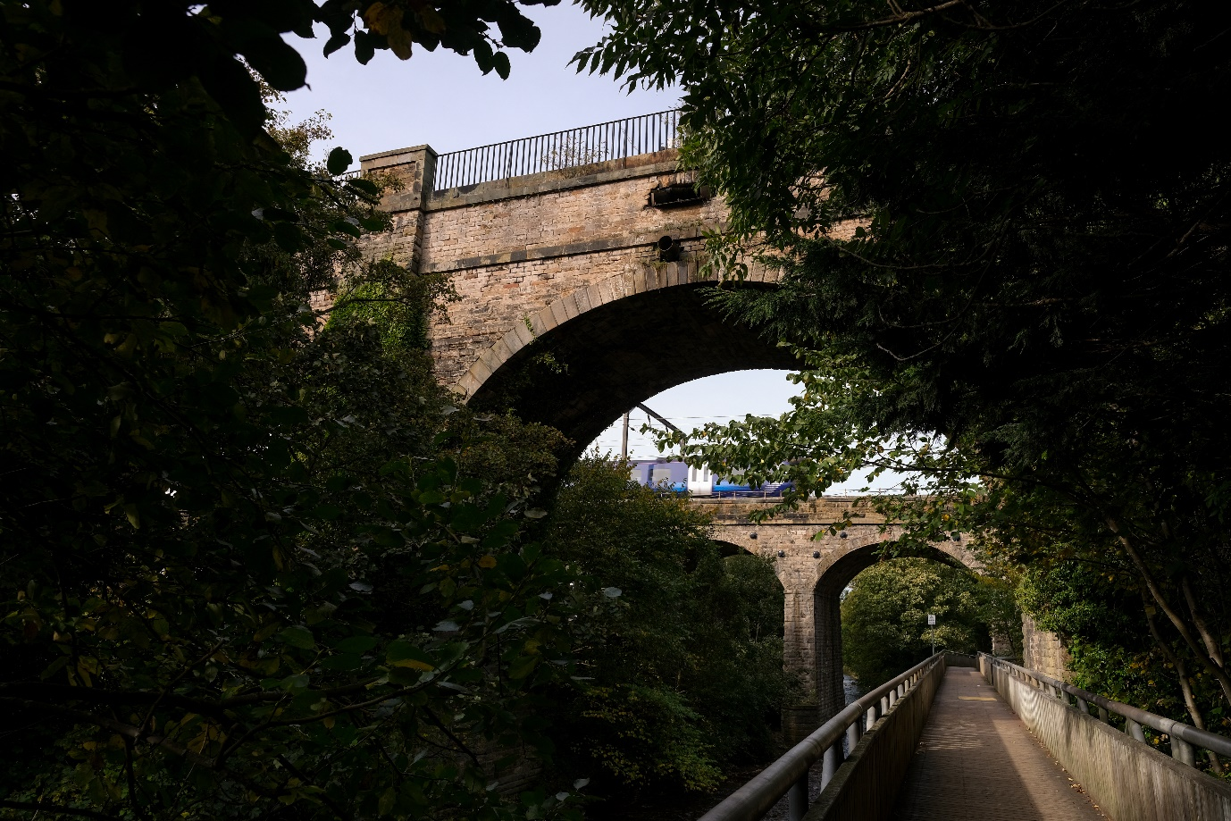
Caption: From Water of Leith walkway, Slateford Aqueduct seen in the high foreground and the Slateford Railway Viaduct seen in the background with a train passing through
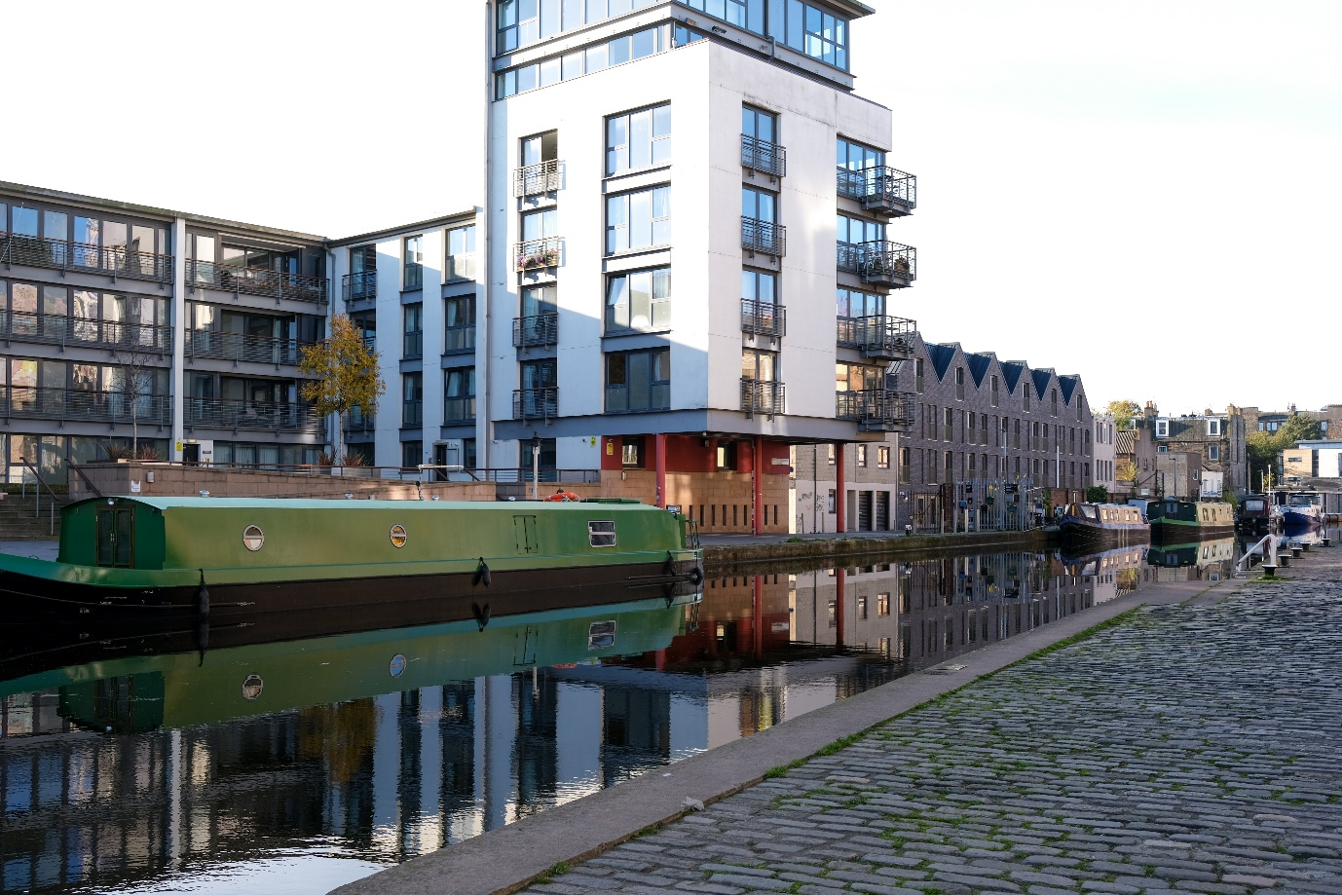
Caption: Canal boat seen along the Union Canal at Lochrin Basin with new development in background
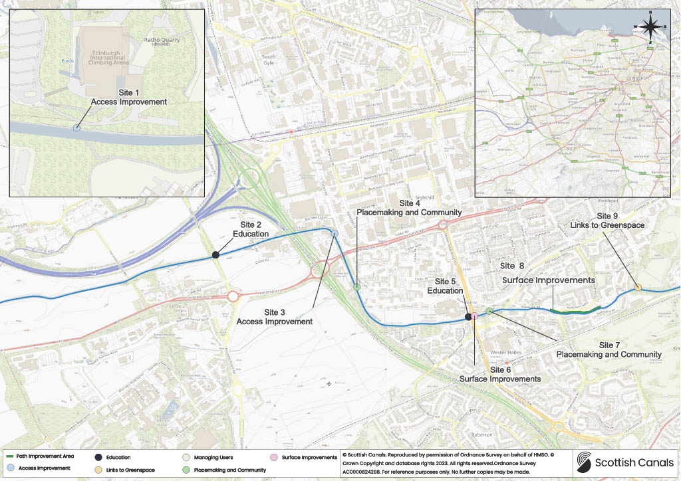
Caption: Map of West Edinburgh showing points of focus along the Union Canal
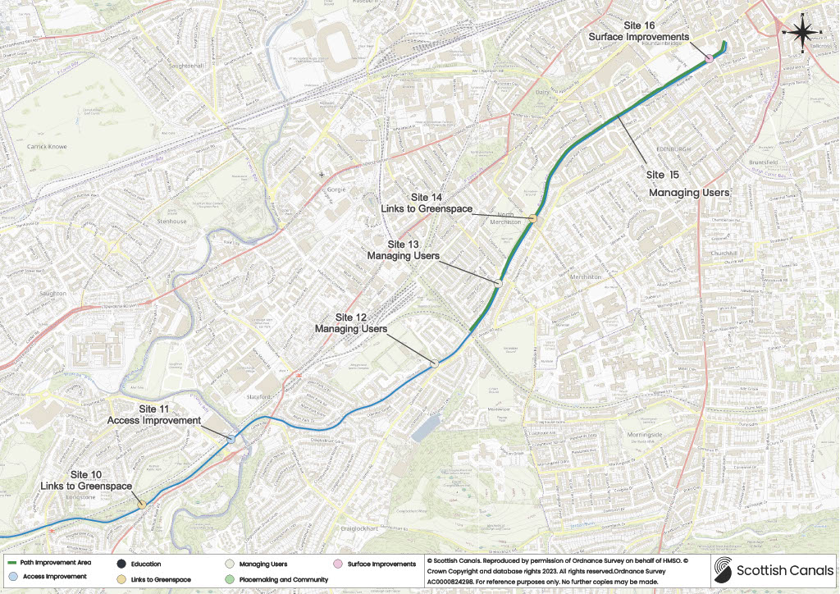
Caption: Map of Union Canal in Edinburgh city centre with points of focus
Site | Improvement Type | Action Required
1 | Access improvement | Access improvements at Edinburgh International Climbing Arena and Lost Shore resort.
2 | Education | Connections to Heriot Watt University.
3 | Access improvement | Improve access point at the Calders.
4 | Placemaking and community | Improved visibility and connections to Bridge 8 Hub.
5 | Education | Connections with Wester Hailes High School in line with the Wester Hailes Local Place Plan.
6 | Surface improvements | Improvements to Union Canal frontage in Wester Hailes.
7 | Placemaking and community | Connections to the local centre of Westside Plaza in line with the Wester Hailes Local Place Plan.
8 | Surface improvements | Improving path by managing tree roots and resurfacing along the towpath between Wester Hailes town centre and Hailes Quarry Park.
9 | Links to greenspace | Improvement connections from the towpath to Hailes Quarry Park. Accessing green space adjacent to the towpath.
Site | Improvement Type | Action Required
10 | Links to greenspace | Improving connections to Redhall Park. Accessing green space adjacent to the towpath.
11 | Access improvement | Reviewing access to Slateford Aqueduct and possible development of alternative routes to increase safety.
12 | Managing users | Working with sports clubs at Meggetland to ensure water sports can be carried out safety.
13 | Managing users | Promote school safety at the entrance to Craiglockhart Primary School.
14 | Links to greenspace | Review alternative routes around Harrison Park to help disperse footfall during peak times.
15 | Managing users | Look at solutions to address high densities of users during peak times along the stretch between Polwarth and the Lochrin Basin.
16 | Surface improvements | Working with new developments at Fountainbridge to create new and enhanced towpath segments.

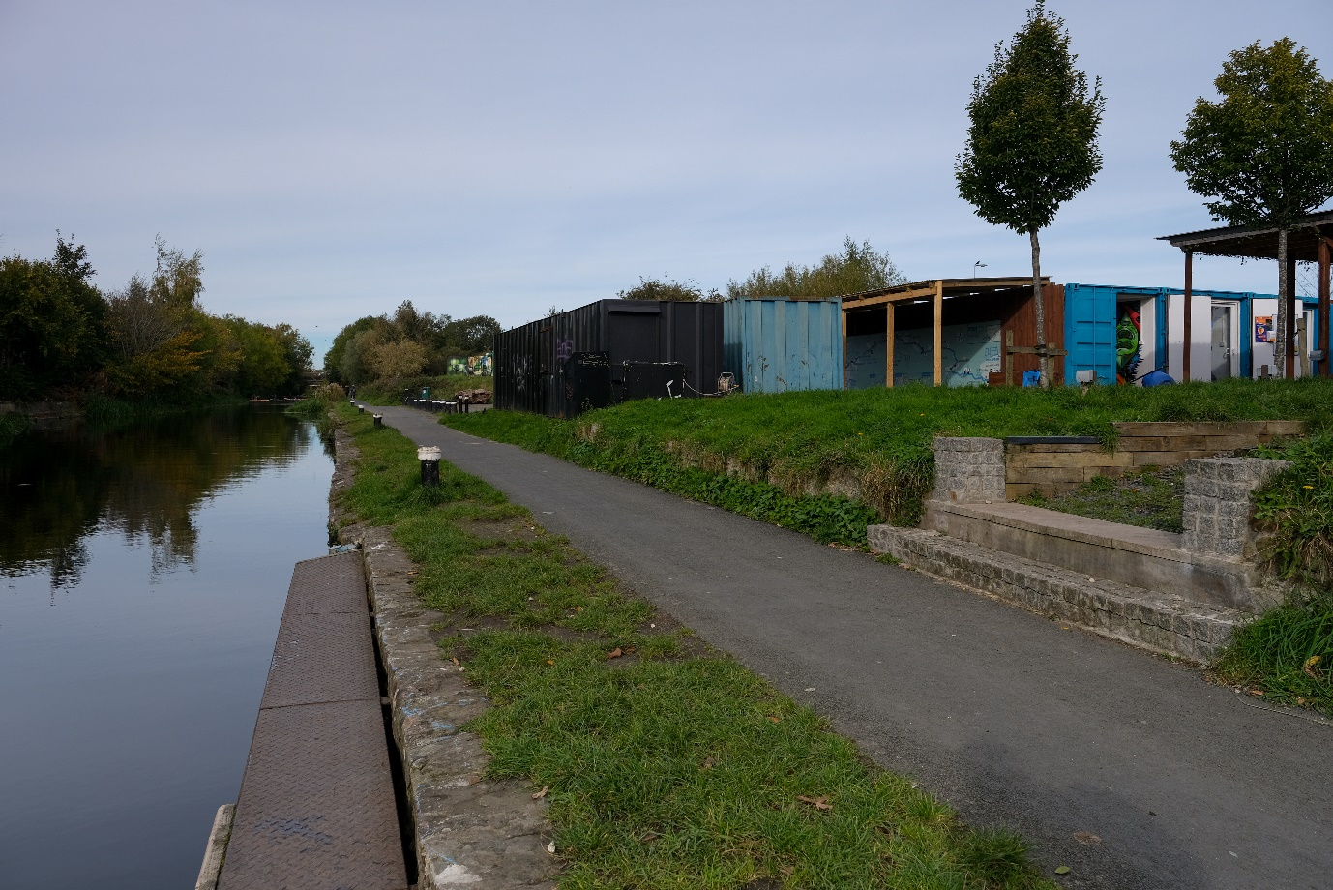
Caption: Image of Site 4 – Bridge 8 Hub
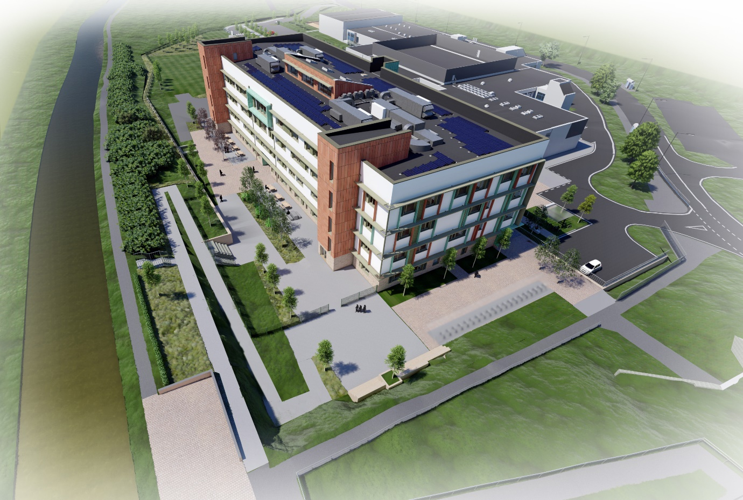Caption: Image of Site 5 – Image of new Wester Hailes High School (Note these are artistic images and may vary from actual)
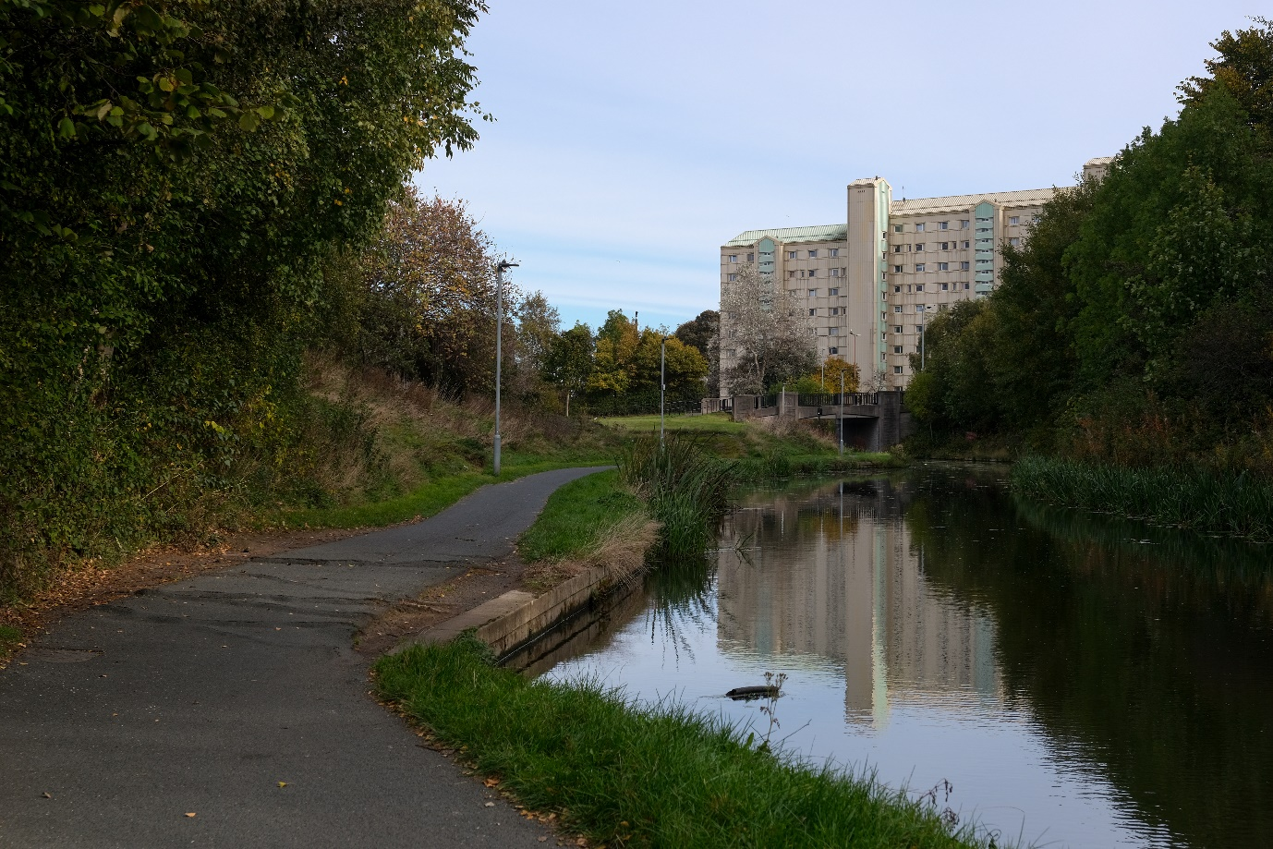
Caption: Image of Site 6 – Tree root damage along towpath at Wester Hailes
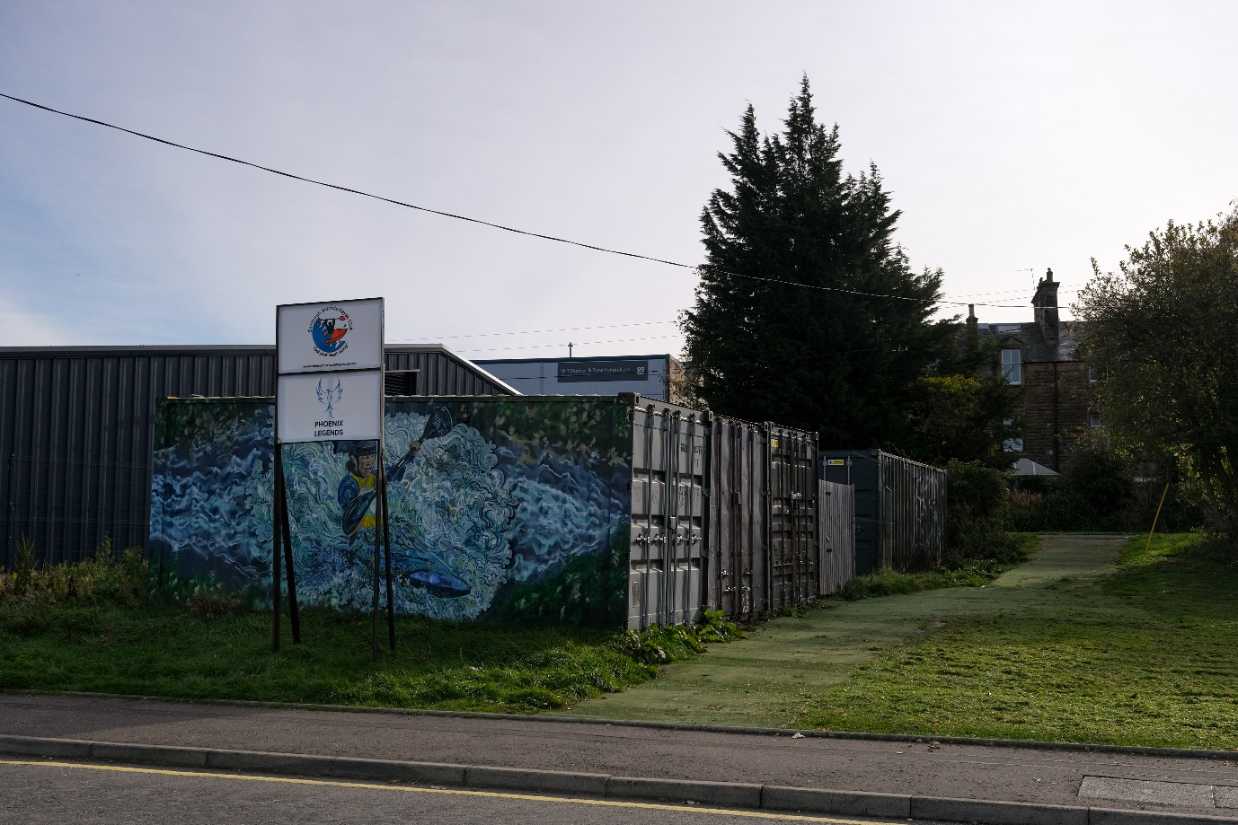
Caption: Image of Site 12 at Meggetland showing Edinburgh Schools Kayak Club
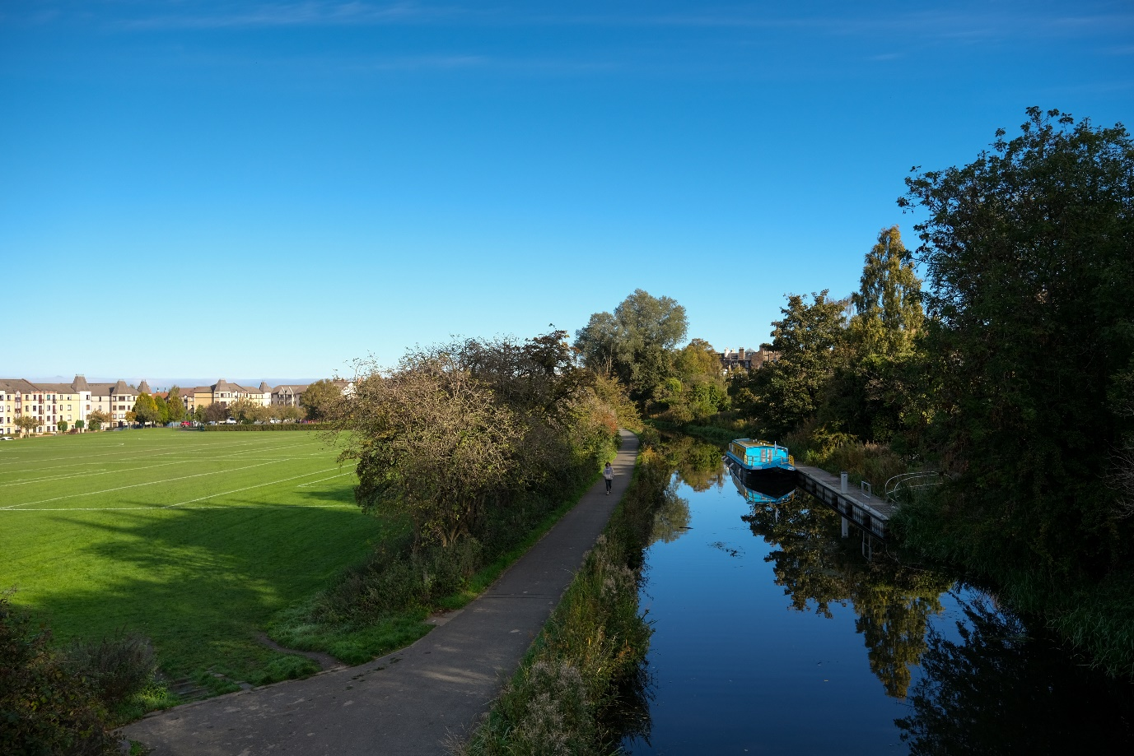
Caption: Image of Site 14 at Harrison Park
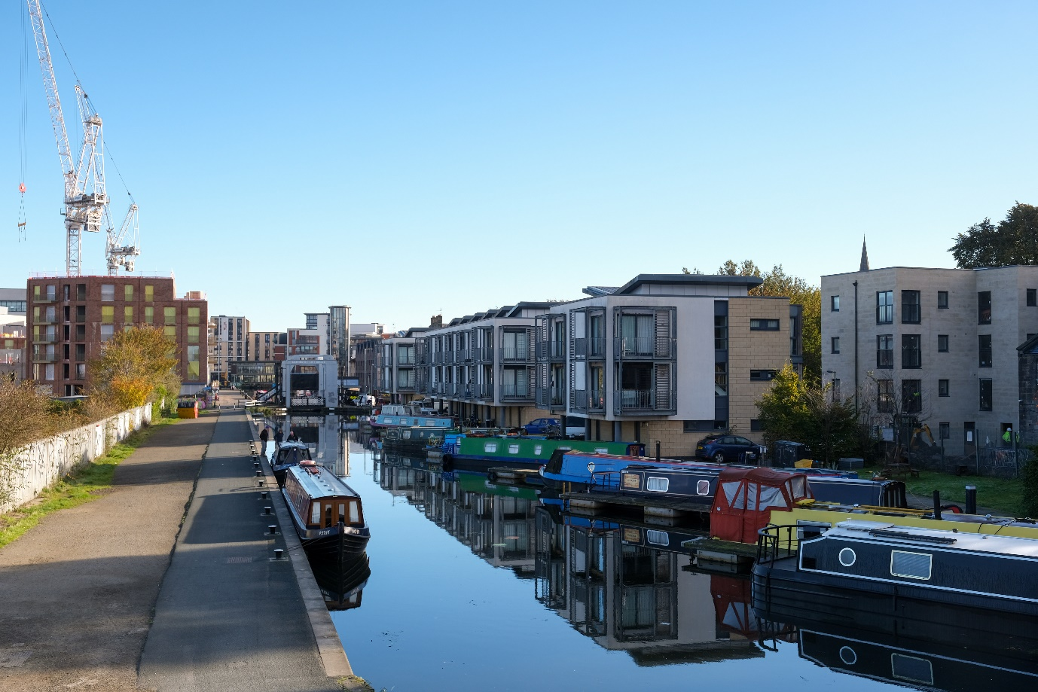
Caption: Image of site 16 at the Canal basin with Leamington Lift Bridge in background
Get in touch
City of Edinburgh Council: union.canal@edinburgh.gov.uk
Scottish Canals: enquiries@scottishcanals.co.uk
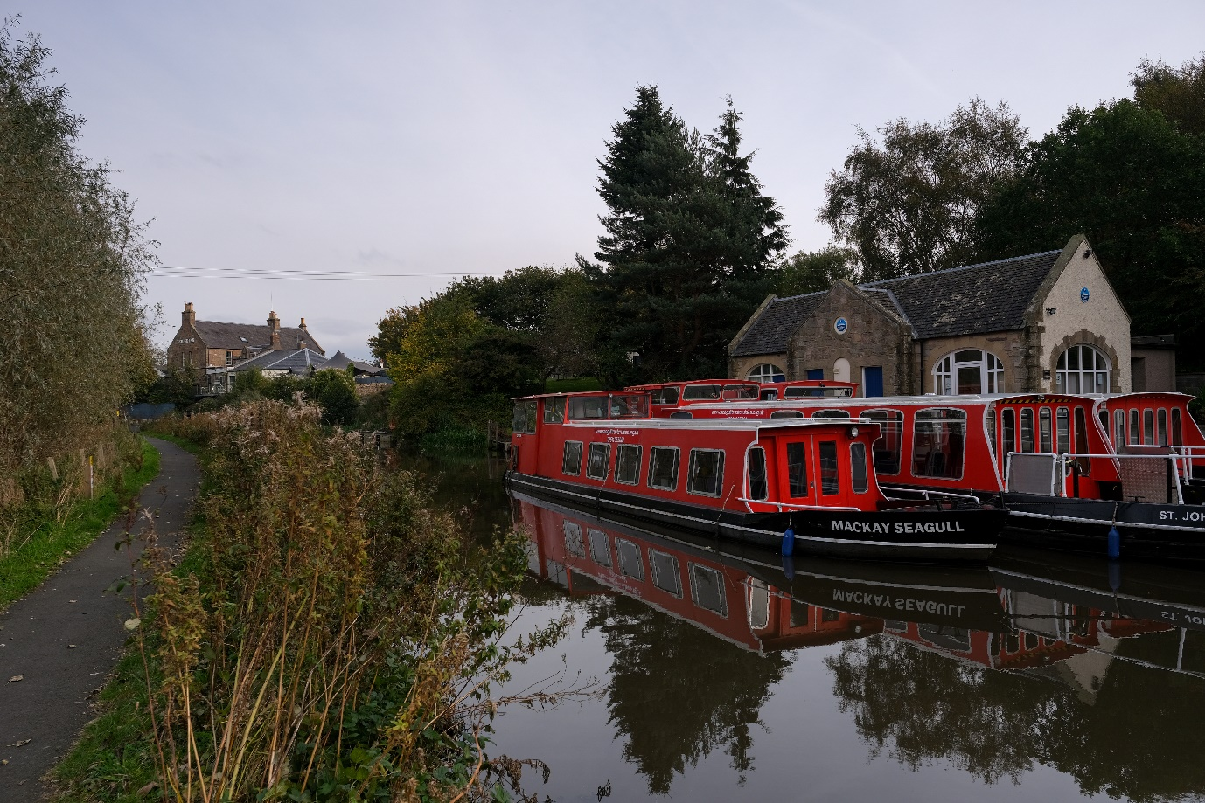
Caption: Seagull Trust Canal Boats moored outside centre at Ratho

