UK Parliamentary Election –Nomination Templates for UK Parliamentary Election in Great Britain

This nominations template has been designed to save time and help candidates complete their nomination forms correctly first time.
It is a guide for candidates and agents to help completion of their nomination for any UK Parliamentary Election held on or after 2 May 2024.
The annotated notes cover common points that cause confusion or difficulty.

Annotated nomination papers – UK Parliamentary Election
- Process and forms
  - Generally, there are three forms that you must submit to make your nomination valid:
- Nomination form
- Home Address form
- Consent to nomination
You must deliver these forms by hand, and they must be originals – so not copies. Any documents sent by email or fax will not be accepted. They must be submitted by 4pm on the nineteenth working day before the poll.
  - If you are standing on behalf of a registered political party you will also need to submit:
  - a certificate of authorisation
  - an emblem request form (if you want an emblem on the ballot paper)
These can be delivered by hand or by post but must be originals and anything received by email or fax will not be accepted.
  - UK Parliamentary candidates also need to pay a deposit of £500. The Returning Officer (RO) will provide you with instructions about how this can be paid, (cash/card/bank transfer). For the Edinburgh constituencies, BACS Bank Transfer is preferred. This deposit must be deposited with the Returning Officer by 4pm on the nineteenth working day before the poll. Candidates who poll more than 5% of the total valid votes cast in the constituency will have their deposit returned. Those candidates who have polled less than, or equal to, 5% of the total valid votes cast will lose their deposit.
  - You may also submit an agent appointment form. This does not need to be submitted with your other nomination forms but must be submitted before 4pm on the nineteenth working day before the poll to be accepted. If you do not submit an agent appointment form, you become your own agent by default.
  - All of the Edinburgh constituencies are burgh constituencies and no sub-agents can be appointed in a burgh constituency.
  - If you have any issues with completing your nomination forms, please contact the RO at the Elections Team, City Chambers, High Street, Edinburgh EH1 1YJ. 0131 469 3126, elections@edinburgh.gov.uk .
  - It is a good idea to have your nomination paperwork informally checked by the RO before you formally submit them. This can allow you to make any corrections or complete new nomination forms if there are any mistakes.
  - Once your nomination is formally submitted you cannot amend any details. If you change your mind and no longer want to stand for election, you can withdraw your nomination until 4pm on the nineteenth working day before the poll (the withdrawal deadline). You may withdraw as a candidate by signing and submitting a withdrawal notice, which must be witnessed by one other person.
  - If you are validly nominated by more than one form, you may request that the details of your proposers, seconders and other subscribers for up to two more valid nomination forms be added to the statement of persons nominated.
- Further Information
Other useful guidance sources
Guidance for Candidates and Agents at UK Parliamentary general elections in Great Britain
Schedule 1, Representation of the People Act 1983

- Annotated forms
These annotated forms cover areas of common confusion or difficulty for you to refer to as you complete your nomination paper. Notes have been added to draw attention to areas where mistakes are often made, or where you are likely to have questions.

Form 1a – Nomination paper (header)

This section should be completed by RO staff when the form is formally submitted.

The name of the constituency should be given here.

If it has not been pre-printed; the date of the election should be given.
A candidate may deliver multiple nomination forms, up to a maximum of three. If delivering more than one nomination form, you will be asked to confirm the order in which you want the forms to appear on the Statement of Persons Nominated.

Form 1a – Nomination paper (Candidate’s details)
The Candidate’s details section must be completed in full before any electors sign the nomination paper

Full names must be added here – no initials. Prefixes (e.g., Sir) or suffixes (e.g., Snr) must not be used.

The description may be left blank.

OR you could use the description ‘Independent’.

OR - for political party candidates, you will need to enter the registered party name or description as authorised by the party. This must be as registered with the Electoral Commission, and must match EXACTLY with the description authorised on Form 2 – the Certificate of Authorisation.

OR the Speaker of the House of Commons can use the following description: “The Speaker seeking re-election”.
It is important to read the Electoral Commission Guidance if a description is used.

This is optional.
If you are commonly known by a different name to your actual name, you should enter it here. Or, if you use one or more of your names given on your nomination paper in a different manner (e.g. if you are known by your middle name), you should enter it here.
The commonly used name will appear on the ballot paper and Statement of Persons Nominated instead of your actual name.
It is important to read the Electoral Commission Guidance if a commonly used name is used.

Form 1a – Nomination paper (subscribers)

You should include the polling district reference and elector number from the register in force when the Notice of Election is published.

The form must be signed by registered electors, a proposer, seconder and 8 assenters from the constituency.
Prior to the publication of the Notice of Election, the Electoral Registration Officer can assist you with elector numbers if you tell them the full name and address of the subscribers. Contact them at enquiries@lothian-vjb.gov.uk 0131 344 2500.
Each subscriber must sign the nomination form in the signature column. Their name may be printed too, preferably in capitals and does not have to match the name as printed in the register. If this column is not completed it does not invalidate the nomination.
Each elector may only subscribe one nomination form at the election. If subscribers sign more than one nomination paper, their signature will only be valid on the first paper delivered to the Returning Officer.
For further information see the Electoral Commission Guidance.

Form 1b – Home address form (header)
This section will be completed by RO staff when the form is formally submitted.

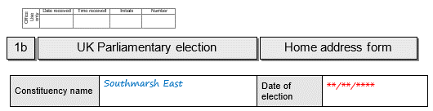
The name of the constituency should be given here.
If it has not been pre-printed; the date of the election should be given.

Form 1b – Home address form (Part 1)
Your home address must be given here:
- in full and without any abbreviations
- it must be your current home address
- it must not be a business address (unless you run a business from your home).
For further information see the Electoral Commission Guidance.

For further information see the EC ARO Guidance.

All candidates must complete Part 1 of Form 1b

This should be your full name, rather than any commonly used name.
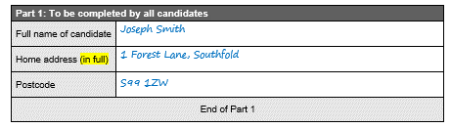

Form 1b – Home address form (Part 2)
Candidates who do not want their home address printed on the ballot paper must complete and sign Part 2 of Form 1b.
Part 2 should be submitted whether it is completed or not.

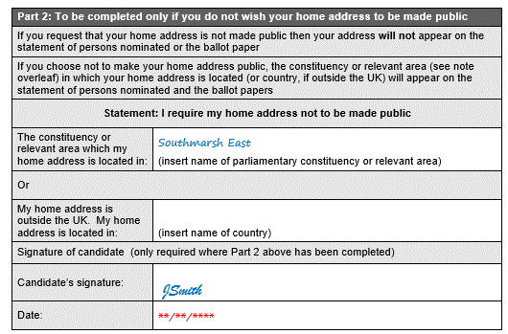
You can choose to give the name of the UK Parliamentary constituency OR the relevant area in which your home address is situated (if your home address is in the UK), OR if you live outside the UK, the country in which your home address is situated.
The relevant area is the county/district/London borough/county borough/local government area/local government district (as appropriate) in which your home address is situated.
For example, if your home address is in the CITY OF EDINBURGH COUNCIL area, the name of the relevant area is ‘CITY OF EDINBURGH COUNCIL’.
In this example, the candidate has chosen to give the name of the constituency their home address is situated in.
For further information see the Electoral Commission Guidance.
If either of the two boxes above have been completed the form must be signed and dated.

Form 1c – Consent to nomination
The entire form must be submitted.

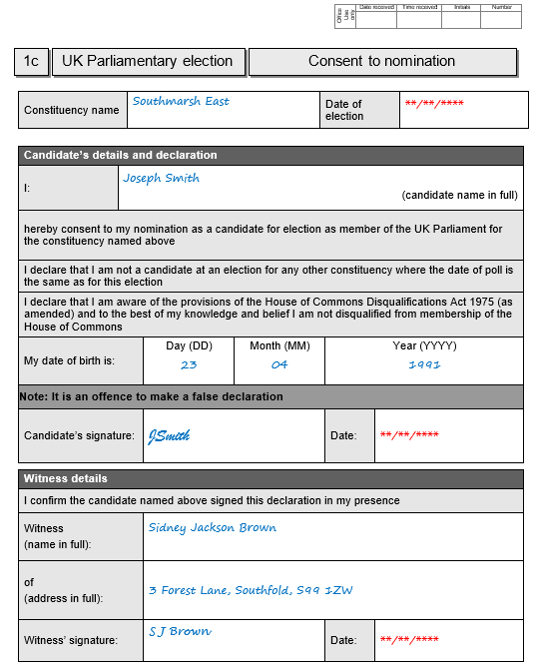
There are no restrictions on who can be a witness.
You must sign here, and the date should not be earlier than 1 month before the deadline for nominations.

This should be your actual full name (rather than commonly used name) as given in Form 1a.

You must be 18 or over on the date of submitting the nomination paper.

Form 2 – Certificate of authorisation
For party candidates only

If you are authorised to use a specific registered description or party name, it should be written here. It must match the description you give on Form 1a.
Or, if you are authorised to choose from a range of registered descriptions or party names, it should say ‘any registered description or the party’s name as registered with the Electoral Commission’.
Check the Electoral Commission website for descriptions.

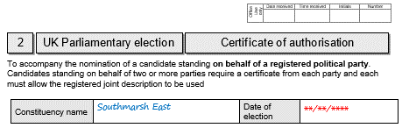
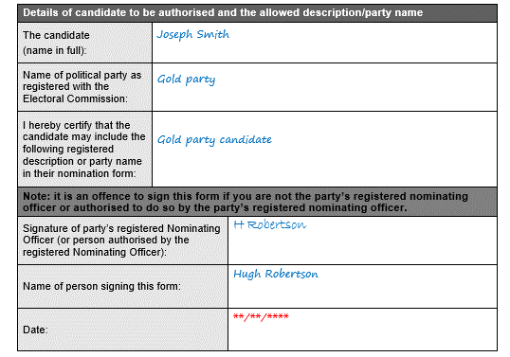
Registered party names and descriptions can be found on the Electoral Commission website
Search the registration details of the party and
click for more details to view the descriptions
available to choose from.

Must be signed by the party’s Nominating Officer or someone authorised by them.

Form 3 – Emblem request form
For party candidates only

(To request an emblem as registered with the EC)
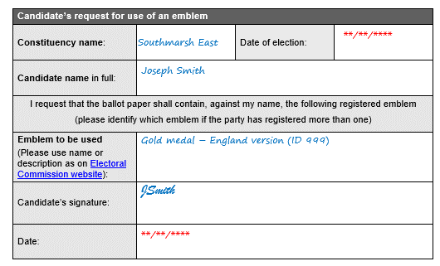
Emblems can be found on the Electoral Commission website
Search the registration details for the party and click for more details to view the emblems.

This must be signed by you.

This should be the name as registered with the EC e.g., “Emblem for use in England” or “Emblem ID 999”

Form 4 – Agent notification form
Optional – if a candidate does not appoint an agent they will become their own agent by default.
If you appoint yourself as your election agent, but are withholding your home address from the ballot paper and do not want it to appear on the Notice of Election Agents, you can provide an office address which is different to your home address.
For more information see the Electoral Commission guidance.

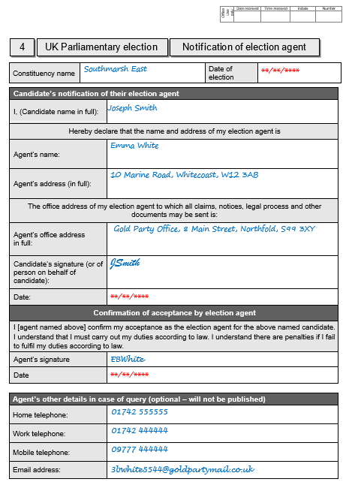
Must be a physical address. Must be within this parliamentary constituency or one that adjoins it.
The agent’s office address will appear on the Notice of Election Agents.

It is useful to provide this information in case of query or follow up contact.

Form 5 – Sub-agent notification form (not relevant for Edinburgh constituencies)
Optional – in a county constituency only, election agents may appoint individual sub-agents for particular parts of the constituency, as long as those parts do not overlap. The election agent can determine the parts into which they wish to sub-divide the constituency.

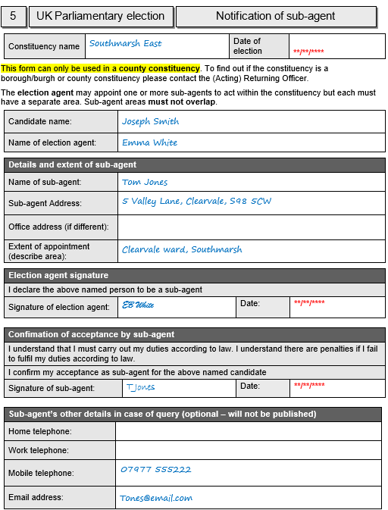
It is useful to provide this information in case of query or follow up contact.

The office of the sub-agent must be in the area within they are appointed to act.
Appendix A – Example of correctly completed nomination
