**Public Performance Scorecard

Annual Report 2023/24

Foreword

In 2023 we began to publish quarterly data on how our services are performing. Each year this work concludes with a single annual performance scorecard looking at our performance over the twelve months. This is our first annual performance scorecard and covers April 2023 to March 2024.

It shows that we have continued to put more money directly into the pockets of people who need it most – delivering £20m of financial gains for people using the city’s money and welfare advice services.

We have been successful in reducing the number of children in our care placed outwith Edinburgh restoring their connections to their local communities. In schools, our latest attainment figures are increasing, and the poverty related attainment gap has reduced. While this is welcomed, there is much more to be done here in the coming years.

Our investment in our roads and streets are showing results with improvements in both our street cleanliness and road condition scores.

Following the launch of Trams to Newhaven, we have also opened the City Centre West to East Link providing a safe and direct segregated route for walkers and cyclists through the heart of the city centre. These steps and more will help our journey to becoming a net zero, nature positive and climate resilient city.

Substantially increasing the number of social houses in the city and getting households out of homelessness remains one of our biggest challenges and the reason we declared a housing emergency. We were disappointed to learn that the Scottish Government funding for new affordable homes had been cut which has made it harder to respond to the urgent need for new housing across the city.

We continue to work hard to find the right balance for the many people that work, live and visit Edinburgh. We have welcomed visitors for international events which helped our economy but also presented challenges for us to manage and maintain clean streets.

Our Edinburgh People Survey reported that 94% of residents were satisfied with their life in Edinburgh and at the 2023 Urbanism Awards, the Shore in Leith was voted as the best neighbourhood in the UK and Ireland.

This report represents our challenges, progress and improvements in the services we deliver. It shows what we have done to help the lives of people who are struggling to get by in this city as well as the impact of the investments we are making in our surroundings.

There are also areas where we’re not doing well enough, and we are continuing to focus our efforts on driving improvements in these areas. The actions we are taking to make improvements are highlighted in this report and ongoing performance will be monitored through our quarterly public performance scorecard.

For now, we remain committed to delivering for the citizens of Edinburgh in 2024 and beyond.

|  |  |
| --- | --- |
|  | Photo of Paul Lawrence |
| **Councillor Cammy Day**  Leader | **Paul Lawrence**  Chief Executive |

Contents

Overview 3

Adult social care 2

Children, Families and Communities 5

Education 5

Children’s services 12

Communities 15

Libraries 15

Involving people 17

Keeping people safe 18

Climate change 20

Customer and Corporate Services 22

Customer contact 22

Customer transactions 25

Council Tax and Business Rates collection 27

Finance 28

HR and Information compliance 31

Environmental Services 33

Roads 34

Street cleaning 35

Parks and street lighting 36

Waste 38

Housing 39

Homelessness 39

Housing management 42

Housing development 44

Planning and building standards 46

# Overview

This is our annual Public Performance Scorecard Report. It gives an overview of performance across our services between April 2023 and March 2024. In this report, our key performance indicators show how we are performing in the current year as well as over the last five years. We highlight areas of good performance, show areas of concern and provide updates on some of the actions we are progressing to improve our performance and also deliver our Business Plan priorities. A more detailed [report on our Business Plan actions](https://democracy.edinburgh.gov.uk/documents/s73465/7.3%20Council%20Business%20Plan%20Progress%202023%2024.pdf) went to committee in August 2024. This annual report builds on the regular updates we give on our performance through our [quarterly Public Performance Scorecard](https://www.edinburgh.gov.uk/downloads/download/15644/public-performance-scorecard).

This report is one way in which we are meeting our public bodies statutory reporting requirements (as set out in the [Audit Scotland statutory direction](https://audit.scot/what-we-do/council-performance-reporting)) and shows how we are delivering [Best Value](https://www.gov.scot/publications/best-value-revised-statutory-guidance-2020/). Our series of reports during the year strengthens how we make performance data more readily available to the public.

The visual below sets out in more detail our performance reports which are submitted to committee for scrutiny and these reports are available on the [performance pages of our website](https://www.edinburgh.gov.uk/strategy-performance-research).

The image shows the annual cycle of performance reports and how they are processed throughout the year:

PPS (Public Performance Scorecard):

Apr - Jun
Jul - Sep
Oct - Dec
Annual Performance Report is generated after the PPS periods.

Business Plan Progress Update (annual) is reviewed.

The report then goes through:

Governance, Risk and Best Value Committee
Policy and Sustainability Committee
Finally, the performance report is presented to the Full Council for review or approval.

We have split this report into the following six sections:

* Adult Social Care
* Children, Families and Communities
* Climate Change
* Corporate Services
* Environmental Services
* Housing

Within each section, we monitor:

* our performance against targets we set for our Key Performance Indicators (KPIs);
* track short term changes through a direction of travel calculation (comparing performance for the same time last year);
* and show longer term trends in the charts of each measure.

On the next page are two summaries showing our current performance rated against the current target (where one is set) and direction of travel (performance this year compared to the same time last year):

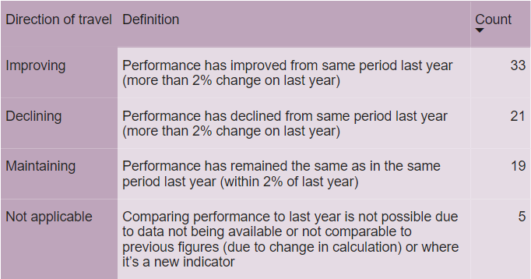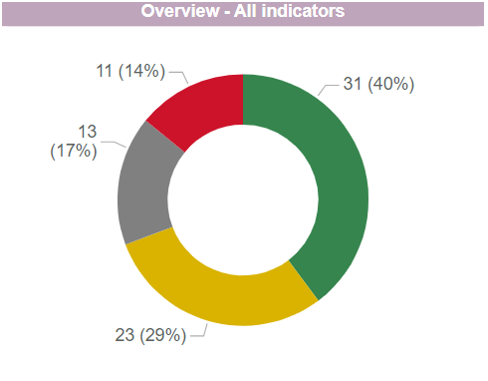

Indicators are assessed against a target and given a RAG status where:

**Green** - Performance is on or ahead of target

**Amber** - Performance is behind target by 5% or less

**Red** - Performance is behind target by more than 5%

**Grey** - Monitoring only or awaiting target

Why do some indicators not have a target?

Grey RAGs are shown for measures that are tracking demand for a service so setting a target is not appropriate; where it is a new measure and a target will be set for next year; or where there is no current target but work to set a target is underway.

# Adult social care

The Health and Social Care Partnership (HSCP) supports vulnerable people across Edinburgh. This includes older adults and people with disabilities as well as mental health and addiction. They help people to identify their social care needs and then support them to live independently for as long as possible. When staying at home is not possible, the partnership works to find places in care homes which meet the individual's needs.

On the following pages, we show performance and update on progress with some projects over the last year.

|  |  |  |  |  |
| --- | --- | --- | --- | --- |
| KPI Name | RAG | Value | Target | Direction of travel |
| Nº: People waiting for discharge from hospital | Within 5% of target | 169 | 164 | Improving |
| Nº: People waiting for package of care | On target | 321 | 564 | Declining |

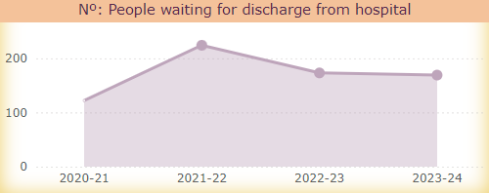

People are living longer with more complex or multiple conditions which increases demand for social care support. In the last year, we have seen the number of hours of care commissioned for older people aged 65+ increase by 10% to over 52,000 hours per week.

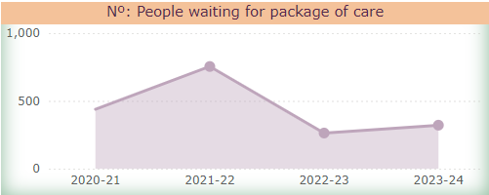Two of the HSCP’s priorities are to support people to move on from hospital once they are ready, and to provide people with the care and support they need to live independently at home. The **number of people waiting for discharge from hospital** decreased to 169 in March 2024 from a peak of 224 in March 2022. While the **number of people waiting for a package of care** also reduced from 754 in March 2022 to 321 in March 2024, this is still higher than March 2023 when there were 263 people waiting for care. These reductions in people waiting, both to leave hospital and for packages of care, are due to increased purchasing of care by the HSCP in 2022-23.

Following the joint inspection of ‘adult support and protection’ and a separate ‘adult social work and social care services’ inspection, an [improvement plan](https://democracy.edinburgh.gov.uk/documents/s58179/7.1%20Adult%20Support%20and%20Protection%20and%20Social%20Work%20Social%20Care%20Inspection%20Improvement%20Plans.pdf) was agreed in 2023 in response to the recommendations in the inspections. This plan includes actions to improve:

* leadership;
* the way the HSCP carries out its social work activities;
* social care activities to ensure people are safe and are supported to live independently in a homely setting for as long as possible.

However, there is an ongoing challenge to provide the support that people need and manage the budget. A range of activities is being taken forward to promote the [financial sustainability](https://democracy.edinburgh.gov.uk/documents/s68215/Item%207.3%20MTFS.pdf) of the Integration Joint Board. In addition to the increased need for support, it has also been hard to recruit and retain staff to deliver the care required.

Given these challenges, the HSCP has been delivering transformation projects such as Home First, Three Conversations and a new nursing care model into three of their own care homes.

The Home First programme focuses on keeping people at home when they might otherwise be admitted to hospital and helps people move home after time in hospital.

The Three Conversations approach is when the HSCP works with people to see their strengths and what support they already have in their network. People keep the same worker with them as they work out what help they need and until the support they need is in place. This keeps the person as the focus of the discussion rather than service processes.

To better meet the changing needs of care home residents the HSCP has been recruiting nurses into three of their own care homes through a new nursing care model. This will help to ensure they are providing the right level of care in the right places to support people to remain independent at home or in a homely setting.

The HSCP also reviewed how older people’s bed-based services were commissioned. [Recommendations from this exercise](https://democracy.edinburgh.gov.uk/documents/s66649/Item%206.1%20An%20Older%20Peoples%20Pathway.pdf) were agreed by the Edinburgh Integration Joint Board in February 2024 and will be implemented across 2024/25. A range of activities are being taken forward to promote the [financial sustainability](https://democracy.edinburgh.gov.uk/documents/s68215/Item%207.3%20MTFS.pdf) of the Integration Joint Board.

A more detailed [performance report](https://www.edinburghhsc.scot/the-ijb/performance/) is produced by the Integration Joint Board on an annual basis and is due to be published in the summer.

# Children, Families and Communities

## Education

We continue to focus on raising attainment and improving outcomes for all children and young people. We know that children from our most deprived communities were particularly affected by the impact of Covid-19 restrictions. We are working hard to reengage all children with school life and are focused on reducing the attainment gap. We remain committed to ensuring an inclusive education for all and offer support to ensure all children can get the best start in life.

In this section, we show a range of attainment measures from across primary and secondary schools.

*.*

|  |  |  |  |  |
| --- | --- | --- | --- | --- |
| KPI Name | RAG | Value | Target | Direction of travel |
| % Primary pupils achieving literacy | Within 5% of target | 77.3% | 78.5% | Improving |
| % Primary (deprived areas) achieving literacy | Within 5% of target | 64.4% | 65.0% | Improving |
| % Primary (looked after) achieving literacy | On target | 40.0% | 38.5% | Improving |
| % Primary pupils achieving numeracy | Within 5% of target | 83.7% | 84.5% | Improving |
| % Primary (deprived areas) achieving numeracy | Within 5% of target | 72.3% | 74.0% | Improving |
| % Primary (looked after) achieving numeracy | On target | 40.0% | 38.5% | Improving |
| Primary literacy gap | Within 5% of target | 22.3 | 22.0 | Improving |

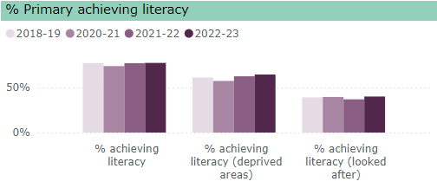

In 2022/23, we had just over 30,000 primary school pupils in our 90 primary schools. Our staff have worked hard to ensure all children are in school and engaged and we provide additional support where it is needed.

We see gradually improving trends in all seven of our primary school indicators in 2022/23. There were larger increases for pupils from deprived areas in both literacy and numeracy, so our poverty related attainment gaps are improving. We are down 2 percentage points from 2021/22 to 22.3 in 2022/23 for literacy and down 1 percentage point in numeracy for the same time period.

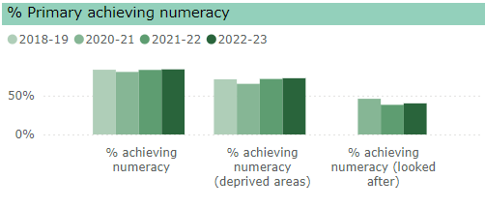However while we saw improvements for 2022/23, we are ahead of our target for two measures (**% of primary pupils (looked after) achieving literacy and numeracy**) and slightly behind target for the other five measures.

We are driving improvement in literacy attainment through our actions arising from our [review of literacy](https://democracy.edinburgh.gov.uk/mgConvert2PDF.aspx?ID=65943). After a fall following Covid-19, **the percentage of primary pupils achieving literacy** shows a gradual increase over the last two years and at 77.3% in 2022/23 is now above pre-Covid levels.

The impact of our revised Numeracy and Mathematics Strategy (2020) actions are seen in the improving levels of numeracy skills since the pandemic rising from 80.4% in 2020/21 to 83.7% in 2022/23.

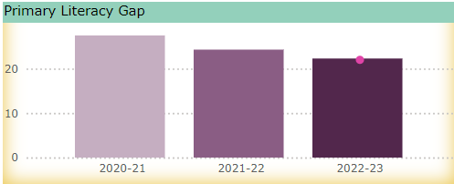Some of our actions included:

* embedding an ‘Stages in Early Arithmetical Learning’ approach to ensure high-quality teaching of numeracy. This is a model used to understand the development of children’s numerical skills.
* using Progression Pathways to ensure continuity and progression in learning as pupils start making course choices as they move through the school years.
* and our comprehensive professional learning offer for numeracy was complemented by more targeted 1:1 coaching and team teaching to further develop teachers’ skills.

We have a rigorous approach to the tracking and monitoring of how pupils are doing throughout the academic year. This results in targeted intensive support to schools where issues are highlighted. We also adopted a ‘coaching in context’ approach into our Raising Attainment meetings and local moderation.

We remain focused on increasing attainment for all primary school years and reducing the poverty related attainment gaps further in the 2023/24 academic year.

|  |  |  |  |  |
| --- | --- | --- | --- | --- |
| KPI Name | RAG | Value | Target | Direction of travel |
| % Leavers achieving 1 or more awards (SCQF, L.5) | Within 5% of target | 86.8% | 88.5% | Declining |
| % Leavers achieving 1+ awards (L.5, deprived areas) | Within 5% of target | 74.6% | 78.5% | Declining |
| % Leavers achieving 1 or more awards (SCQF, L.6) | Within 5% of target | 68.2% | 69.0% | Maintaining |
| % Leavers achieving 1+ awards (L.6, deprived areas) | Within 5% of target | 44.9% | 45.5% | Maintaining |
| Attainment Gap – 1+ level 5 | Over 5% from target | 20.8 | 16.8 | Declining |
| Positive destinations for school leavers | On target | 95.3% | 95.0% | Maintaining |

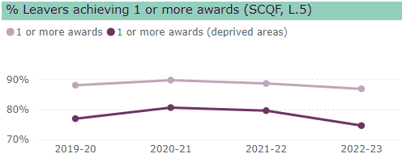

In 2022/23 we had just over 23,000 secondary school pupils in our 23 secondary schools.

Due to changing assessment methods during and following Covid-19, we cannot compare secondary school performance between 2019/20 and 2022/23. However, we can compare differences in year.

As we know that children and young people who live in areas of deprivation tend to have lower levels of attainment, we have included results for these groups of children separately. In academic year 2022/23, there was an increased gap between ‘all pupils’ and ‘pupils from deprived areas’ – up to 12 percentage points in academic year 2022/23 for **Scottish Credit and Qualifications Framework** (**SCQF) level 5 awards** (86.8 compared to 74.6) compared to 9 percentage points in academic years 2020/21 and 2021/22. Our **SCQF Level 6 awards** continues to show a consistent gap between ‘all pupils’ and ‘pupils from deprived areas’ and is around 22 percentage points.

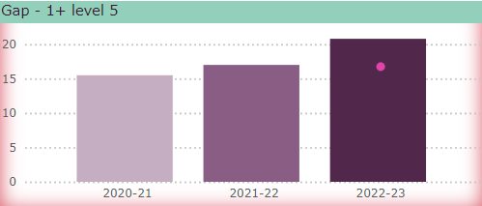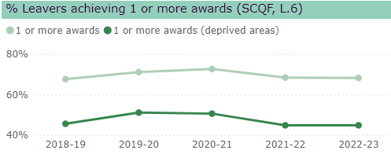We know that attendance is an important factor in improving attainment. We are working hard to engage all pupils and improve attendance and support those struggling to attend the most. In April 2024 we provided an update on [attendance](https://democracy.edinburgh.gov.uk/documents/s68696/Item%207.2%20-%20Maximising%20Models%20of%20School%20Attendance.pdf) at school. This highlighted that overall attendance in Edinburgh is good, but that some children are at greater risk of poor attendance. Ensuring that resources, such as Pupil Equity Funding, are managed well and focus on interventions to close the poverty-related attainment gap, such as supporting pupils to return to school, has been a key area for us.

We know that exam based qualifications are not best suited for some of our pupils. We are working with our partners to diversify the courses we offer and open up opportunities that work for all young people to move on positively into adult life.

We have seen a gradually increasing trend in the **proportion of school leavers going to positive destinations** (going into work, training or further education) since 2019/20 (92.5%). There has however been a small decrease in the figure for 2022/23 (down from 96.1% in 2021/22 to 95.3%) but remain ahead of our target (95%). We will continue to be relentless in securing appropriate pathways for our young people.

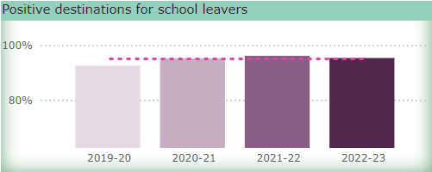Young people identified at risk of leaving school without a positive destination are given appropriate follow-up support. We have expanded our range of course options in school to provide fairer, more equitable pathways and raise attainment. The model for delivering Foundation Apprenticeships is being adapted to provide closer links to industry and improve choices for young people.

We offer 64 vocational whole course awards in the form of National Progression Awards (NPAs) or Skills for Work Courses. The NPAs, where the course content and assessment are similar to that in college, are particularly suited to preparing learners whose post school destination might be college.

In 2022 we established a collaborative review with our partners to address the recommendations from the 2020 national independent review of additional support for learning. This [collaborative improvement report](https://democracy.edinburgh.gov.uk/documents/s62632/Item%207.6%20-%20Inclusion%20Review.pdf) resulted in the relaunch of [Edinburgh Learns for Life](https://www.edinburgh.gov.uk/downloads/file/34257/edinburgh-learns-for-life-outcomes-framework) in February 2024 and we continue to work to support [inclusion](https://democracy.edinburgh.gov.uk/documents/s65945/Item%208.3%20Inclusion%20in%20the%20City%20of%20Edinburgh%20Schools%20-%20Annual%20Report.pdf) for children and young people who have additional support needs in our schools.

The cost of living crisis continues to impact on our young people and their families. To support those who are struggling financially, we have reduced the cost of school day to zero for every child. To support parents and carers with their own employment we continue to develop the flexible services for children under school age.

|  |  |  |  |  |
| --- | --- | --- | --- | --- |
| KPI Name | RAG | Value | Target | Direction of travel |
| % Receiving funded EL & Childcare (preferred model) | On target | 91.2% | 85.0% | Improving |

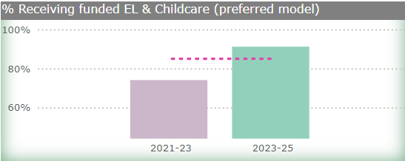

We also monitor services for children under school age, and whether parents and carers get their preferred model (e.g. forest kindergarten, childminder, full year or term time settings) as this can affect their own employment.

In November 2023, we asked parents about their experience of the Early Years service their children received. We have increased flexibility in places offered and how funding is accessed – while some people prefer funding across the whole year, others prefer funding to be focused during school term time only. 91.2% stated they received their first-choice of **preferred model**, which is an increase of around 15% from when we last ran this survey in November 2021.

We are continuing to increase the flexibility of Early Learning and Childcare in our own settings. In 2023/24, we will offer additional hours and review the number of settings open all year round. We provided a [report](https://democracy.edinburgh.gov.uk/documents/s65931/Item%207.15%20The%20Early%20Years%20Service.pdf) on the Early Years Service to committee in January 2024.

.

## Children’s services

We support families to ensure that children are safe, well and thriving. We aim to ensure that all children and young people should be enabled to live within their own families and communities and protected from harm.

We focus on the rights of the child but sometimes we need to put in place formal measures supporting children and young people through the child protection system or through alternative care arrangements. When we do, we make sure that the welfare of the child is paramount; the child is listened to and that we intervene as little as possible.

Below we have included several measures to show how we support and safeguard young people.

|  |  |  |  |  |
| --- | --- | --- | --- | --- |
| KPI Name | RAG | Value | Target | Direction of travel |
| Nº: Children on child protection register (per 1K population) | On target | 1.1 | 2.2 | Improving |
| Looked after children (per 1K population) | On target | 10.6 | 12.3 | Improving |
| % Children’s Services cases that are allocated | Over 5% from target | 88.1% | 100.0% | Not applicable |
| % Children with 3 or more placements in a year | Within 5% of target | 5.3% | 5.0% | Not applicable |

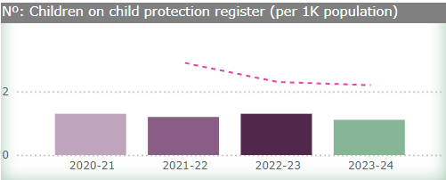

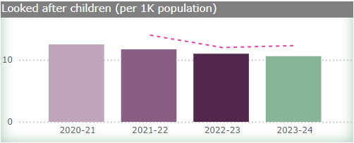Families are facing increasing challenges in terms of food and fuel poverty, the housing crisis and the general cost of living. These impact on the emotional wellbeing, capacity and resilience of families. We work in partnership with other agencies to support families who are struggling to enable children and young people to remain safely in their own family and community. At any one time we support around 3,000 children and one way to capture how we support these families is by tracking changes in our rates of Looked After Children and children on the Child Protection Register and comparing to national trends.

The **rate of children on the Child Protection Register** has shown a slight reduction from 1.33 in March 2021 to 1.11 in March 2024 and remains ahead of our target (the national average at 2.2). The **rate of Looked After Children** has also been falling from 13.2 in March 2021 to 10.6 in March 2024 and remains ahead of our target.

Where a child does need to move into alternative care, we are committed to that care being with extended family, where it is safe, and/or in their local community. This keeps them close to family relationships and all that is familiar to them. Any alternative care arrangements should be for the shortest possible time unless it is in preparation for a move to a permanent placement.

We are committed to working with our partners and set out our joint priorities in the [Edinburgh Children’s Services Plan](https://democracy.edinburgh.gov.uk/documents/s67694/Item%206.1%20-%20The%20Edinburgh%20Childrens%20Partnership%20Plan.pdf) 2023-26. We are now working to progress actions to ensure that every child and young person can enjoy their childhood and achieve their potential in

an environment that supports good health and wellbeing with any issues being dealt with before they become a crisis.

In 2023/24 we introduced two new measures to monitor the impact of our actions. The percentage of children and young people allocated to a named worker and percentage of children with three or more 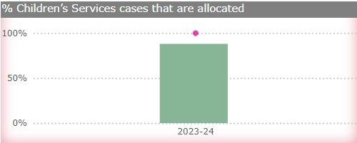placements in a year show how we work with and support children and young people.

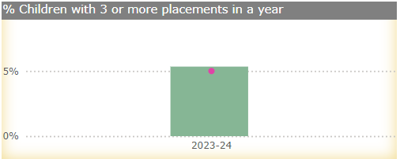**The percentage of children and young people allocated to a named worker** has risen from 80% in April 2023 to 88% in March 2024. In January 2024, we increased the resources to deal with child protection and are increasing the resource to the child assessment team. The increased resources should ensure all child protection cases are allocated to a named worker within 24 hours and that we closely monitor any children with child care concerns who don’t have an allocated worker and who are on a waiting list to be allocated a named worker. We expect to see this percentage continue to rise as our new practice standards are embedded.

Moving between placements for children is disruptive, so we aim to minimise this wherever possible. In 2023/24 5.3% **children had three or more placements in a year** and we will continue to track this to identify where we can improve our support.

We are making good progress in our [Children’s Services and Edinburgh Residential Services Improvement plans](https://democracy.edinburgh.gov.uk/documents/s65927/Item%207.12%20Childrens%20Services%20Improvement%20Plan%20and%20Edinburgh%20Residential%20Services%20Improvement%20Plan%20U.pdf) although recruitment remains a challenge. We have developed service specific training about safe recruitment practice. We have also established a family-support outreach service (Edge of Care). This test of change provides dedicated direct support to children, young people and their families to enable young people to remain living within their family and/or support young people to move back home with family.

This shows how we are delivering on the commitments we made in [Edinburgh’s Promise](https://www.edinburgh.gov.uk/children-families/edinburghs-promise) to help children and young people, as far as possible, live in their own families and communities. We are also continuing to develop an emergency care resource as part of the reprovision of Edinburgh Secure Service.

## Communities

We provide a wide range of services to communities in Edinburgh from library resources to keeping people safe. It is key that we ensure equal access for everyone and one of our Business Plan objectives is focused on ensuring that people can access services locally.

Our libraries are at the heart of our communities for many. They provide not only a place to borrow books, but a place for groups to meet, access the internet and engage with services. Our library services adapted during Covid-19 restrictions by expanding the use of digital and online library services.

People’s views remain important to us and so we regularly consult and engage on our service proposals to make sure people can be involved in our decision making on the issues that are important to them.

Below we cover a range of measures that show how we are performing across our community services.

## Libraries

|  |  |  |  |  |
| --- | --- | --- | --- | --- |
| KPI Name | RAG | Value | Target | Direction of travel |
| No. of active library users | On target | 99,800 | 85,303 | Improving |
| Nº: Library loans - physical | Monitoring only | 1.28M |  | Improving |
| Nº: Library loans - digital (e-books and e-audiobooks) | Monitoring only | 399,302 |  | Improving |
| Nº: Digital downloads and streaming | Monitoring only | 3.51M |  | Improving |

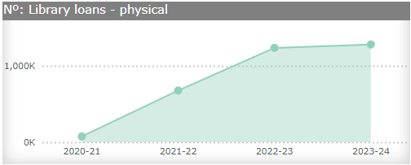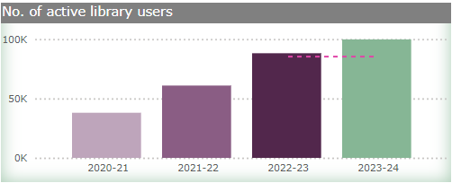The number of people using our libraries, in person or online, has continued to increase since we reopened as Covid-19 restrictions eased. The **number of active library users** at 99,800 is above our target for 2023/24 and now sits just below our pre-pandemic level of 101,098 in 2018/19. **Our physical loans** have recovered as we reopened libraries and remain at around 1.28 million each year. Our **digital** (**e-books and e-audiobooks**) and downloads and streaming continues to grow rapidly, showing the ongoing appetite for online material. **Downloads and streaming** average almost 120,000 higher each quarter in 2023/24 compared to 2022/23.

We are engaging with local communities as we develop a strategy for library service delivery and development over the next five years. The strategy aims to respond to the changing needs of the city’s population and the ways that people choose to access our library services.

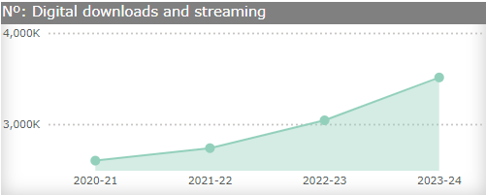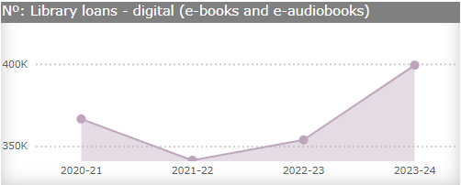

## Involving people

|  |  |  |  |  |
| --- | --- | --- | --- | --- |
| KPI Name | RAG | Value | Target | Direction of travel |
| Nº: Consultations/ Engagement Activities opened in period | Monitoring only | 90 |  | Not applicable |
| Nº: Responses for closed consultation/ engagement activities | Monitoring only | 23,588 |  | Not applicable |

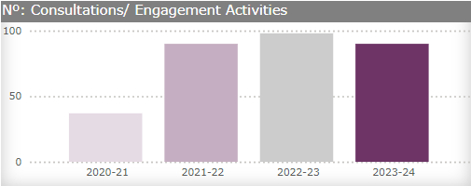

We continue to involve communities and individuals in our decision making by running consultations and engagement activities. Consultations are the formal time limited way we ask for people’s opinions on a specific proposal. Engagements are the various informal ways we gain feedback from communities and ensure people’s voices are heard which help us develop services and policies. In 2023/24, we have run 90 **consultations and engagement activities** and in total have received 23,588 **responses**.

Topics we have asked about in the last 12 months include: inclusive education; several new/replacement school proposals; future libraries; travel route options; open spaces proposals; the Workplace Parking Levy and our Gaelic Language Plan.

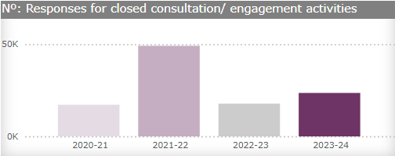

## Keeping people safe

|  |  |  |  |  |
| --- | --- | --- | --- | --- |
| KPI Name | RAG | Value | Target | Direction of travel |
| Nº: ASB complaints per 10K | Monitoring only | 19.9 |  | Improving |

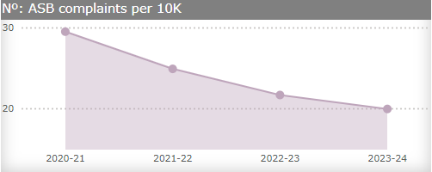

The **rate of antisocial behaviour complaints** we received over the last four years has been gradually reducing from 29.5 per 10,000 population in 2020/21 to 19.9 per 10,000 population in 2023/24.

We are currently reviewing our Family Household Support Service which helps residents who need support with their day to day lives. From health and wellbeing to parenting, neighbour disputes to welfare benefits, we will talk to them about their needs and put them in touch with the right services. This review includes our out of hours service and how we respond to noise complaints. Our staff are currently undergoing refresher training on relevant legislation and national guidance. We have also tightened our links with Environmental Protection services in relation to managing complaints about noise.

|  |  |  |  |  |
| --- | --- | --- | --- | --- |
| KPI Name | RAG | Value | Target | Direction of travel |
| % Community Justice orders successfully completed | On target | 76.3% | 75.0% | Improving |

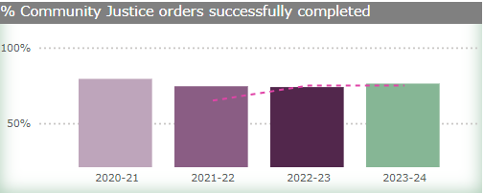

We support people who have offended to remain engaged with their community justice order until it is completed. Our **percentage of community justice orders successfully completed**, at 76.3% in 2023/24 is ahead of our target of 75%. We know that post-Covid-19, courts continued to deal with a number of outstanding breaches, and this impacted on the number of successful completions shown in our performance in 2021/22 and 2022/23.

We continue to develop trauma informed models of care across our justice services. With additional fixed funding from Scottish Government we have employed more people in both our adult and young people services to support the social work role.

During 2023/2024 we implemented a new structure to strengthen collaboration between different justice teams and reduce duplication and barriers. We have also expanded our unpaid work options. For example, a service which delivers a garden planning and maintenance project now offers weekend provision allowing those in work to complete their hours without disrupting their employment.

We fund two community pantries and bring affordable food to those experiencing poverty. The pantries operate alongside existing community supports. We continue to provide support for the people we are supervising on a 1:1 and group basis to increase their awareness of a healthy balanced diet, to access affordable food, and to gain confidence in food preparation and cooking.

We have a peer support programme for women which enables those who have experienced domestic abuse to support each other to build lives free from abuse within a safe and supportive community.

Many people leaving prison lack basic essentials to help them adjust to life outside prison. To address this, we have worked with other partners to provide winter liberation packs for those in greatest need. Items available include mobile phone, hat, gloves, torch, diary, notebook, useful telephone numbers for supports, wipes, deodorant, and water bottle/flask. The inclusion of a basic mobile phone enables them to keep connected with support networks to help them live crime free lives, and advance digital inclusion.

# Climate change

We are making steady progress to reduce our carbon emissions and adapting Edinburgh to make it more resilient and sustainable for the challenges ahead. However we are not moving fast enough to meet our net zero by 2030 ambitions – one of our Business Plan priorities.

We monitor our progress by measuring the level of our greenhouse gas emissions.

|  |  |  |  |  |
| --- | --- | --- | --- | --- |
| KPI Name | RAG | Value | Target | Direction of travel |
| 3-years carbon budget spent (in thousand tonnes of CO2e) | Within 5% of target | 192 | 190 | Improving |

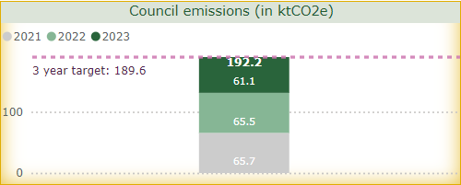

Our emissions continue to decrease slowly. The latest data available is for 2022/23 when we were responsible for 61 thousand tonnes of CO2 equivalent (61 ktCO2e) emissions. This was a 7% decrease on 2021/22. This is encouraging as we expected an increase due to a post-pandemic rebound as people got moving again. The decrease is due to actions we have taken such as reductions in natural gas and oil consumption; a reduction in landfilled waste; and externally, the decarbonisation of the electricity grid. More detail can be found in our [Public Bodies Climate Change Duties Report](https://democracy.edinburgh.gov.uk/mgConvert2PDF.aspx?ID=62268). While this reduction in CO2e emissions is good news, we were beyond our three-year cumulated budget, exceeding it by almost 3 ktCO2e.

So far, we have accessed significant funding to progress the transformation we have already undertaken. These include the retrofit of 1,299 homes in the last year to support emissions reductions and alleviation of fuel poverty; opened the new trams to Newhaven line and completed construction of the [City Centre West to East Link](https://www.edinburgh.gov.uk/ccwel/) cycle route, the first major segregated cycling route in the city. The city also surpassed its tree planting target in the last year to ensure we are on track to become a one million tree city by 2030.

We need to make sure our services are as sustainable as possible while meeting growing demand. The energy we use now is more decarbonised and we are transitioning our fleet to electric vehicles. A number of our historic buildings are challenging to retrofit sympathetically but we are making more progress with new developments such as the net zero carbon housing development in Granton. We are also increasing the number of electric vehicle chargers in the city and investing in new electric vehicles for our fleet.

Since the development of the [Council Emissions Reduction Plan](https://www.edinburgh.gov.uk/downloads/file/30792/council-emissions-reduction-plan-2021), the challenges to reduce emissions in our buildings and fleet have become increasingly clear. Other local authorities are dealing with the same issues. We are taking a lead role in Scotland on deep building retrofits starting with projects to retrofit Brunstane Primary School and Liberton Nursery. We are also working to deliver our first Passivhaus new-build schools at Currie High School and Maybury Primary School.

We remain a local authority leader, demonstrated by the [Carbon Disclosure Project Cities A list](https://www.cdp.net/en/cities/cities-scores) status obtained in 2021 and 2022 and we have made real progress towards our 2030 target.

We continue to move forward and have developed the draft [Local Heat and Energy Efficiency Strategy](https://www.edinburgh.gov.uk/climate-2/local-heat-energy-efficiency-strategy-lhees) (LHEES) to inform the decarbonisation of heat and energy across the city, and are finalising our new [Climate Ready Edinburgh Strategy](https://democracy.edinburgh.gov.uk/documents/s73467/7.4%20Draft%20Climate%20Ready%20Edinburgh%20Plan.pdf) following consultation which will ensure we are fully prepared and resilient to the impacts of climate change in the future.

.

# Customer and Corporate Services

It’s important that when people get in touch we respond quickly – whether it is answering their questions, processing their requests for financial assistance or putting them in touch with the most appropriate service.

Modernising and streamlining our processes to deliver better outcomes for people, and a more secure and efficient organisation remains one of the objectives in our Business Plan.

Below we report on a range of measures to show how we are performing when people get in touch with us as well as highlighting some of the ‘back office’ functions we need to run well to support our public facing services.

## Customer contact

|  |  |  |  |  |
| --- | --- | --- | --- | --- |
| KPI Name | RAG | Value | Target | Direction of travel |
| Nº: Calls handled | Monitoring only | 44,600 |  | Not applicable |
| % Calls answered within 60 Seconds (Customer Hub) | On target | 62.9% | 60.0% | Improving |
| % Abandoned calls | Within 5% of target | 12.2% | 10.0% | Improving |
| Customer hub satisfaction | Within 5% of target | 71.3% | 75.0% | Maintaining |

|  |  |  |  |  |
| --- | --- | --- | --- | --- |
|  |  |  |  |  |

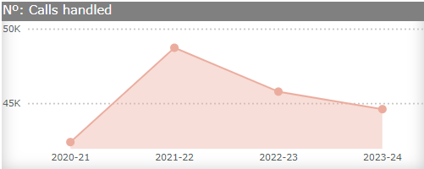How people want to get in touch with us continues to change and we continue to expand how people can do this including email, online forms and webchats covering more of our services. However, people can still pick up the phone us or speak to us face to face ensuring everyone has a suitable method to get in touch.

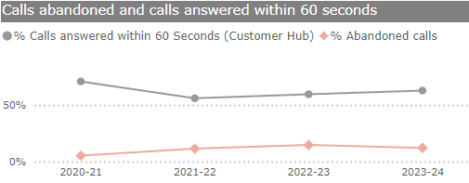We have seen a reducing **average number of calls per month** since 2021/22 as people shift to getting in touch with us online. However, we still receive between 40,000 to 50,000 calls each month and answer 62.9% of those **calls within 60 seconds** against our target of 60%. While this has fallen from 70.9% in 2020/21, the percentage has shown a gradual increase since 2021/22 when it was 56%.

During 2023/24, 12.2% of calls were **abandoned by the caller** before they were answered. This is behind our target of 10% and is up from 7.1% in 2019/20. **Customer contact satisfaction** has sat at around 71% for the last four years, apart from a dip in 2020/21 when it fell to 66%.

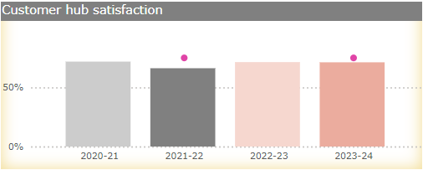Satisfaction survey responses are analysed to inform the contact methods we offer, shaping our training and defining improvement actions we will take. Satisfaction surveys, using QR codes, are also available in our registration and local offices. Satisfaction levels reported for the Customer team continue to be influenced by the outcome of the call (for example, did the person receive a service). The Customer team shares feedback and suggestions with the appropriate services to enhance the customer experience.

We are currently trialling a two tier contact model for key services. This enables calls to be quickly assessed and allocated to a dedicated team to resolve the query and complete any follow up actions.

The pilot is delivering positive results in call response times and improving customer satisfaction. We are expanding this pilot to other areas in 2024/25.

We will continue to use available technology (webchat, automated chatbots, online forms, text links to website) enabling customers to self-serve 24 hours a day.

## Customer transactions

|  |  |  |  |  |
| --- | --- | --- | --- | --- |
| KPI Name | RAG | Value | Target | Direction of travel |
| Days to process: New benefit claims | On target | 18.3 | 28 | Declining |
| Days to process: Benefit change of circumstances | Within 5% of target | 9.6 | 8 | Declining |
| Days to process: Crisis grant scheme applications | On target | 1.8 | 2 | Improving |
| Days to process: Community care grant scheme applications | On target | 10.2 | 15 | Maintaining |
| Days to process: Discretionary Housing Payment claims | On target | 20.7 | 30 | Improving |

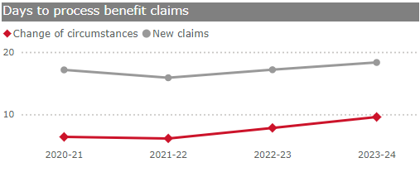

The cost of living crisis continues to drive increasing demand for financial support as people struggle to meet day to day living expenses. One way we see this is through the large increase in demand for community grants since 2019/20 and the ongoing rise in discretionary housing payments. We paid out over £3.75 million in community grants and over £7.5 million in discretionary housing payments in 2023/24.

We also see peaks and troughs in the requests we receive for additional financial support during the year. For example, applications for free school meals and clothing grants are submitted and processed in August as children return to school.

We process applications for grants and benefits as quickly as we can. Our performance is ahead of our targets for 2023/24 in four out of our five measures.

Our performance for **crisis grants** (1.8 days in 2023/24 compared with 2.0 days in 2020/21) and **discretionary housing payment claims** (20.7 days in 2023/24 compared with 26.6 days in 2020/21) are fairly steady over the last five years.Our performance for **community care grants** shows a spike due to Covid-19 in 2021/22. 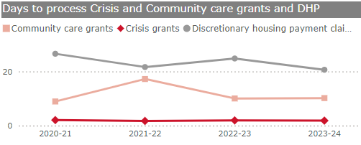However, at 10.2 days in 2023/24, our performance has returned to levels seen in 2020/21 (at 8.9 days). The time we take to process **new benefit claims** has risen in the last two years, from 17.1 days in 2021/22 to 18.3 days 2023/24. There has also been an increase in the processing times for **change of circumstances** in the last few years (from 6.4 days in 2021/22 to 9.6 days in 2023/24).

The demand for grants has increased as people struggle with the cost of living. In response, we have added capacity within our teams to meet this additional pressure. To ensure we respond quickly but within our tightening budget, we have also cross trained our team to allow us to move people across teams to meet these fluctuating demands.

We will continue to focus on workforce management plans, technology improvements and process streamlining in 2024/25 to best meet the expected volumes.

## Council Tax and Business Rates collection

|  |  |  |  |  |
| --- | --- | --- | --- | --- |
| KPI Name | RAG | Value | Target | Direction of travel |
| % Council Tax collected | Within 5% of target | 96.4% | 97.3% | Maintaining |
| % Business Rates collected | Within 5% of target | 92.5% | 94.6% | Declining |

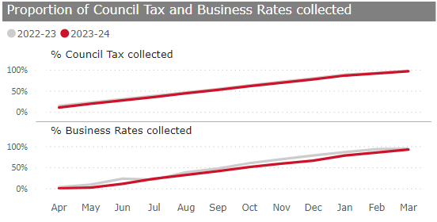

In 2023/24, we gathered £317.9m in Council Tax which is used to fund our services. Collection levels for Council Tax and Business Rates continue to be impacted by the wider economic conditions and cost of living pressures. However, we have collected 96.4% **of Council Tax due** in 2023/24 which is an increase from 96.0% in 2020/21. The **percentage of Business Rates collected** has increased to 92.5% in 2023/24 from 90.5% in 2020/21.

To support Council Tax and Business Rates collection in 2024/25 we will continue to engage with customers who are falling into arrears, and we have invested additional resources to support processing activities and query response times. We are also making changes to the online process enabling customers to access their account more quickly and easily.

## Finance

Managing our finances is vital for us to continue delivery of all of our services. Good governance and financial management continues to ensure that we are managing the pressures from tight budgets and rising costs.

Below we report on measures to show how we are managing our finances; supporting delivery of our Business Plan objectives; enhancing our sustainable working practices and maintaining our financial resilience through developing our Medium Term Financial Plan.

|  |  |  |  |  |
| --- | --- | --- | --- | --- |
| KPI Name | RAG | Value | Target | Direction of travel |
| % Revenue outturn | On target | 99.8% | 100.0% | Maintaining |
| % Revenue spend with contracted suppliers | Over 5% from target | 84.1% | 93.0% | Declining |
| % Invoices paid (30 days) | On target | 95.4% | 95.0% | Maintaining |
| % Suppliers committed to Living Wage | On target | 96.0% | 72.0% | Improving |
| % New contracts that have applied Fair Work criteria | Monitoring only | 81.0% |  | Declining |

|  |  |  |  |  |
| --- | --- | --- | --- | --- |
|  |  |  |  |  |

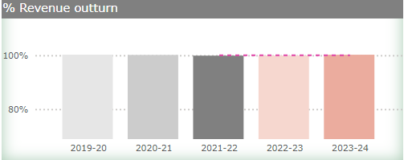We continued to manage our budget well in 2023/24. Our **outturn** for 2023/24 was 99.8%. However, we anticipate future years will continue to be financially challenging and this will impact on the services we can deliver. Our Medium Term Financial Plan ensures that the priorities committed to in our Business Plan are affordable and achievable within the resources we have available.

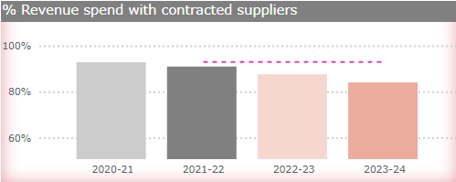We continue to see a decrease in our **percentage of revenue spend with contracted suppliers** from 92.8% in 2020/21 to 84.1% in 2023/24; behind our target of 93%. While most services have exceeded our target, there is a large portion of home based care with non-contracted suppliers which has led to the decreasing trend. It should be noted that this spend is still monitored under contracts but has not been set up with our usual contracted suppliers. It is expected that the current re-procurement of home-based care services will lead to an increase in spend sitting with contracted suppliers in future.

We paid 95.4% of our **invoices within 30 days** in 2023/24 (95.6% in 2020/21) and this above target performance reflects our ongoing commitment to pay invoices accurately and on time.

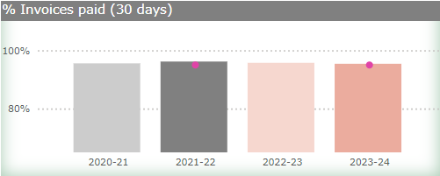We use our contracts with suppliers to support delivery of our Business Plan priorities by focusing on commitments to Fair Work, the living wage and sustainability. We are now tracking two additional elements of our contracts with suppliers: how many of our suppliers are committed to the Living Wage and the percentage of our new contracts that have applied Fair Work criteria.

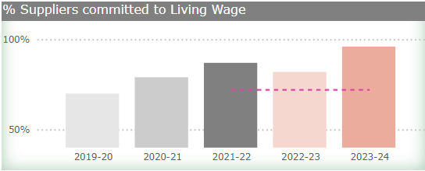The proportion of new contracts that have applied fair work criteria has reduced in 2023/24 to 81% from 87% in 2022/23. 
The percentage of our **suppliers that are committed to Living Wage** has shown a gradual rise since 2019/20 with a dip to 82% in 2022/23. A change to our contracting to make ‘commitment to the living wage’ mandatory over the last year has resulted in our 2023/24 figure rising to 96%. The percentage of **new contracts** that have applied Fair Work criteria is a new measure and between 2022/23 and 2023/24 we saw a fall from 87% to 81%. This results from a higher proportion of our new contracts being bound by national Framework Agreements. These Framework Agreements were set up before fair work critieria were introduced, run for mulitple years, and we have limited abiltiy to influence these until they are being revised.

## HR and Information compliance

|  |  |  |  |  |
| --- | --- | --- | --- | --- |
| . KPI Name | RAG | Value | Target | Direction of travel |
| % Sickness absence | Within 5% of target | 6.1% | 4.0% | Maintaining |
| % Gender pay gap | On target | 0.8% | 3.0% | Improving |
| % FOIs completed within timescale | Over 5% from target | 91.0% | 100% | Maintaining |

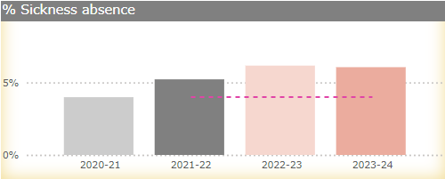

Our staff are at the heart of how we deliver our services for residents, workers and visitors to Edinburgh. We see a gradual increase in the number of people we employ rising from 19,727 in March 2020 to 20,416 in March 2024. However, we are experiencing ongoing challenges in recruitment and retention for some services.

The way we recorded **sickness absence** was different during the pandemic (initially excluding any absence due to Covid-19). Over 2023/24, our sickness absence was 6.1% which is behind our target of 4% and higher than 4.6% in 2020/21 (when Covid-19 absence started to be recorded within our sickness absence rates). We are seeing high levels of absence for stress, depression, anxiety, mental health and fatigue as well as musculoskeletal problems.

We have developed a range of supports to help people maintain their wellbeing including arranging wellbeing weeks (a series of talks and practical sessions run over a week covering a wide range of topics, interest areas, and tips on wellbeing) as well as providing external support through our PAM assist programme.

Our sickness absence is also being impacted in part by external factors, such as a continued backlog of NHS waiting times and associated recovery times; enhanced levels of stress due to the ongoing cost of living crisis and a rise in persistent infections including Covid-19 related complications.

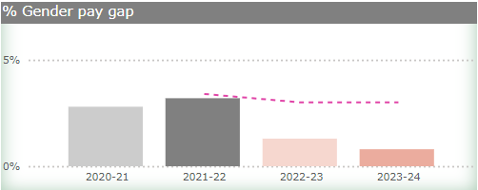We will continue to look at ways to support our staff to maintain their wellbeing as well as continue their skills development as part of our Business Plan delivery.

We have changed how we calculate **our gender pay gap**. From 2022/23 we included supply and casual workers which has led to our gender pay gap decreasing to 1.3%. It reduced again to 0.8% in 2023/24 which is ahead of our target (3%, the national average). Last October we [reported in greater detail](https://democracy.edinburgh.gov.uk/documents/s62275/7.8%20Pay%20Gap%20Report%202023.pdf) on the gender pay gap in 2023.

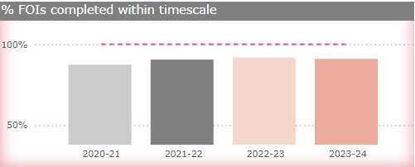We developed a new People Strategy 2024-27 setting out how we are continuing to support our workforce to thrive. Alongside this is our new Workforce Plan and our behaviours of respect, integrity and flexibility. We are working on an updated Wellbeing Strategy aimed at having a positive impact on colleagues’ wellbeing and subsequently, levels of sickness absence when it is delivered in 2025.

We have received over 3,000 **Freedom of Information requests** (the highest since the introduction of the legislation in 2005) and continue to complete over 90% within timescale. The statutory target is to complete Freedom of Information within 20 working days and we always aim to meet that timescale whenever possible and have set this as our target for 2023/24. The complexity of the requests has also had an impact on our response times.

# Environmental Services

Our environmental services are all around us from our roads, lighting the streets, collecting waste and making our open spaces safe and inviting places to visit.

We have met increased demand within tightening budgets and Covid-19 restrictions added pressure on how our services were being delivered. We have started to reinvest in these services in the last couple of years and we have seen improvements in our performance across roads and street cleansing.

On the following pages we report on a range of measures that show how we are performing across our environmental services and give an update on how we are progressing with some of our projects.

## Roads

|  |  |  |  |  |
| --- | --- | --- | --- | --- |
| KPI Name | RAG | Value | Target | Direction of travel |
| % of Cat 1 road repairs made safe in 24 hrs | Within 5% of target | 99.0% | 100.0% | Maintaining |
| % of Cat 2 road repairs in 5 days | On target | 98.6% | 85.0% | Improving |
| % of Cat 3 road repairs in 60 days | On target | 99.4% | 85.0% | Maintaining |
| Road Condition Index | On target | 34.3% | 35.2% | Maintaining |

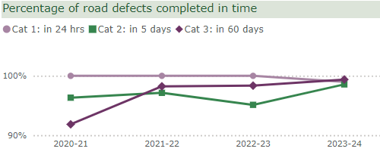

Edinburgh has over 940 miles of road for us to maintain and we continue to perform well for all three categories of road repairs. In our Business Plan we set out our ongoing commitment to maximizing the impact of investment in our roads. Our **Category 1 (repairs made safe in 24 hours)** is just below target (99.0%). Between 2020/21 and 2023/24 **Category 2 (repairs** **made safe in 5 days)** have increased from 96.3% to 98.6% and **Category 3 (repairs made safe in 60 days)** have increased from 91.9% to 99.4%.

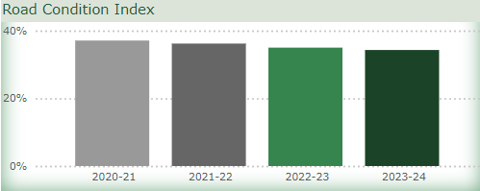Our **road condition index** is gradually improving from 37.1% in 2020/21 to 34.3% in 2023/24 and is ahead of our target, 35.2%. We refreshed our [Transport Asset Management Plan](https://democracy.edinburgh.gov.uk/documents/s65415/Item%208.4%20-%20Transport%20Asset%20Management%20Plan%20TAMP.pdf) in January 2024, setting out different options for continuing that improvement in the our roads over a 20-year period, based on the available funding. Since then we have secured an additional £12.5m annual investment in roads, pavements, lighting and drainage improvements for 2024/25.

## Street cleaning

|  |  |  |  |  |
| --- | --- | --- | --- | --- |
| KPI Name | RAG | Value | Target | Direction of travel |
| LMS/ LEAMS Score | Within 5% of target | 90.6% | 93% | Improving |
| Nº: Flytipping and dumping Service Requests | Monitoring only | 11,550 |  | Declining |
| Nº: Street litter Service Requests | Monitoring only | 5,248 |  | Declining |
| Nº: Dog fouling Service Requests | Monitoring only | 1,824 |  | Declining |

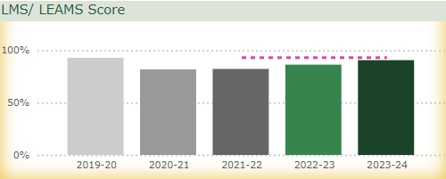

Our latest **Litter Monitoring Score (LEAMS)** increased to 90.6% in 2023/24, which continues our improvement since the drop in our scores seen during the pandemic. We are just short of our target of 93% but the increase in our budget and the changes we’ve made to the service are improving the cleanliness of the city. Some of these changes include new graffiti/washing vehicles, recruitment of additional staff, rerouting of small mechanical sweepers and targeting the cleaning up of our town centres.

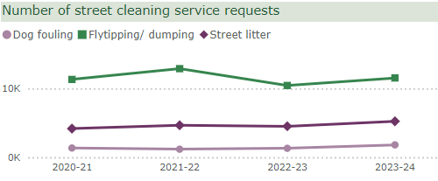We also monitor changes in demand for our services and so report on the **number of requests we receive to respond to flytipping, street littering, and dog fouling**. Over the last five years the number of dog fouling and street litter requests have remained low at below 2,000 a year. Meanwhile, the number of flytipping/dumping requests saw a rise during Covid-19 restrictions in 2020/21 and 2021/22, but these requests have returned to lower levels over the last two years.

## Parks and street lighting

|  |  |  |  |  |
| --- | --- | --- | --- | --- |
| KPI Name | RAG | Value | Target | Direction of travel |
| % of Street lighting emergency repairs complete in 4 hrs | On target | 97.6% | 95.0% | Maintaining |
| % of Street lighting urgent repairs complete in 24 hrs | On target | 98.6% | 75.0% | Maintaining |
| % of Street lighting repairs complete in 5 days | On target | 58.1% | 50.0% | Declining |

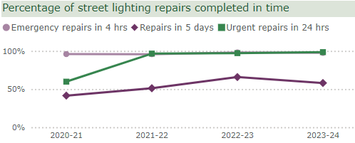

We are continuing to perform well for the most urgent street lighting repairs in 2023/24 with 97.6% and 98.6% of **emergency and urgent repairs** being completed in time respectively. However, only 58% of **‘5 day repairs’** are being completed in time and we remain ahead of our target. We will always focus our resources on urgent and emergency repairs first.

|  |  |  |  |  |
| --- | --- | --- | --- | --- |
| KPI Name | RAG | Value | Target | Direction of travel |
| % of Parks meeting standard | On target | 92.0% | 92.0% | Maintaining |

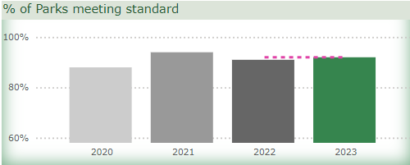

Our parks and open spaces were a key resource during the pandemic as people cherished good quality outside space. People’s expectations of our parks can be conflicting and, as noted in our Business Plan, we aim to ensure our parks and greenspaces are safe, well maintained and accessible to all while still being places where wildlife flourishes.

The **percentage of parks meeting our minimum parks standard** at 92% in 2023 is similar to 2022 (91%). We have been near or over 90% for this measure for the last four years.

We invested an additional £3m in parks and open space in 2023/24 and we have delivered a number of improvements to parks throughout the city. These include the completion of the Dean Path landslip project; completion of refurbished tennis courts within Inverleith, St Margaret’s, Victoria, and Leith Links parks; as well as enhancement to car parking and facilities within the Pentland Hills Regional Park. In addition, we are also investing in the 189 play areas we have in the city, focusing first on those most in need of refurbishment.

We will be adapting our parks and greenspace service in future to help respond to the Nature Emergency declared in 2023. Our [[Edinburgh Biodiversity Action Plan programme](https://www.edinburgh.gov.uk/biodiversity)](https://www.edinburgh.gov.uk/biodiversity) has been delivered across the city in 2023/24, with a number of projects and operational programmes underway, to increase resilience in our natural environment.

.

## Waste

|  |  |  |  |  |
| --- | --- | --- | --- | --- |
| KPI Name | RAG | Value | Target | Direction of travel |
| Domestic missed bin requests | Within 5% of target | 22,106 | 21,516 | Declining |
| Communal full or missed bin requests | On target | 17,959 | 22,020 | Declining |
| % Waste recycled | Within 5% of target | 40.8% | 45.0% | Maintaining |


The chart shows that domestic missed bin requests peaked in 2021-22 and rose again in 2023-24, while communal missed bin requests decreased in 2022-23 before increasing slightly in 2023-24.

Our **domestic kerbside missed bin service requests** continue to fluctuate year on year and at 22,106 in 2023/24 we are slightly behind our target of 21,516. Meanwhile the number of **communal missed and full bin service requests** which saw a large decrease in 2022/23 (to 16,027), has also risen in 2023/24 (to 17,959) but remains ahead of our target of 22,020.

Our **recycling rate** has increased slightly in 2023/24 to 40.8% but we remain behind our target of 45%.

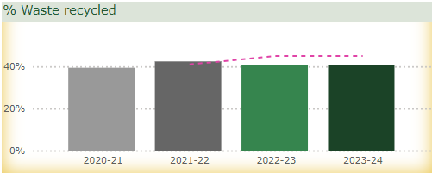Through the changes we are making to [communal bins](https://www.edinburgh.gov.uk/bins-recycling/communal-bin-review), more space is available for residents to recycle as we’re introducing more on-street mixed recycling bins and increasing the frequency of collections. These changes should increase our recycling rate and reduce overflowing bins in 2024/25. The communal bin review is one example of delivering on our Business Plan priority of net zero while meeting the changing needs of the city.

# Housing

We support people with their various housing needs. From helping people who are homeless into settled accommodation, renting our council housing, and ensuring repairs to our properties are completed quickly and to a high quality. We are working with developers to support house building in this city and grow the number of affordable houses as well as efficiently processing planning and building applications.

We monitor how we are performing across all these different areas through our Key Performance Indicators shown in the tables and charts below.

## Homelessness

|  |  |  |  |  |
| --- | --- | --- | --- | --- |
| KPI Name | RAG | Value | Target | Direction of travel |
| % Advice only presentations | Over 5% from target | 29.0% | 35.0% | Improving |
| Avg Homeless case length - housed | Over 5% from target | 785 | 400 | Declining |
| Nº: Households in temporary accommodation at month end | Within 5% of target | 4,969 | 4,764 | Declining |
| Nº: Households in unsuitable accommodation | Over 5% from target | 1,340 | 1,005 | Declining |
| Nº: Homeless cases housed | Monitoring only | 1,541 |  | Improving |

|  |  |  |  |  |
| --- | --- | --- | --- | --- |
|  |  |  |  |  |

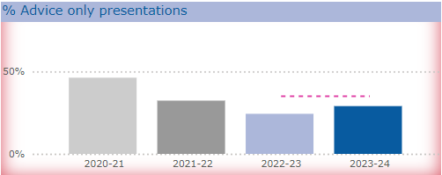There are unprecedented pressures to meet Edinburgh’s growing housing needs and in November 2023 we declared a Housing Emergency. While we continue to see Edinburgh’s population grow, we have also seen growth in demand for affordable and social housing due to the impact of world events and the UK and Scottish Government responses to these, and the cost of living crisis.

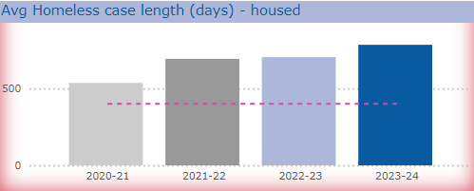One way in which we are meeting the rising demands for our housing services is by focusing on prevention. We work to prevent people from becoming homeless through our support and advice services. After a decreasing trend since 2020/21, the percentage of **presentations that are advice only** has increased in 2023/24 to 29.0%. Advice only presentations are where we offer support and advice to people to maintain their tenancy to prevent them becoming homeless. As one of our objectives in our Business Plan, we continue to develop services that prevent homelessness and provide support (such as the Multi-Disciplinary Team, the Private Rented Sector Team and the Early Intervention Team).

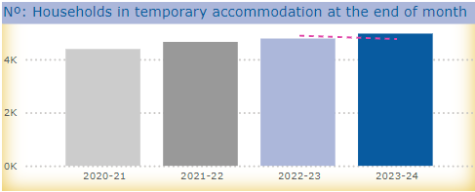The Multi-Disciplinary Team work with Council tenants who are at risk of eviction due to rent arrears and who are not engaging with their local housing officer. The Early Intervention Team have been working in new ways with social rented tenants suffering from domestic abuse or racial harassment exploring options to find solutions that avoid homelessness. Across these services, we prevented 461 households from becoming homeless and supported 685 households to move on from temporary accommodation in 2023/24.

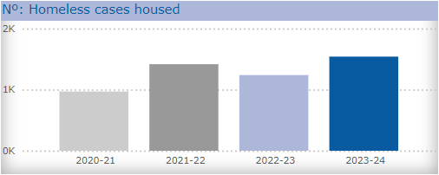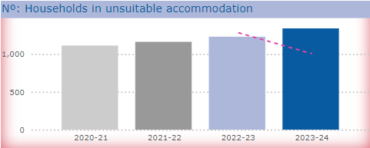The increase in numbers of individuals and families presenting as homeless and a high demand for social housing is reflected in increases in the **average case length** (505 days in 2021/22 rising to 785 days in 2023/24); the **number of households in temporary accommodation** (4,657 in 2021/22 rising to 4,969 in 2023/24), and the **number of households in unsuitable accommodation** (980 in 2021/22 rising to 1,288 in 2023/24). Part of the rise in these figures is due to an increasing number of asylum seekers and refugees settling in Edinburgh as part of recent Scottish and UK asylum and refugee policies.

We have housed between 1,200 and 1,600 **households into settled accommodation** each year for the last three years with 1,541 in 2023/24.

We are committed to reducing the levels of homelessness in the city and this is one of the key priorities in our [Housing Emergency Action Plan](https://democracy.edinburgh.gov.uk/documents/s67342/Item%207.7%20-%20Responding%20to%20the%20Housing%20Emergency%20Declaration%20V2.pdf). This plan is wide ranging and includes actions aimed at reducing homelessness, improving access to housing and housing advice, improving the supply and quality of housing across the city,

preventing harm and improving the experience of tenants in Council housing.

## Housing management

|  |  |  |  |  |
| --- | --- | --- | --- | --- |
| KPI Name | RAG | Value | Target | Direction of travel |
| Avg Time to complete emergency repairs (hours) | Over 5% from target | 5.3 | 4 | Improving |
| Avg Time to complete non-emergency repairs (working days) | On target | 13.2 | 20 | Improving |
| Avg time to re-let properties | Monitoring only | 134 |  | Declining |
| Rent collected as % of total rent due | On target | 99.2% | 99.0% | Maintaining |
| Rent lost from empty homes (£) | On target | £1.4M | £2.2M | Improving |

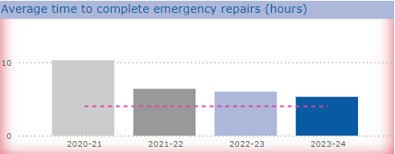

The ageing condition of our Council housing stock means there is more work required to bring them up to standard. This increases the time we are taking to prepare houses for people to live in.

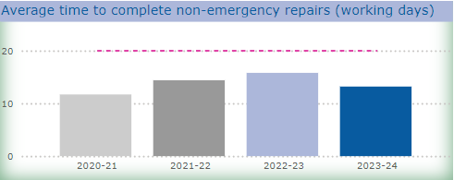We are working to ensure that repairs to our properties are completed timeously, with the **average time to complete both emergency and non-emergency repairs** reducing between 2022/23 and 2023/24 (5.9 hours reducing to 5.3 hours and 15.8 working days reducing to 13.2 working days respectively). However, the time we are taking on emergency repairs is currently behind our target. We are taking forward various projects to assist our teams to better monitor and manage performance. One project was the introduction of early intervention processes to tackle dampness and mould. We provide updates on our actions through [regular updates](https://democracy.edinburgh.gov.uk/documents/s67342/Item%207.7%20-%20Responding%20to%20the%20Housing%20Emergency%20Declaration%20V2.pdf) on our Housing Service Improvement Plan.

The **average time to re-let our properties** is higher in 2023/24 (134 days) compared to 2022/23 (106 days) and almost double the time in 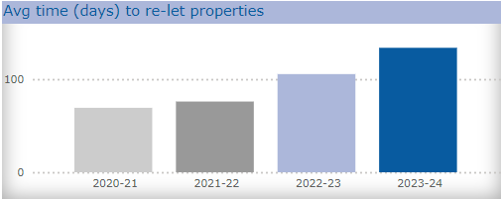2020/21 (69 days). The number of void properties increased significantly during the pandemic when work in homes was restricted and the lettings process was impacted heavily due to Scottish Government Public Health guidelines. Following this, letting times have increased as a result of bringing properties that have been out of use for a long time back up to the lettable standard.

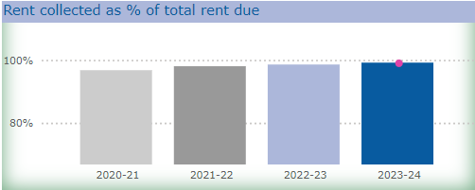Reducing the time to re-let our homes is a top priority for us going forward. This would also reduce the amount of rent we lose whilst they are empty.

Our annual **rent loss for empty homes** is £2.06m. We are increasing resources to help carry out repairs quicker, however as we bring properties that have been out of use for a long time back up to lettable standard, the average “time to let” will continue to increase. We consistently collect almost all of the rent that is due to us at 99.2% for 2023/24 and work hard to support those that may be struggling.

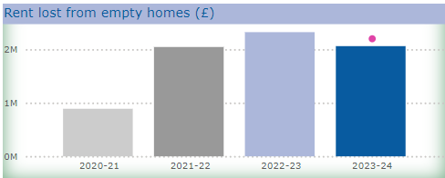

## Housing development

|  |  |  |  |  |
| --- | --- | --- | --- | --- |
| KPI Name | RAG | Value | Target | Direction of travel |
| Nº: of affordable homes approved | Over 5% from target | 668 | 902 | Declining |
| Nº: of affordable homes completed | Over 5% from target | 934 | 1,247 | Declining |

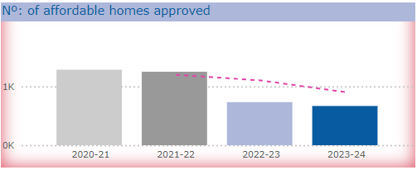

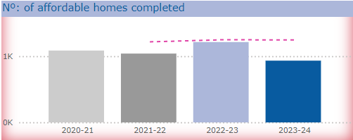We work with our partners to deliver housing and support services for residents of Edinburgh. Our ambition to provide more affordable housing has been hindered by increasing costs, reduced funding and reduced return on investment meaning developers are less willing to commit to building. We need to ensure the mix of housing in Edinburgh meets the needs of its residents. In particular we are focussed on increasing the number of social and affordable homes.

Since the 20,000 homes commitment was made in 2017 and subsequently revised to a 25,000 target, around 9,700 new affordable homes have been approved and around 9,000 completed.

There were 668 **affordable home approvals** in 2023/24, which is lower than the estimate outlined in the [Strategic Housing Investment Plan 2024–29](https://democracy.edinburgh.gov.uk/documents/s64359/Item%207.6%20-%20SHIP%202024-29.pdf) (SHIP). Approval figures have been impacted by a number of site delays or deferments. Amongst these is a site of over 150 units that will not come forward for approval until 2024/25. Many house builders and developers are delaying new contracts due to cost inflation, reduced demand, reduced mortgage availability and affordability. In the last 12 months, two affordable development partners have suspended house building programmes due to viability. Compounding this, uncertainty in the wider market due to rises in interest rates and risks to rental income streams has resulted in developers not bringing forward projects previously estimated for approval in 2023/24.

There were 934 **affordable home completions** in 2023/24, which is lower than the revised estimate outlined in the SHIP 2024-29. The reason for this is that several projects, including a large strategic site (306 homes), have been slightly delayed and will now complete in the first quarter of 2024/25.

A report on [Increasing Affordable Homes Delivery](https://democracy.edinburgh.gov.uk/documents/s67010/Item%207.5%20-%20Increasing%20Affordable%20Homes%20Delivery.pdf) (which included a revised approvals and completions outturn) was provided to the Housing, Homelessness and Fair Work committee in February 2024.

Delivery of affordable housing remains a priority for us and our partner Housing Associations however, its delivery is becoming increasingly challenging. Whilst the amount of grant funding available per home has been increased by the Scottish Government, the national budget for delivering affordable homes has reduced by over 35% in the last two years. Edinburgh’s grant allocation for 2024/25 was confirmed at c.£34m, £11m less than the previously indicated Resource Planning Assumptions (RPA) of £45.2m. This has a significant and immediate impact on affordable housing delivery in the city. If this low level of funding continues beyond 2024/25, this will seriously impact on delivery of our Business Plan objective.

## Planning and building standards

|  |  |  |  |  |
| --- | --- | --- | --- | --- |
| KPI Name | RAG | Value | Target | Direction of travel |
| Avg No: wks to determine local planning applications | Over 5% from target | 15.8 | 14.4 | Improving |
| Avg No. wks to determine householder planning applications | On target | 8 | 8.9 | Improving |
| % Building warrants issued within 10 days | On target | 92.0% | 90.0% | Maintaining |

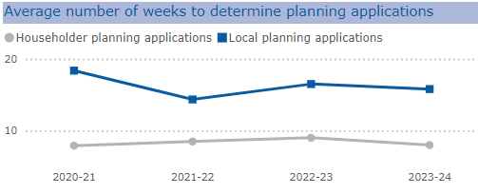

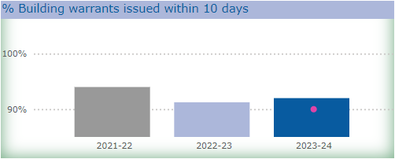The **average time to determine local planning applications** (at 15.8 weeks in 2023/24) has improved since last year (16.5 weeks in 2022/23) and over the longer term (18.4 weeks in 2020/21). **Householder planning applications determinations** in 2023/24 (8 weeks) is a week quicker than in 2022/23 (9 weeks) but unchanged over the longer term (level with 7.9 weeks in 2020/21). While we meet our target for householder applications, we are slightly behind our target for local planning applications. We have had a focus on clearing legacy applications (applications that are more than one year old) in 2023/24, which has had an impact on our performance.

The **percentage of building warrants issued within 10 days** has stayed consistently high throughout 2023/24 with an average of 92% issued on time, which is ahead of our target of 90%. However, this is lower than 2021/22 when 94% were issued within 10 days. Benchmarking against neighbouring Local Authority Building Standards Services shows we compare favourably, and we have just received our highest quarter score from the National Customer Survey, which has been a focus for us over the last year.