**Appendix 2**

**Edinburgh’s Local Housing Strategy: DRAFT Consultation and Engagement Report**

**Nov 2024**

**Introduction**

The Housing (Scotland) 2001 Act requires that local authorities consult on their LHS, and the statutory Equality Duty on public bodies requires the involvement, consultation and engagement of as wide a range of local residents, tenants and stakeholders as possible.

Consultation and engagement play an integral role in the development of the Local Housing Strategy. Developing the strategy has presented a unique opportunity to engage with a wide range of stakeholders on the housing system as a whole, as well as reflecting on specific topics and issues. These inputs have helped paint a picture of Edinburgh’s current housing challenges, as well as the priorities and concerns of our residents and those who work in the city.

This report is a supporting document for the LHS and sets out a summary of the range of engagement and consultation that was carried out across the city to help inform the development of the draft strategy.

Please note: This Consultation and Engagement Report is a summary of the thoughts, opinions and beliefs of those that took part in engagement events and workshops. This means that there might be inconsistencies in language used or language which is not used by the City of Edinburgh Council.

**Consultation and Engagement Approach**

A three-phase approach to engagement was established to support the development of the LHS. The feedback from each phase has helped to inform the next phase of engagement by drawing out key issues, recurring themes and underdeveloped areas. The insights gathered across all three phases will help to shape the strategy and, in particular, will help inform the development of the Action Plan which will accompany the final strategy.

|  |  |  |
| --- | --- | --- |
| **Phase** | **Timeline** | **Detail** |
| **Phase 1:**  **Early Engagement** | May – June 2024 | Early engagement discussions with colleagues and partners. Early engagement survey, open to residents and organisations. 345 survey responses received. |
| **Phase 2:**  **Targeted Engagement** | August – October 2024 | Stakeholder and resident workshops, partnerships/ forums and community engagement events. 20 events in total and over 550 people participated. |
| **Phase 3:**  **Formal Consultation** | To follow (February 2025-April 2025) | This phase will include an online consultation on the draft strategy, supplemented with further targeted engagement. |

Scottish Government Guidance

The Scottish Government Local Housing Strategy Guidance sets out some key considerations for engagement and consultation. This is summarised below.

| **Scottish Government Guidance** | **Approach taken** |
| --- | --- |
| **Engagement and consultation is undertaken early on in the LHS development process** | Early discussions took place with colleagues and partner organisations to gain some initial insight into challenges and to start building a picture of the wider strategic landscape.  An early engagement survey ran for six weeks during May-June 2024, open to residents and organisations. The survey included questions about current housing circumstances and future housing aspirations. It asked respondents to identify their housing priorities for Edinburgh and gave an opportunity for further comments in relation to the development of the strategy or housing issues more generally. |
| **A range of media and advertising is used to ensure as wide an audience as possible within local communities and from relevant representative groups including people with or who shared protected characteristics** | A mix of digital and non-digital platforms were used to advertise and carry out engagement. This included the Council’s website, social media platforms and e-footers, as well as advertising via partner organisations to reach their networks through their webpages, social media platforms, newsletters and word-of-mouth. Posters were displayed in community buildings across the city, a dedicated telephone line was set up and paper copies were available for all materials. |
| **In an effort to end inequality, that the make-up of the local population is accurately reflected** | Demographics data was captured to enable analysis of this. Whilst the survey respondents were broadly reflective of the city as a whole, a couple of gaps were identified: low response rate from under 16’s and over 75’s, and lower response rate from males than females. Targeted engagement activities were organised for the next phase of engagement to help address these gaps.  At the conclusion of the first two phases of engagement, opportunities to further strengthen our engagement have been identified. This includes dedicated engagement with the private sector, with individuals with no recourse to public funds and with minority ethnic people. This will be built into the third phase of engagement. |
| **Less traditional forms of engagement methods are undertaken to ensure all those willing or able to engage have the opportunity to do so.** | A range of engagement opportunities were carried out to offer choice and flexibility, in a bid to make the engagement as accessible and inclusive as possible.  These included workshops held online and in-person, attendance at a range of different partnerships/ forums as well as a selection of community outreach events. The community outreach events proved particularly effective in reaching out to people who may otherwise not have participated. |

Governance

The LHS engagement proposals were reviewed and approved by the Council’s Consultation Advisory Panel. This process helped to shape the planned engagement activities, with feedback provided on additional stakeholders to include and extending the early engagement survey from four to six weeks.

The LHS reports into an internal Steering Group comprising senior managers from a range of key service areas. Updates on the LHS are also reported regularly to the Council’s Housing, Homelessness and Fair Work Committee.

Promoting the engagement

The promotion of the engagement activities followed the principal of making this as accessible and inclusive as possible, using both digital and non-digital platforms. Digital platforms included promotion on the Council’s website and social media channels, as well as development and distribution of an email footer. Information published online was made accessible for Read Aloud software and all materials could be provided in other languages through the Council’s translation services.

Partners played an important role in helping to promote engagement opportunities and supported this through their own social media channels, as well as through newsletters and word-of-mouth.

Other non-digital methods included the use of posters displayed in community building across the city, as well as promoting the engagement through various meetings and forums. Face-to-face engagement was carried out in Council office buildings and colleagues were encouraged to help raise awareness across their networks. A dedicated telephone line was set up and paper copies could be made available on request.

What worked well and lessons learned

The LHS engagement has been a learning opportunity and there has been reflection throughout on what has worked well, and what could be improved in future.

The inclusion of a free-text box in the early engagement survey was very successful and yielded more responses than anticipated (over 200 out of 345 respondents). The responses to this question were very helpful in painting a picture around key issues and helped to shape the second phase of engagement. Indeed, many of the themes identified from the early engagement survey were recurring throughout the second phase of engagement.

The stakeholder workshop was particularly effective. Bringing together a range of organisations, in-person, for a full morning session creating the space for in-depth discussions across a range of topics.

The community outreach events also worked well. This enabled residents to take part in community-based settings which they identified as a safe space – often with the involvement of trusted individuals from those community settings, such as Team Leaders and Support Workers.

The resident workshops had a lower attendance than the stakeholder session. This enabled more in-depth discussion, more akin to a focus group than a larger workshop. The feedback from those who attended was positive and they welcomed the opportunity to participate in this way. However, the low uptake was slightly disproportionate to the level of organisation and venue cost incurred for the in-person event, and didn’t enable us to reach as many residents as was hoped. This is something to reflect on for future engagement, both in terms in terms of how these events are promoted and how they are pitched, recognising that an additional number of smaller ‘focus group’ style sessions might be more effective than a larger resident workshop.

**Overview of key themes**

The key themes that arose across phases 1 and 2 of the engagement were:

* Housing supply – this was by far the most frequently recurring theme
* What is meant by affordable housing/ is affordable housing truly affordable?
* Lack of funding and competing priorities such as building homes vs the costs of energy efficiency standards
* High housing costs across all tenures
* Comments on specific types of housing: short-term lets, Purpose-Built Student Accommodation and the private rented sector more broadly
* Potential impacts of the Housing (Scotland) Bill
* New build housing developments and infrastructure
* The need for more accessible housing
* Neighbourhood safety and anti-social behaviour

**Phase One: Early Engagement**

Initial discussion took place early on in the process with a range of colleagues and partner organisations to capture some initial views on the strategy, the early engagement survey and to explore avenues for promotion and further engagement. This included:

* Edinburgh Tenants Federation (ETF)
* Equalities Leads within the Council
* Equalities and Rights Network (EaRN)
* Strategic Homelessness Action Partnership Edinburgh (SHAPE)
* Elected members
* Internal Steering Group, made up on senior managers across a range of key service areas

From there, an early engagement survey was developed which ran from the 6 May to 14 June 2024. The content and findings from the survey are set out below.

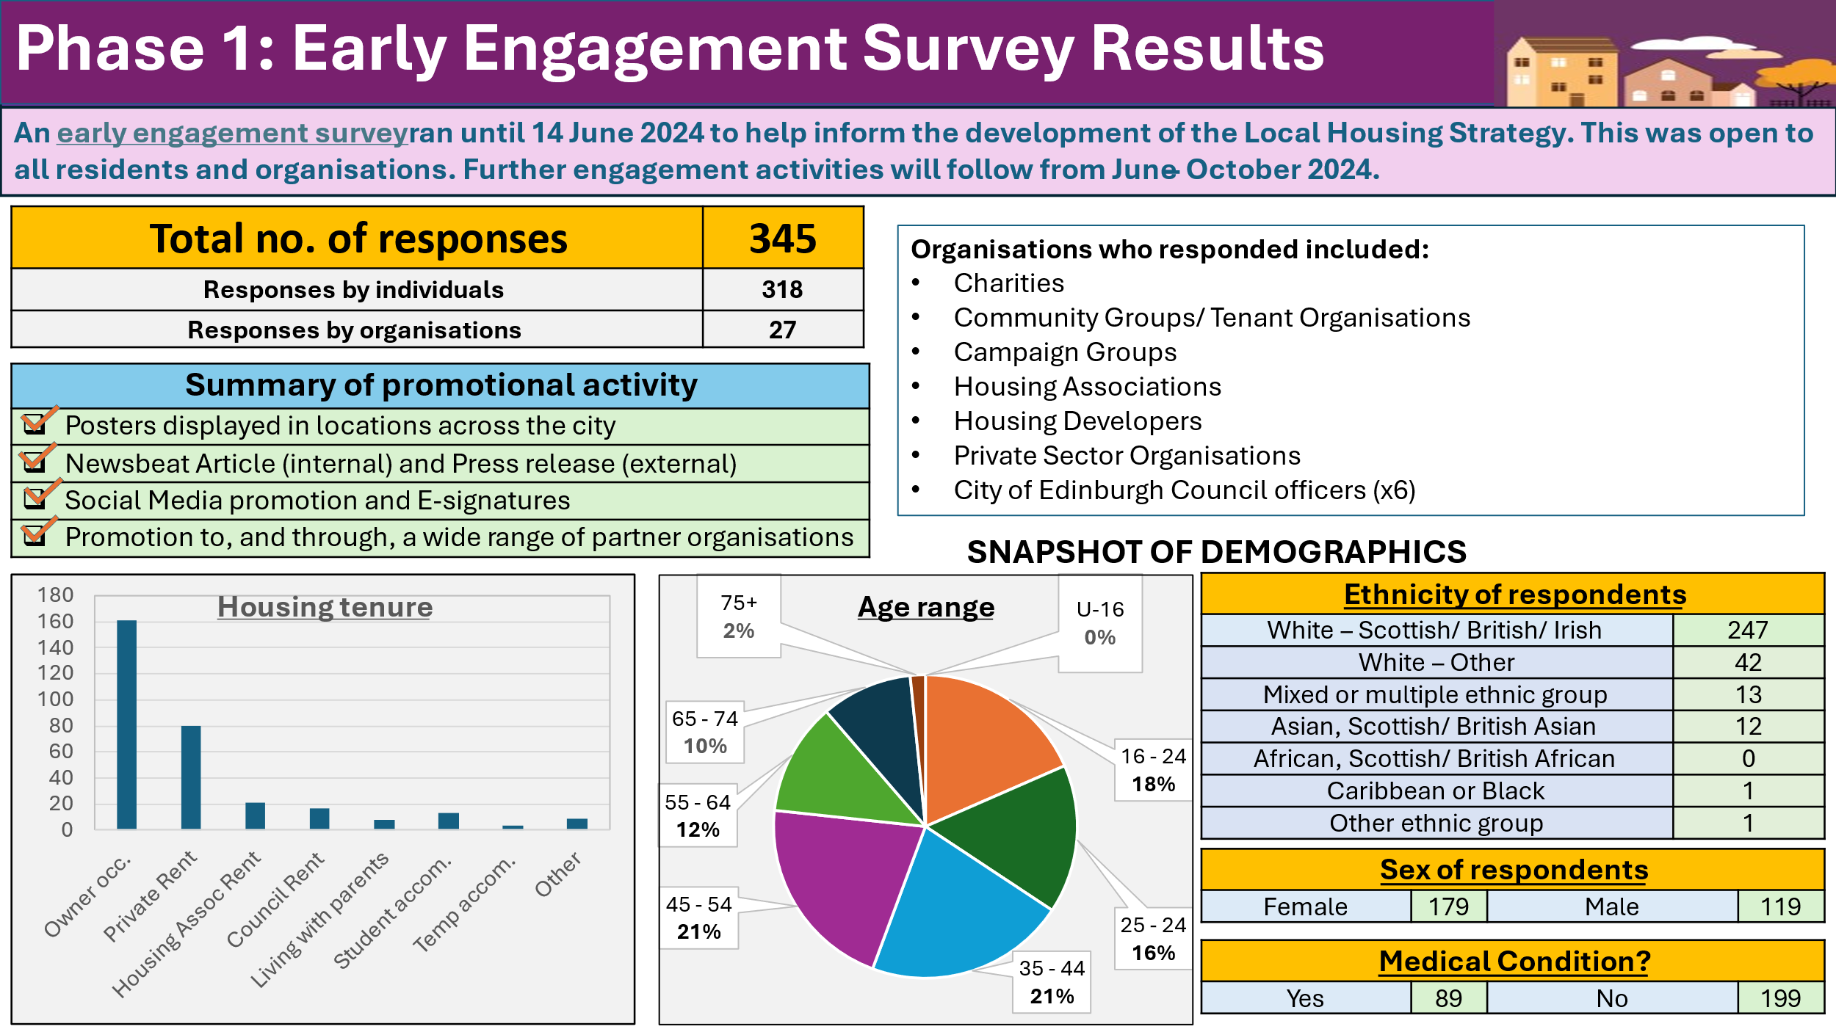

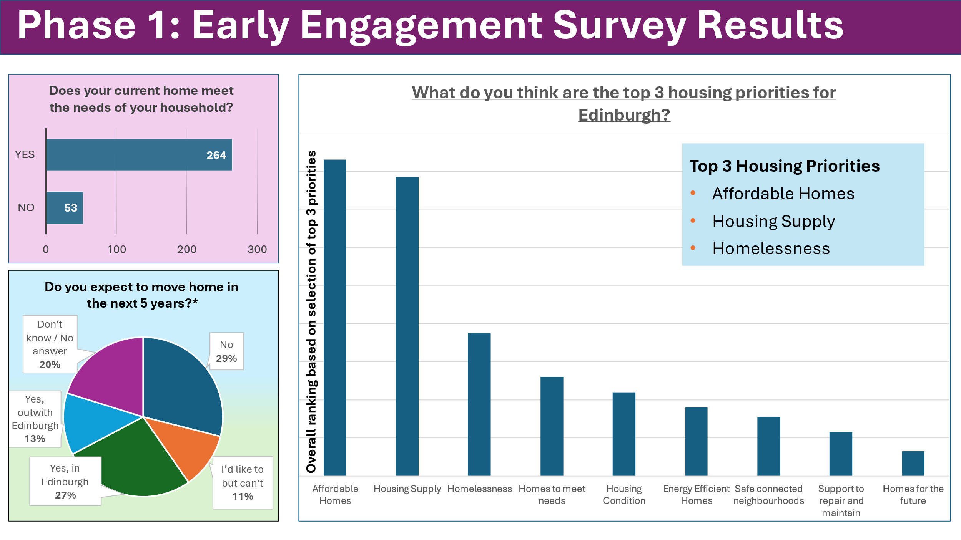

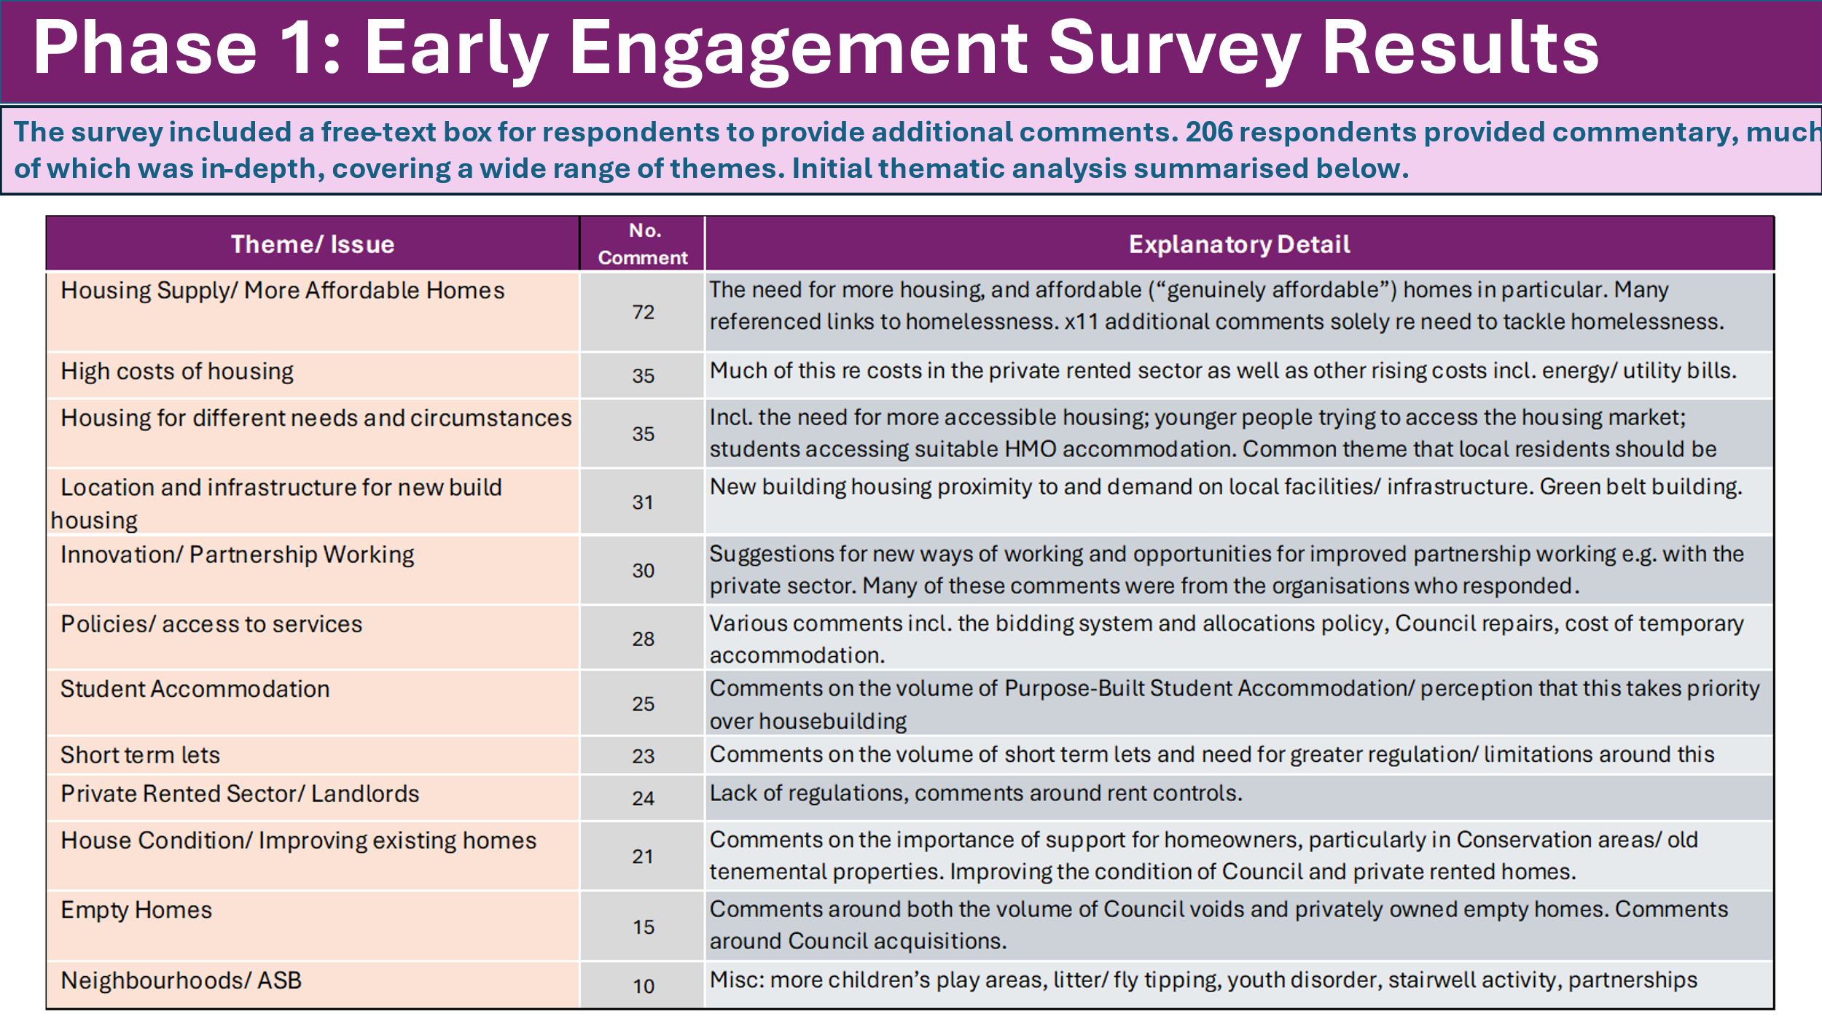

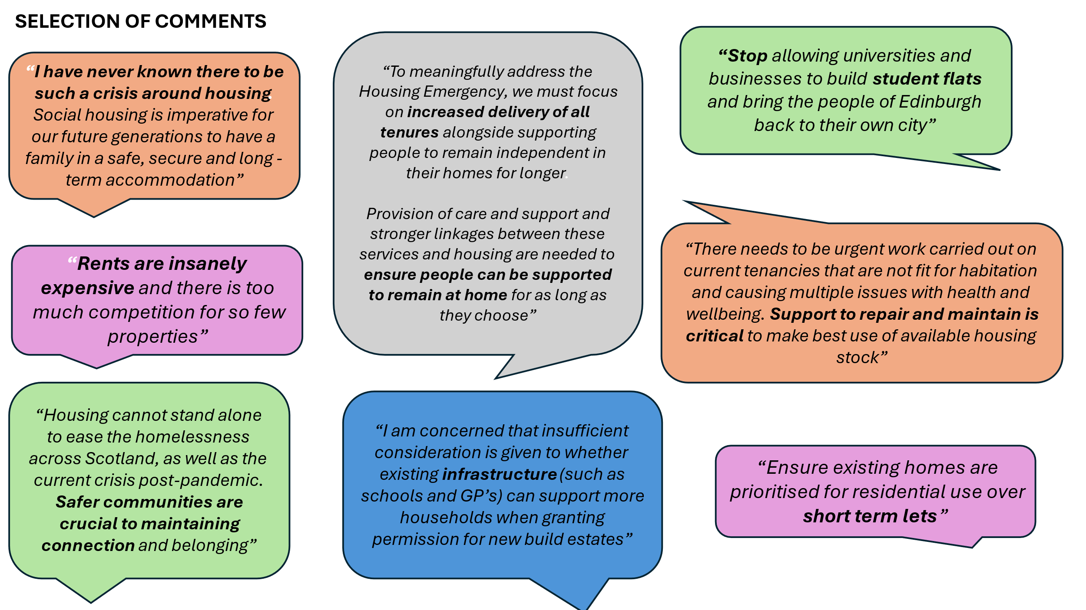

**Phase Two: Targeted Engagement**

A wide range of engagement activities were carried out between August and October 2024. Overall, it is estimated that over 550 people were engaged with during this time. A summary of the engagement activities is set out below.

|  |  |  |  |
| --- | --- | --- | --- |
| **Event** | **Event Type** | **Date** | **Attendees** |
| Edinburgh Tenants Federation (ETF) Meeting | Forum | 06-Aug-24 | 16 |
| Development Directors Forum | Forum | 23-Aug-24 | 9 |
| ETF High Flats meeting | Forum | 26-Aug-24 | 14 |
| Learning Disabilities Group | Community | 06-Sep-24 | 8 |
| Council Housing Colleagues via Service Director Engagement Session | Forum | 16-Sep-24 | 145 |
| Older adults group - Newhaven knitters | Community | 17-Sep-24 | 5 |
| Primary school pop-up | Community | 18-Sep-24 | 20 |
| Stakeholder Workshop Event | Workshop | 23-Sep-24 | 53 |
| Edinburgh Homelessness Task Force | Forum | 23-Sep-24 | 30 |
| Edinburgh Poverty Network Meeting | Forum | 24-Sep-24 | 121 |
| Residents Event On-line | Workshop | 25-Sep-24 | 6 |
| Refugees and asylum seekers - English class | Community | 01-Oct-24 | 4 |
| Residents Event In-person | Workshop | 01-Oct-24 | 7 |
| Older adults group - Leith Men's Shed | Community | 02-Oct-24 | 5 |
| Strategic Homeless Action Partnership in Edinburgh (SHAPE) | Forum | 02-Oct-24 | 16 |
| Edinburgh Local Employability Partnership Summit | Forum | 02-Oct-24 | 35 |
| Older adults group - Libertus | Community | 03-Oct-24 | 17 |
| Student Union Sabbatical Officer engagement | Community | 08-Oct-24 | 3 |
| Joint Council Housing/ Planning meeting | Forum | 08-Oct-24 | 6 |
| Muirhouse Youth Music Club | Community | 08-Oct-24 | 37 |
| **Total** |  |  | **557** |

Overview and Summary Outputs

**Stakeholder Workshop**

An in-person half-day workshop was held on 23 September 2024 to explore a range of topics. The event was open to and promoted to any organisations operating in Edinburgh and 30 organisations signed up for the event:

* The Poverty Alliance
* Fresh Start
* Edinburgh Tenants Federation (ETF)
* Equality and Rights Network (EaRN)
* Edinburgh Access Panel
* Simon Community Scotland
* Living Rent
* Cyrenians
* Tenancy Rights and Support Service
* Hallam Land
* Edinburgh Poverty Commission
* Home Energy Scotland
* End Poverty Edinburgh
* University of Edinburgh
* Shelter Scotland
* Manor Estates
* Cairn Housing Association
* Viewpoint Housing Association
* Prospect Community Housing
* Hillcrest Homes
* Wheatley Homes East
* Muirhouse Housing Association
* Home Group
* Harbour Homes
* Edinburgh Chamber of Commerce
* NHS Lothian
* Health and Social Care Partnership
* City of Edinburgh Council – various departments

The workshop was centred around four break-out group discussions, supported by discussion papers which are attached at Appendix 1. For each topic, there was reflection on challenges and opportunities/ actions. The outputs of these discussions are summarised below.

|  |  |
| --- | --- |
| **Accessible Housing/ Independent Living**  Accessible Housing   * Need for larger family homes * Accessible housing needed across all tenures * More planning controls needed for accessible housing and S75 for affordable * Housing to be accessible from the outset – refer to SG consultation on Housing for Varying Needs Standard * Issues with Passivhaus and accessibility * Conflicting priorities – e.g. loss of ground floor for bike storage * Adequate parking for H&SC workers * Accessibility in wider neighbourhood e.g. dropped kerbs, smoother pavements   Allocations   * Sheltered housing – ‘stage rather than age’ * Issues with households being allocated homes/ having to bid for homes that don’t meet their needs * Greater flexibility needed with EdIndex – more nuanced consideration of need * More flexibility to advocate for own needs * Allocations are failing people and leading to issues further down the line   Adaptations and forward planning   * Adaptation assessments – could be simplified for some, needs more nuanced approach * Delays with simple measures can have major consequences e.g. falls, hospital admissions * Neurological disabilities can be overlooked * RSL funding pressures for adaptations * Tenants unable to return home from hospital * Broken lifts in high rise blocks * Consider accessibility when decanting   Support/ wider comments   * Could sheltered housing be repurposed? * Staffing level concerns for support workers * More support needed for using technology * Small but growing group with very high needs who will not manage a tenancy – Housing First good but not a panacea. * People with low level need can be overlooked * Opportunities to flip temp if it meets needs * Impact on dignity of having a home that meets your needs – cannot be underestimated * More use of Mutual Exchange Schemes | **Modern, Warm and Sustainable Homes**  Challenges   * Retrofit and large-scale repairs and concerns about decants – communication is key * Funding gap and resources to carry out the work required is a major challenge. * Council has multiple roles and sometimes conflicting priorities - owner, landlord, factor. * Asbestos issues ongoing, tenant knowledge needs to be built up about different types of asbestos and the dangers * Ban on new gas boilers will be challenging particularly for tenement owners * Restricting Scottish Welfare Fund has caused issues with tenancy sustainability and pushed more people in to poverty. * Ageing population and more vulnerable people would benefit from more advice and support. * The 2030 net zero target may be too ambitious – misalignment of funding as well as technology development. * Lack of support for PRS tenants * Inconsistent advice from energy companies * Challenge of raising repairs in PSL/ temp * Risk of a build standard that is too difficult/ costly to achieve – drive developers out? * Lack of capacity for repairs and retrofit work e.g. recruitment and keeping up with new technologies. Expertise and knowledge is lacking in the market. As the work intensifies throughout Scotland all RSLs will be competing for same limited number of contractors.   Priorities/ Opportunities   * Communicate mixed tenure work to tenants and owners as early as possible and set clear expectations of Council’s role * Clearer expectations for maintenance (specifically at point of purchase for new owners) and net zero responsibilities. * Consider consolidation of advice to one contact rather than multiple organisations and contacts (benefits, income max, training and employment, housing improvement, etc) * Engagement “strategy” that is sustainable and could be rolled out across all service areas. * Consider drying facilities in new builds * Consider resources to enforce new legislation * Transparency and scrutiny of contractors * Link up with employability agenda - can we work with universities and colleges to build skills gaps into housing workforce? * Damp and mould issues should remain a priority issue - tenants should be provided with practical help/ intervention from the beginning. * Fabric first policy is still in a journey with design teams and need to future proof buildings to enable future technologies |

|  |  |
| --- | --- |
| **Private Rented Sector**  Challenges   * Agreement with challenges set out * Lack of accessible housing in PRS * Challenges in PRS are down to overall housing supply across all tenures * PRS often not a choice but a necessity due to lack of affordable housing * What is ‘affordable’ - subjective * Concerns re. landlords leaving the sector * High rents = wider impact on economy * Uncertainty on how to report landlords * High rents, risk of eviction & mental health   Opportunities/ Priorities   * Private Sector Leasing (PSL) Scheme – scope to expand? * Landlords should be supported – risk of shrinking PRS sector and switch to STL’s * Improved comms message around funding shortfalls for affordable housing * Increase awareness of prevention support * Increase awareness of Rent Service Scotland * Explore opportunities to prevent excessive rent increases * Explore employment opportunities to support people into work – esp. in construction sector | **Partnership Working and Innovation**  Challenges   * Housing (Scotland) Bill – risk of unintended implications of policy, preventing investment in the PRS * Clear direction needed around increasing affordable housing. More MMR? * Landlords in the PRS remortgaging and unable to cope with rates – leaving sector or increasing rents * Use of data/ data sharing   Examples of innovation/ partnership working   * Partnerships with specialist housing providers for acquisitions * ‘Homes for Good’ model from P&K Council * Wheatley Group work to avoid terminating tenancies e.g. housing for prison leavers * Social Investment Funding – Cyrenians using this approach to provide temp accom for people fleeing domestic violence * Direct matching – Wheatley working with Glasgow City Council – seek to reduce refusal rate * Edinburgh Partnership working more closely with Scottish Government re. policy * Hillcrest modular housing and knowledge exchange   Opportunities/ Priorities   * More partnership working with third sector to support tenancy sustainment * Could RSL’s support the Council with voids * Could we do more with data e.g. demographics to guide house type requirements, school attendance records to inform homelessness prevention * More joined up working e.g. between the Council and developers on housing need * Public sector estate – explore opportunities for affordable development before selling * Improve tenant and resident consultation to guide strategy development and budget allocation. More meaningful participation – third sector/ charities can help facilitate |

**Resident Workshops**

Two resident workshops were held, an online session on 25 September 2024 and an in-person event on 1 October 2024. Six people attended the online session and seven people attended the in-person event. Both sessions included an overview presentation followed by discussion around four questions. The discussion outputs are summarised below.

|  |
| --- |
| **Thinking about the issues and challenges we’ve outlined so far, is there anything you would add or draw particular attention to?**   * What is meant by ‘affordable’ housing? A definition is needed if LHS is to be accessible to the public. * Concerns around mid-market rent and what happens if circumstances change e.g. income? * Housing costs a recurring theme – particularly PRS and PBSA rent levels. * PRS and the Housing (Scotland) Bill – risk of unintended consequences * Greater transparency needed between landlords and tenants * ‘Catastrophe looming’ in rent rises across all sectors due to financial pressures and inflation increases * Cumulative effect of lack of grant funding for affordable housing – private developers pausing * Public sector estate being sold off for ‘high end’ development * Location of new-build should not just be on the fringes of the city and infrastructure is key * Graduates unable to afford to stay in Edinburgh – loss of talent for the city * Reflections on how challenging it is to get on the property ladder in Edinburgh * Social worker for the over 50’s – current case load is mainly housing related/ accessibility issues. More social housing is vital in this regard. * Older housing stock presents real challenges for accessibility/ adaptations * Issues around over occupation and length of time to facilitate a move – shortage of one-bedroom homes * Households who are not homeless but trapped in a home that doesn’t meet their needs * Balancing Housing for Varying Needs design principles/ future proofing with budget implications. * Tensions between 20 minute neighbourhood model and perceived lack of infrastructure for new build housing developments * Concerns about housing quality for new-builds |
| **Do you agree with the top three priorities from the early engagement survey? Housing Supply, Affordable Homes and Tackling Homelessness**   * Yes – housing supply and affordability are central to everything * *“Housing supply is key. We must focus our efforts there”* * Child homelessness raised as a particular issue – unsuitable accommodation * Property condition and links to health also highlighted * Risk of vulnerable people being moved into mainstream housing where needs are not fully met – availability is only part of the answer |
| **What actions would you like to see taken to help address the housing situation in Edinburgh?**   * Continue to build on engagement with residents * Provide a clear definition of what affordable housing is * Consider a Right to Buy policy for PRS tenants when the landlord seeks to sell * Sufficient grant funding for affordable housing is vital along with a longer-term funding commitment to enable forward planning * More flexibility around commuted sums to improve viability for RSL’s * Brown-belt land should always be prioritised over green-belt * Scale is key – example of the Liberton Hospital site * Improved information and communication between the Council and tenants |
| **Any further comments to make about housing or the development of this strategy?**   * Reflections on whether declaring a Housing Emergency enables additional powers/ resources, or whether it’s more a focusing of minds, accountability and priority actions. * LHS should consider safeguarding nature * How do residents know where s.75 contributions go? * Who is best placed to deliver housing? Who are the risk takers? Ref. to housing co-op models. |

**Homelessness Task Force and Strategic Homeless Action Partnership in Edinburgh (SHAPE) Partnership Meetings**

Two meetings were attended with homelessness service providers on 23 September and 2 October 2024. An introductory presentation was followed with general discussion on the LHS and more focused discussion on the homelessness chapter. This discussion considered the four strategic objectives set out in the Rapid Rehousing Transition Plan and whether these still remained relevant.

A housing association representative provided an input from the perspective of the EdIndex Board, summarised below:

* Supply is key
* Highlighted the financial strain and how that manifests in delivery – tough decisions need to be made, we want to deliver more than we can
* PRS and unintended consequences – a diminishing PRS sector would have a huge knock on effect
* Allocations Review forthcoming – this is important and needed – but it won’t change the supply
* Support for housing homelessness households – risk of setting people up to fail if the appropriate support is not in place – importance of pre and post tenancy work
* Partnerships are absolutely key
* Net Zero standard has a huge financial impact – potential for further strain on supply

Reflections on the RRTP

* Broad agreement that the RRTP’s four strategic objectives still stand and still remain relevant.
* We need to “continue to focus on getting the basics right”
* The four strategic objectives are:
  + Preventing homelessness in the first place
  + Where temporary accommodation in required it meets the needs of the household
  + Supporting people to access settled housing as quickly as possible
  + Reducing the number of people rough sleeping in the city
* It was noted that there is no confirmed funding for the RRTP beyond March 2025 and it is intended that the RRTP will be mainstreamed into the LHS
* In relation to the strategic objective for temp to meet the needs of households – it was highlighted that a key action here around changing the mix of temporary accommodation. Workshop on this was to follow.
* Question around whether temporary accommodation can be flipped to permanent. It was explained this is case-by-case as we simply don’t have the supply of either temporary or permanent accommodation at the moment.

Wider Questions/ Comments:

* Interest in HNDA3 and whether there’s a risk of ‘hidden homelessness’ being missed?
* Allocations Review – highlighting the importance of early communications for providers and possible changes. For example, IT impacts for housing officers. Reflections on pros/ cons of choice based letting. SHAPE keen to be involved in the allocations review.
* Comment around [Forth Green Freeport](https://forthgreenfreeport.com/) – fantastic job creation opportunity but how will these workers be housed? Has this been considered?

**Edinburgh Poverty Forum**

A meeting of the Edinburgh Poverty Forum was held on 24 September 2024 dedicated to the Local Housing Strategy. An estimated 40 people were in the meeting and the meeting was recorded and made accessible to a total distribution of 121 people. An introductory presentation was given then the session opened up for discussion. Key points are summarised below:

* “Housing is driving poverty. Addressing the housing crisis is a key part of addressing poverty”
* Defining affordability – affordable housing is not affordable for many on low incomes.
* Student accommodation – is there a definition of student housing? Request for the LHS to include figures for this. Noted that college students generally don’t require accommodation, should this be defined as university student housing?
* Housing Emergency and the impact of declaring this
* Sustainable housing - reference to embodied carbon and considering this at planning/ procurement stage
* LHS engagement – consider whether views differed between younger and older residents. Low number of under 16’s is a common theme across other engagement – is a different approach required for this age group? Good uptake from 16 -24 age group, indicating that housing is a key issue for this age group
* Housing and health – links between housing and public health should be strongly made in the LHS. Links to LOIP outcome 3 – a good place to live. Health shouldn’t be considered in the LHS solely in relation to accessible housing
* Homelessness – what is good practice re. homelessness support? Do we manage expectations? Will the LHS consider how the Council can move away from costly temporary accommodation.
* PRS – PRS is less of an option for many people that Income Maximisation Officers now support – they can feel frustrated by lack of options to offer people
* Reflections on potential unintended impacts on the PRS of the Housing (Scotland) Bill – will LHS take a view on volume of PRS properties in the city?
* Poverty Commission – suggestion to engage with Libertus group

**Elected Member Sessions – members of the Housing, Homelessness & Fair Work Committee and members of the Planning Committee**

Briefings were held with members of the Housing, Homelessness and Fair Work (HH&FW) Committee on 17 April and 5 August 2024. In addition, a session was held on 8 October 2024 to bring together the members of the HH&FW and Planning Committees, to focus on a number of topics which span across the remits of housing and planning. The key discussion outputs are summarised below:

* Are we identifying sufficient land and sites to meet housing needs? Yes, reference to City Plan 2030.
* Will the LHS strategy be an aspirational document (e.g. how many homes we need) or a realistic document (e.g. how many homes we can build based on current funding?) Response that it will seek to strike a balance – a visionary document but grounded in reality. Annual updates will help to report on progress.
* Discussion around unavoidable financial uncertainty, around future budgets and what this might mean for HRA finances and finances more broadly, as well as in legislative terms e.g. impacts of the Housing (Scotland) Bill. How will this uncertainty be dealt with in the LHS?
* How do we know we’re building the right type of new housing that’s needed for people with accessibility needs? Will the LHS also consider adaptations and the demographics around accessible housing/ housing for particular need as this isn’t noted within the HNDA? Response made reference to Policy 16 of NPF4 – Part C, sets out different housing responses within it. City plan 2040 will need to look at this in more detail.

Student Housing; PBSA, PRS and HMOs

* Discussion around data obtained from the universities around PBSA, current and projected student numbers. Direction to clearly set out the facts.
* Have we been analysing PRS HMO levels i.e. how many are there and are they open to students? Do we have data on HMO’s/ students living in HMO? This is an important part of the picture

Short Term Lets

* Does the data take into consideration change of use where it was previously a business premises? As this could distort figures around loss of housing. Reference to the separation between licencing and planning.

New Build & Infrastructure

* Can specific infrastructure requests sometimes be made of developers? Specific infrastructure is sometimes needed e.g. to support ageing population with mobility issues and people who are disabled.

**Edinburgh Local Employability Partnership Summit**

The Edinburgh Local Employability Partnership SUMMIT was a half day online workshop on 2 October 2024. This focused specifically on the challenges around supporting Universal Credit claimants who are not working (currently 9,600 citizens) and what factors may be preventing them moving into work. To do this effectively, input was provided from a wider range of stakeholders within the Local Employability Partnership and related areas that impact on this client group. A paper with learning, insights and next steps has been produced for consideration at the Edinburgh Partnership.

For the housing input at this summit, an overview presentation was delivered covering housing, homelessness and the LHS. Key discussion points are summarised below:

* Co-location of advice and support services: it makes sense to embed the same approach to co-location in hospitals (which Cyrenians are doing) and other places where people at very high-risk of homelessness are found, including HMP Edinburgh.
* Additional employability training can be made available for colleagues across homelessness services.
* Housing supply and specifically a need for more social housing. This is not just a challenge for the Council but for the whole Edinburgh Partnership. Reference to the public sector estate and a need for strong leadership to cut across the silo mentality of separate budget holders.
* Housing is vital – feedback that the presentation and discussion served as an important reminder of how vital secure housing is and how much of a barrier this can be to other areas of life, including access to employment. Focus should be support with housing first but raising awareness that support with employment is there, will be there for them when the time is right. Reference to the Scandinavian model of prioritising housing first.
* Discussion in relation to high housing costs, around leaving UC/ potential loss of housing benefit. Noted as a particular issue for people in private sector lets who claim housing benefit. The move to work can have much bigger cliff edges.
* Perception of solutions doesn't always align with the problems they are intended to solve.
* Discussion around ‘ask and act duties’ – could and should local employability services be considered one of the public bodies subject to this duty?

**Edinburgh Tenants Federation**

Meetings were held with the Edinburgh Tenants Federation on 16 April, 17 June, 6 August and with the ETF High Flats Group on 26 August 2024. A summary of key discussion points are noted below.

* Promoting the strategy: Opportunities were highlighted from ETF, including future meeting dates and opportunities to share across their social media platforms. Request for both digital and non-digital, with paper copies for tenants when requested.
* Involving younger people: This was highlighted as importance.“Can we reach out to all the schools in Edinburgh, especially those in poorer areas?” Limitation of time and resources was noted, but a commitment given to carry out a session in a primary school and a session with teenagers.
* Sheltered Housing: “Sheltered Housing doesn’t seem to be being discussed. Why isn’t there proper sheltered housing any more and why aren’t Wardens available on-site?”
* Neighbourhoods:“Can Councillors come out to visit different areas of the city and do walkabouts to see the state of the different schemes so they can see what’s going on and what’s going wrong? They will see the anti-social-behaviour if they visit. “
* Improving frequency of contact with Housing Officers – “I haven’t seen my Housing Officer in years. It’s not really good enough.”
* Issues raised in relation to high rise: Poor quality of work, mixed tenure challenges, lack of accountability, energy billing issues, high fuel bill costs, issues with lifts, accessibility concerns, bin issues,.
* Improvements to communication – “when capital investment comes – what will be done?" and a call for greater resident involvement.

**Development Director’s Forum**

The Development Director’s Forum brings together representatives from the Council and housing association partners with development programmes in Edinburgh. On the 23 August 2024 a discussion was held on the Local Housing Strategy. Key discussion points summarised below:

* Conflicting priorities: “Can we highlight the tensions in the strategy i.e. what do we prioritise when tensions are created due to limited funding? The same funding is needed to build new homes and to make energy efficiency improvements to existing homes.”
* Alternative Tenures; can the LHS make reference to other tenures including low-cost home ownership?
* Alternative funding mechanisms: “There should be reference to alternative funding mechanisms to delivery affordable housing and the impact on the tenure mix. It is incredibly difficult to achieve the required minimum level of 70% homes for Social Rent within affordable housing in the current economic climate.”
* Mid-market rent: There’s an important role to promote MMR as a good housing option. There is an education piece on this to be done. Provision of MMR links to supporting key workers.
* Differing targets: Social Housing energy efficiency requirements and Council commitment to meet Net Zero Standards should be included. The difference between the two requirements should be highlighted i.e. the Council having a higher standard it is trying to meet with the higher costs associated with this aim.
* Climate Change mitigation: will the strategy touch on this?

Community Engagement Events

**Student Representatives**

A meeting was held with student sabbatical officer representatives from University of Edinburgh, Napier University and Heriot-Watt University on 8 October. A Council representative from Planning also joined this discussion in relation to City Plan 2030 and 2040.

An introductory presentation was provided before opening up for discussion. Key discussion points are summarised below and a further meeting is to follow to continue the conversation.

Purpose-Built Student Accommodation:

* What about students that live in PRS and their voices? Most of our students don’t live in PBSA and many students don’t want to live in PBSAs. Consideration of housing for students should be broader than that.
* Pricing differential highlighted between university owned and privately owned PBSA
* Affordability – How are we defining it?
* Are students being considered in all areas of the LHS not just in the student section?
* Reflections on public perceptions of PBSA, which are often felt to be negative. It’s difficult for students who need the accommodation. How do we tackle the negative view that students aren’t members of the community? Students are valid members of the community and aren’t tourists. How do we increase community building of students within the accommodation blocks themselves? Student reps can work with the Residents Assistants. It is more difficult to do this in the privately owned PBSA.

Private Rented Sector

* The high cost of the PRS means e.g. that 9% of Heriot-Watt students after paying their monthly rent have £50/ month left of available money. These students can’t afford to engage with activities and can’t contribute to the local economy.
* Many students leave quickly after finishing University as they can’t afford to stay so they are lost to the City.
* The issues students face are the same as other people in the PRS. Students are often impacted by limited finances.
* Some concerns raised about some landlords who take advantage of students and students are often not respected as much as working people. Viewed as “silly kids”. Is there an opportunity here to support students to become more informed and more empowered to navigate the system?

Location and Travel

* Students are more often staying further away from their university and commuting in, sometimes considerable distances. They then spend more time (and money) commuting which has a negative effect on their education and overall student experience.
* The free bus cards are good but extensive time spent travelling means people miss out on socialising or building community at the University.
* University of Edinburgh has data on the number of students living in each postcode area and data on where they are via address, but this is inconsistent across other universities.

Information/ Support

* How can students be supported to become more informed and know their rights as tenants?
* Where do students go for information to try to find accommodation?
* How helpful are the Universities in trying to help students find accommodation?
* Do the Universities provide enough information to prospective international students before they come to the UK and how difficult it can be to find accommodation in Edinburgh?
* It’s a huge challenge to find housing for students, especially international students.
* The steps you need to take to find housing aren’t clear. Information on the University websites can be limited and inconsistent.

‘UK based rent guarantor’ requirements

* For international students trying to secure accommodation in the PRS they need a ‘UK based rent guarantor’ document. Landlords will request this. It’s a UK resident guaranteeing the rent will be paid.
* It was noted that some letting agents won’t accept the UK based guarantee that is provided by University of Edinburgh. Could the Council work more closely with letting agents to encourage them to accept the guarantee? (It was noted that the Council has limited powers to intervene here).
* Could the University of Edinburgh request some information from the letting agencies that are refusing applications?

Student Transition from student to non-student and Council Tax requirements

* When students leave university, they start paying Council Tax the day after their last exam. Could this be reviewed to consider a slight grace period? At this point students don’t have their degree as they haven’t graduated yet. It’s a stressful time with increased expenditure whilst income has likely not changed.

Alternative visions for student accommodation

* There’s room for more housing co-operatives in the City. Noted that there is to be further discussion on this.

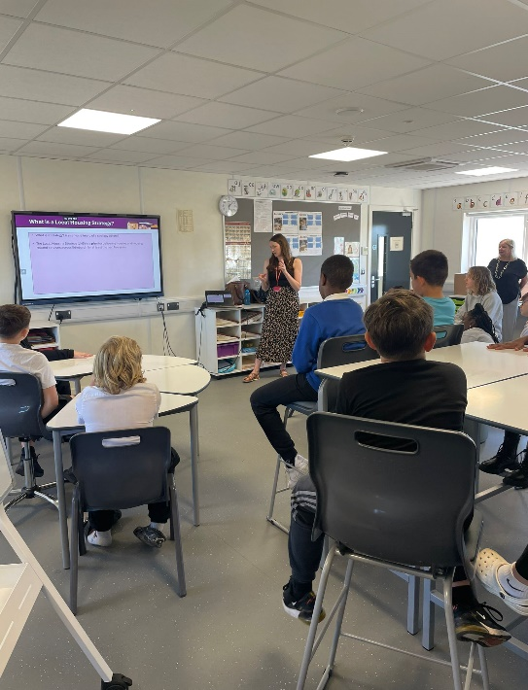**Castleview Primary School**

Castleview Primary School is located in Craigmillar in the North East of the city. An engagement event was held with 16 pupils from the primary seven year group on 18 September. An introductory presentation was delivered, followed by two interactive group activities.

Activity One: Your Housing Priorities

The group were asked to think about developing a local housing strategy. If they were given this task, what sort of things would they consider and what would their priorities be. The outputs are summarised below:

* Think about how many homes you have space for – land
* Need to work well with architects/ consultants – have a clear plan
* Think about the size and layout of homes - make sure there’s enough space for the household
* Budget management – we’d need to deliver as much as we can. Budget should be spread across new-build and improvements so that everybody benefits in equal ways
* Get the right mix of housing e.g. accessible – build homes based on the needs of the population
* The home should be value for money
* Solar panels (the group mentioned that they had used these in their science classes and were very supportive of this type of technology – but they need to be affordable)
* Lots of discussion and questions about private rent, landlords and how this works
* New homes and infrastructure – example of new homes being built behind their school, but with the school almost at capacity, what will this mean for children who move into these new homes?
* The size of temporary accommodation was raised as an issue (overcrowding)
* Homes should have more outdoor space
* There should be control over evictions. Children should not have to worry about being evicted or moved from one home to the next.
* Discussion around financial support if a household is evicted, to help them get back on their feet
* Anti-social behaviour issues and noisy/disruptive neighbours
* Neighbourhood facilities are important
* Community growing and nature
* Think about the location of new-build homes e.g. is it going to be really noisy?
* Discussion about labour shortages and whether this is an issue

Activity Two: Your Neighbourhood Priorities

The group gathered around a map showing a fictional town with some existing community facilities on it. The group discussed the facilities and whether or not they were felt to be important and the reasons why. Provided with post-it notes, the group added on additional community facilities that they felt were important. Gold stars were stuck on to identify which facilities they felt were most important overall.

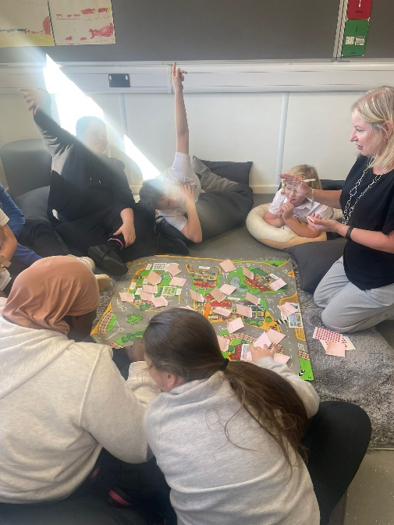The top-ranked facilities included:

* More buses and bus routes
* Libraries – more computers, more books for teenagers, more rooms for different groups/ uses
* Gym that allows entry to teenagers
* Additional sports facilities – football pitches, swimming pool (and access to a swimming instructor), tennis courts, skate park and dance studios
* More/ bigger GP surgeries
* Community growing
* More bins to address issues with litter and fly tipping
* More diverse local shops and cafes

**Tinderbox - Muirhouse Youth Music Club**

On 8 October 2024, a discussion on the LHS was held at a Youth Music Club in Muirhouse, in the North West of the city. The club is run by Tinderbox, who run a number of music programmes open to children and young people aged 10 – 25 years.

The session was attended by 30 teenagers aged between 12 -16 years, along with10 youth group leaders. The leaders took an active role in the session, splitting the participants into groups for discussion.

Participants were asked to identify their housing priorities for Edinburgh. Interestingly, the responses differed slightly from the early engagement survey. Tackling homelessness was the top ranked priority, followed by safe and connected neighbourhoods. Anti-social behaviour was a particularly strong theme amongst this group.

When asked whether they liked the neighbourhood they live, 63% answered yes and 37% answered no.

Positive about the area included: proximity to school, an area that’s familiar (“it’s where I grew up”) and local facilities (“a good chippy!”)

Negative reflections about the area included: safety concerns and anti-social behaviour, particularly “youth trouble” and concerns about knife/machete crime. Bonfire night was highlighted as a particular issue. Comments were raised about a lack of street lighting. When asked what would improve the area, community spaces for teenagers was highlighted, along with more police and more street lighting.

When asked about whether their current home met their needs, there were differing views on this. Positive and negative reflections were again primarily tied to anti-social behaviour issues and noisy neighbours, along with housing quality issues such as damp and mould.

When asked where they saw themselves living in five years time, the majority felt they would still be at home due to their age. However, some of the older participants shared thoughts on this which included: “still in Muirhouse”, “still at home – probably won’t be able to afford to move out” and for one, “probably living in a shed”. Housing aspirations for the future were low amongst this group, with reflections on housing costs and a perception of limited options for social mobility.

**English Language Class for Asylum Seekers and Refugees**

On 1 October 2024, a discussion on the LHS was held at an English Language class. Often attended by up to 15 students, this class was quieter with three students attending. It is a Council run, beginner level, English language class. Two students were Ukrainian and one Japanese. In addition, there was a Ukrainian translator, the class tutor and ESOL Lead worker and all completed the LHS questionnaire.

Reflecting on their current housing situation, the Ukrainian students, both in the 65-70 years age range, noted that they had to move multiple times before being given more settled accommodation. They lived for a year on the ship first, followed by hotel accommodation and then moved into social housing. This was difficult for them.

One of the Ukrainian attendees was unhappy with their accommodation as they are living in a Council social housing studio flat which is small for two people. They report using EdIndex every week to try to bid for a new home. The other was very happy with their accommodation in South Queensferry where they live with their daughter and her family in Council social housing. The Japanese student’s accommodation is ‘tied’/ a part of his work as a live-in chef. Issues with old tenement housing being cold was mentioned by two respondents.

In terms of more general comments re housing in Edinburgh, it was highlighted that there needs to be more affordable housing for working people. It was also suggested that the Council should create new financial opportunities, so it can build more social homes.

**Edinburgh Learning Disability Advisory Group**

On 6 September 2024 the LHS was discussed at a meeting of the Edinburgh Learning Disabilities Advisory Group. The meeting co-chaired by representatives from Edinburgh’s Health and Social Care Partnership and FAIR. Six service users were preset (from People First Scotland and the Action Group) along with two support workers. Participants had a range of different circumstances and accommodation, ranging from supported accommodation, living with family but looking to move out and living in an adapted property.

The group had a broad discussion and two participants had prepared written contributions which they shared with the group. The discussion and written contributions are summarised below:

* Choice is key – not everyone wants to live in shared accommodation and if they do, they’d like to choose who they live with. Location also important (for family support, transport links, close to doctors, dentists etc).
* There should be the support there to enable people to live independently if they choose to do so – flexible services built around our needs so that we have more control
* There is not enough housing for people living with disabilities. It shouldn’t all be in the same location, it should be spread out
* We need housing for young people to move out and live independently
* “we should have the same rights as everyone else, to live the life we want to live”
* Moving can be very stressful – experience shared of needing a lot of help with the practical things and getting organised. Moving is costly too.
* Too much student housing
* Question about acquisitions
* Concerns about government cutting social care budgets.
* Lack of information about the rights people have when it comes to housing. People don’t always know where to get advocate to help them.
* Group highlighted role of digital support.
* Mention of good experience with housing support worker – really helpful.
* Comment that parent carers of children with a disability (including adult children) not necessarily seen as a risk or high priority as they are in a home and being looked after. However, many worry about what will happen to their child as they get older and it’s not a conversation that people find easy to have.
* More disabled children than ever before.
* Should be discussions at school age - information about support services and transition.
* EdIndex is not that accessible. Really need a phone number and paper copies (of adverts) like it used to have. But need to be careful with phone lines – being put on hold and asked to select from options can be difficult for some people.
* Sometimes writing is too small in information
* Easy Read information about services is useful but can be difficult to find. Online isn’t good for everyone.
* Need specialist workers to deal with disabled people and their families to help with housing issues. Further training for housing officers.
* It’s difficult to navigate all the different services.
* Support Worker gave example of Easy Read checklist they were working on to help people with moving. Can be harder for people with disabilities – might have specialist equipment that needs moved too.

**Newhaven Knitting Group**

On 17 September, five women were interviewed at the Newhaven Knitting Group. Ages ranged from 25 to 75 years. Four were home owners and one lived with family.

Home meeting your needs and future plans to move: All felt their home currently meets their needs. Two had no plans to move, one plans to downsize, one will require a bigger family home, and one would like a garden in the future.

Comments on the local area: Generally positive with reflections on good sense of community. Some specific issues highlighted: poor quality pavement (concerns for wheelchair users in particular); more care of local area needed (reference to a former playground that is now a railed concrete area); more facilities needed for younger people; issues with fly tipping; and some issues with anti-social behaviour.

Further comments:

* More social homes are needed. Ensure ‘affordable’ homes are affordable
* Infrastructure is needed in areas where new-homes are built.
* More sheltered housing.
* There should be an initial focus on the most deprived areas/ most sub-standard housing.
* Challenges in trying to rent privately with a pet
* High housing costs and challenges getting on the property ladder
* Scottish First Homes Fund highlighted as very helpful – greater awareness needed
* Importance of community and ‘nice neighbours’
* Positive reflection on community growing and the ‘knock-on effect’ of taking pride in the area
* Can newbuild development support deprived areas e.g. community benefits
* Shared repairs in tenements are extremely challenging

**Leith’s Men Shed**

On 2October 2024, five men were interviewed at the Leith Men’s Shed, based in the Heart of Newhaven Community Centre. Ages ranged from 60-80 years, and the group comprised four home owners and one Council tenant.

Homes meeting their needs: home owners generally felt their home met their needs. However, comments raised about the challenges of living in a Conservation Area e.g. can’t put in solar panels or charging points for electric vehicles. The Council tenant highlighted issues with repairs, exacerbated by living in a mixed tenure block, along with issues around anti-social behaviour.

Positives about local area: transport links including the Tram. Good local facilities, including the primary school, shops, restaurants and pub. Positive reflections on natural green spaces, including community gardens and re-wilded ponds.

Negatives about local area: Dog fouling and fly tipping. Anti-social behaviour issues by a minority of residents. Poor state of Newhaven Harbour.

General comments: More social housing is desperately needed. Affordable housing a major issue for the younger generation. There should be greater priority given to preserving and improving green spaces.

**Libertus**

Libertus Day Care Centre is located in Gracemount, in the South East of the city. The centre was visited on 3 October 2024 for a discussion on the LHS. 17 people attended along with 4 volunteers and 2 care-workers as part of a Libertus day-care and lunch club session in Gracemount. Participants ranged from 35 – 94 years old, with 10 participants aged 75 and over.

A game was used to introduce the session, asking participants to guess Edinburgh housing market issues and challenges. Questionnaires were then handed out for people to fill in individually, with support provided as required. 14 people completed the questionnaire, including 13 day-care attendees (4 men and 9 women plus one care worker.

Most of the attendees were owner occupiers who were very happy with their home and areas reporting that it mostly meets their needs. Problems were reported by two attendees living in sheltered housing and in social housing. They raised issues around a lack of co-ordinated support and not being able to access the upstairs of their home. The Care Worker who completed the survey was also very unhappy with her private rented accommodation. Wider points were raised around a lack of housing, a lack of support for those who need it and reflections on households who are less fortunate and the challenges they are facing.

**Written Submissions**

In addition to the range of engagement activities, there was also the option for individuals and organisations to provide written submissions throughout phase 2. Two written submissions were received, one from an individual and one from Shelter Scotland. The feedback from these submissions has been taken into account as part of the overall analysis of engagement and consultation carried out to date.

**APPENDIX 1: DISCUSSION PAPERS FOR STAKEHOLDER WORKSHOP**

**Edinburgh’s Local Housing Strategy**

Stakeholder Workshop Event 23rd September 2024

**Private Rented Sector: Background Paper**

**Data**

|  |  |  |  |
| --- | --- | --- | --- |
| **No.** | **Edinburgh** | **Number** | **Data from** |
| 1 | Registered landlords | 44,111 | Sep 2024 |
| 2 | Registered HMO properties | 6,596 | Mar 2023 |
| 3 | Registered short-term lets licences granted | 4,005 | Sep 2024 |
| 4 | Purpose Built Student Accommodation bed spaces (incl. university & privately owned) | 22,058 | Jun 2023 |
| 5 | Private Sector Leasing scheme properties | 1,830 | Mar 2023 |
| 6 | Homeless cases resulting from loss of PRS tenancies | 520 | 23/24 |
| 7 | Average PRS Rent by property size | 1 bed    £1,035 YoY up 11.8%  2 beds  £1,385 YoY up 6.3%  3 beds  £1,896 YoY up 10.7%  4 beds  £2,553 YoY up 6.3%  All £1,481 YoY up 7.9% | Q1, 2024 |

*Data source 7 - City Lets (YoY = year on year)*

**Key Messages**

* Increased importance of the private rented sector in Edinburgh within the housing system. PRS makes up 24% of homes in Edinburgh.
* Highest ever rents and increases in the private sector since records began. This means renting is becoming increasingly unaffordable in Edinburgh for many people.
* Changing policy landscape - impacts of recent actions such as the mini-budget, legislation re PRS; 2020 emergency legislation and the Housing Bill (Scotland) 2024, leading to unknown impact and implications for tenants, landlords, and investors.

**Feedback on Housing Supply and PRS through LHS engagement**

**Housing Supply**

“We have a chronic lack of affordable rented accommodation this needs to be addressed by increasing supply”

**Rent controls and affordability**

“Housing in Edinburgh is completely out of control with the cost of just renting a room in someone else's house becoming unaffordable. We need more social housing and we need rent controls…”

“…the rents must be affordable. People are having to claim benefits to enable them to pay the very high rents charged by private landlords which therefore means the public purse ie the tax payers are subsidising and lining the pockets of private enterprise.”

**Housing benefit not covering rents in PRS**

“…not enough housing benefit to cover rents of the PRS; average housing cost is no longer reflected in housing benefit.”

**Housing Quality**

“Housing in Edinburgh is abysmal and is at the mercy of uninterested landlords who do nothing to maintain or improve the property but will gouge prices as much as possible.”

**Multiple properties**

“It lacks any ideas regarding tackling landlords who own multiple properties and how they exploit the current state of the market”

**Landlord Registration**

“Living Rent: Greater resources should be used in landlord registration, to ensure that the council is properly enforcing the “fit and proper” requirements of landlord registration.

Issues of serious prolonged disrepair, bad practice (such as threatening or illegal behaviour) failure to upkeep EPC standards should lead to the Council penalising landlords…”

**Young people and Single people**

“Urgent need to supply houses that can be bought or rented by young people or those on modest incomes. ….. Desperate need to consider single people and affordable rental properties …”

**Purpose Built Student Accommodation (PBSA)**

“Edinburgh desperately needs homes to rent at an affordable rent. There seems to be a focus on the build of student accommodation.”

**Fear of eviction in PRS and Support for Mid-market rent**

“I lived in private lets in Edinburgh for 20 years ... Over those 20 years rents went up and up and I had a constant rumbling anxiety that I would be evicted and not be able to afford anything. Buying was impossible so my options were very limited. I feel incredibly privileged to have my current (mid-market rent) home with a reasonable rent and no worries about being evicted.”

**Short Term Lets (STL)**

“More needs to be done to regulate Airbnbs/short-term lets, as this impacts on the availability of affordable accommodation for local residents.”

**Accessible Housing in the Private Rented Sector**

“…There's also a huge accessibility problem with so many properties only accessible by climbing stairs.”

**Increasing regulations**

“The amount of taxes and laws against landlords are setting the example for young people not to follow that path …”

**Private Sector Key Issues/ Challenges**

* Rent levels in the City are at the highest since records began. Demand far outweighs supply and affordability for renters or prospective renters is a significant problem.
* The sustained Cost of Living Crisis is impacting on tenants’ abilities to pay rent.
* Uncertainty about how the sector will develop in terms of growth or reduction in the number of lets.
* Housing quality in the private rented sector for some properties can be poor.
* Single people’s incomes are often stretched the most by high PRS rent levels.
* Whilst improvements have been made in recent years the PRS currently offers less stability than social rent and home ownership
* Short Term Lets reduce the number of longer-term accommodation options available to residents.
* PBSA rent levels are high and developments are often not well received by local residents and students

**Examples of work currently underway**

* The LHS will focus on continuing to improve the operation of the Private Rented Sector through landlord registration and licensing.
* The Council’s Private Rented Sector Enforcement Team deals with over 2,000 complaints per annum. The team takes a range of enforcement action from providing advice and guidance, issuing Rent Penalty Notices, to submitting reports to the Procurator Fiscal where offences are identified.
* Landlords are required by law to register with the Council to ensure they are fit and proper and comply with their legal responsibilities to ensure their properties meet the required safety standards.
* Properties licenced in the private rented sector such as HMOs and STLs are subject to additional safety checks and inspections and additional licence conditions. The aim is to ensure these properties meet the required standards.
* Ensuring Landlords are aware of responsibilities/actions required from them.
* Continue to ensure that Short Term Lets only operate with the relevant planning permission and licences in place, taking robust enforcement action against operators who do not comply with their responsibilities.
* Continue to support people to consider the PRS, where relevant, as a housing option through advice and information.
* Continue partnership working with the police etc to ensure enforcement action can be taken where needed.
* Monitor and report on private rent levels and landlord registrations to fully understand the sector’s size, changes and rent (affordability) levels.
* Create links between Planning and Housing departments and elected members to review housing provision for students.

**Discussion Questions**

* Do you agree with the list of current Private Rented Sector Issues/ Challenges?
* Which challenges should be prioritised?
* What key actions should be taken?

**Housing Quality and Sustainable Homes**

Background Paper

**Key Messages**

* The characteristic/ profile of Edinburgh’s housing (tenement flats, listed buildings, and conservation areas) poses additional challenges to repair, maintain and improve existing homes.
* Timely and good standard of repairs is crucial to keep homes free of draughts, mould and dampness, which in turn helps residents to heat their homes efficiently, reducing fuel poverty and improving health and well-being of the residents.
* Bringing existing homes to net zero standard comes with a cost. For social housing, this is primarily funded by tenants’ rents. It is questionable whether social tenants, who are often the most vulnerable people in the society, should bear these costs.

**Example feedback received so far through LHS engagement**

**Additional challenges due to housing types and characteristics:**

“I love how Edinburgh is trying to protect its own historical building and the cityscape. However, with majority of the housing being tenement buildings (plus many are listed!) it brings difficulties to maintain and live in for a long time comfortably …”

**More support to homeowners:**

“Help should be provided to support home owners to upgrade their house to meet environmental priorities. Refunds should be offered to owners who shouldered those costs to improve the house they live in or they rent out.”

**Housing conditions (repairs) and residents’ well-being:**

“Several children we (Children 1st) have supported have experienced ill health due to poor housing conditions, including mould, damp, broken windows and mice. This, in turn, has led to children missing school or nursery because they are unwell or need to attend medical appointments. We have experienced families who feel embarrassed by the condition of their home environment, and on this basis have refused professionals or family/friends to visit, limiting the support that families can receive.”

**Costs to Council tenants:**

“The burden of repairing and building housing stock should not be placed solely on tenants through year on year rent increases, Edinburgh City Council should seek to keep rents fair for council tenants by keeping yearly rent increases at a fair level, supplementing the HRA with other funds and making sure that tenants are able to use the Discretionary Housing Fund.”

**Bringing empty homes up to standard to help increasing supply:**

“Too little affordable houses within Edinburgh. Many empty properties that could house people after some maintenance work. Existing empty buildings need to be reviewed and fixed.”

“… Edinburgh council need to build new properties to replace [what] has been sold off, bring the housing stock up to a better standard and get all the voids back into circulation …”

**Issues and Challenges**

* The City of Edinburgh Council has a target to reduce carbon emissions to net zero by 2030, i.e. 15 years before the Scottish Government’s target and 20 years before the UK Government’s target. This potentially creates a misalignment between the Council’s plan and possible funding available from the governments for relevant work.
* Homeowners, especially those living in tenement flats, found it difficult to organise repairs, maintenance and improvement to the communal areas of the buildings. Additional challenges for those in listed buildings and conservation areas.
* Costs involved are often the major barrier for homeowners (and private landlords) trying to improve their homes to high energy efficiency/ net zero standard. For social landlords, there is a challenge to keep rents affordable while raising enough rental income to fund the investment required to meet the net zero standard.
* Approximately 50% of the Council homes are situated in mixed tenure blocks, where consent/ agreement is required from a majority of owners in the blocks to proceed with repairs and maintenance in the common areas of the buildings.
* There is little incentive for private developers to build new homes that are above and beyond what is required by the legislation/ building regulations.

**Examples of work currently underway**

**Improving standards of existing (Council) homes**

The Council’s Housing Service has a large Whole House Retrofit (WHR) programme already underway which will make existing Council homes as energy efficient and as close to net zero as possible. The WHR programme will be progressed through a two-prong approach, with the low-rise blocks using the model developed by the Mixed Tenure Improvement Service (MTIS) Pilot in Wester Hailes and working as part of area-based regeneration; and the high-rise blocks to develop specific bespoke design and intrusive survey processes for various construction types found across the blocks.

Since the implementation of the Acquisition and Disposal policy, the Council has purchased 405 homes and sold 205 homes. This has led to 82 blocks becoming fully Council-owned, 150 blocks where the Council has divested its interest and 306 blocks where the Council has further consolidated its majority ownership. This in turns helps the Council to manage blocks repairs and improvements. The policy will continue to work along the MTIS to help facilitate WHR in mixed tenure low-rise blocks.

**Supporting flat owners to organise repairs, maintenance and improvement in communal areas of buildings**

The Council’s Edinburgh Shared Repairs Service (ESRS) offers free advice and information to help owners organise repairs to the shared or common areas of the property. Its Missing Shares Service helps flat owners, who are having problems getting other owners to pay their share of repair costs, to progress essential repairs and maintenance in the common areas of a tenement or block of flats.

The Council has also been working closely with Under One Roof, a charity that provides impartial advice on repairs and maintenance for flat owners in Scotland. In 2023, the charity organised and ran two events for the ESRS, and an on-line event for Landlord Registration which provided information to private landlords in Edinburgh regarding the new repairing standard.

**Future proofing new build homes**

The Council-led housebuilding programme prioritises delivery of homes on brownfield sites, reducing pressure on Edinburgh’s green belt. Building more homes will inevitably produce more carbon, however, the Council aims to build homes which are as energy efficient and sustainable as possible. Since November 2020, all new build Council homes have been designed to achieve net zero carbon.

The Council has also started to roll out heat networks through large scale regeneration in areas where the Council has significant influence and/or areas of strategic importance to the city, for example, at Granton Waterfront.

**Mould and Dampness (in Council homes)**

The Council developed a Dampness, Preservation and Mould Service Improvement Plan, which was agreed at the Housing, Homelessness and Fair Work Committee in May 2023. It includes actions to review and develop all processes and procedures relating to the treatment of dampness and mould in Council homes. A dedicated Damp and Mould team to support the delivery of the actions in the improvement plan has also been established.

**Bringing empty homes up to lettable standard and back in use**

The post for a dedicated private sector Empty Homes Officer (EHO) was made permanent in April 2022. Since 2019, 221 homes have been brought back in to use by the Council’s EHO. Due to the success of the EHO work, the Council’s Housing, Homelessness and Fair Work Committee agreed to recruit an additional EHO for 18 months in February 2024.

The post will be funded by the use of Rapid Rehousing Transition Funding and will aim to create a supply of “empty homes” in the market that can be used as temporary accommodation for homeless households, through the development of a ‘match maker’ scheme – matching homeless households to potential landlords. There may also be scope for using the Council’s acquisitions policy to increase the number of properties in its own stock.

As well as providing advice and information to owners to help bring the empty homes back in to use, the EHO has developed relationships with colleagues in other service areas, including Edinburgh Shared Repair Service (ESRS), typically to identify owners of empty properties where communal repairs are needed, and identify potentially dangerous properties where ESRS may need to carry out emergency works.

**Opportunities**

* Scottish Government consulted on a new Social Housing Net Zero Standard (SHNZS) between November 2023 and March 2024. The new standard will replace the second Energy Efficiency Standard for Social Housing (EESSH2). Based on the anticipated timeline, the new SHNZS is to be introduced in 2025 at the earliest. With the introduction of new standards, it is possible that a new funding regime may be introduced to support social landlords to meet the new standards.
* Housing to 2040, the Scottish Government’s strategic plan for housing, includes an action to introduce legislation to implement a new Housing Standard, which will cover all homes (new and existing). This new standard could potentially help to improve conditions in all homes, especially those in the private sector.
* The Scottish Law Commission published a discussion paper on Tenement law: compulsory owners’ associations in April 2024 for consultation (until 1 August 2024). The discussion paper includes proposals on the establishment, formation and operation of compulsory owners’ associations and the rights and responsibilities to be imposed on them. The discussion paper was prepared in response to the Final Recommendations Report of the Scottish Parliament’s Working Group on Maintenance of Tenement Scheme Property, which contains three interconnected recommendations: a building condition inspection every five years; an owners’ association for every tenement building; and a building reserve fund, to be administered by the owners’ association. The three recommendations aim to help to address disrepair, and to facilitate building improvements to enhance the energy efficiency of the tenement stock. After analysing responses to this discussion paper and carrying out any further research required, the Scottish Law Commission will provide the Scottish Government with a report detailing its recommendations on compulsory owners’ associations and provide a draft Bill for consideration, estimated to become available in the Spring of 2026.

**Discussion Questions**

* Do you agree with the list of current issues/ challenges identified in relation housing condition and sustainable homes?
* Which challenges should be prioritised?
* What key actions should be taken?

**Accessible Housing/Independent Living: Background Paper**

**Data**

* Around 39% of Council and EdIndex Registered Social Landlord (RSL) partner social rented homes are classed as ground floor, but not all ground floor homes are accessible.
* As of 31 August 2024, 470 applicants on EdIndex (Edinburgh’s common housing register) with Gold or Urgent Gold Priority (mobility needs). Around 10%-15% of applicants with Gold or Urgent Gold priority require fully wheelchair adapted housing.
* £3 million spent on adaptations to Council homes, RSL homes and private homes in 2023/24.
* In 2019 there were 7,784 people aged 65 plus estimated to be living with dementia in Edinburgh; 9.8% of this demographic. An estimated 281 people under 65 years were living with dementia.
* Between 2018 and 2030, the number of people estimated to have dementia in Edinburgh is expected to increase by 26.5%
* In Edinburgh, 65.7% of older people aged 65 plus who have high levels of care needs live at home (compared to 63.5% Scotland overall).
* Edinburgh has comparatively few care homes for its population (about 6 care home beds per thousand of its population compared with 8 for Scotland as a whole). The city manages with comparatively few care home beds because it has a large care at home sector.
* Estimated 2,255 people (18 plus) with a learning disability in Edinburgh. National population of adults with a learning disability is predicted to increase by 2% each year.

Edinburgh Health and Social Partnership delivers and commissions services which include:

* Technology Enabled Care to around 9 -10,000 people a year
* Around 2,000 people supported through learning disability services
* Dementia services
* Care at Home services to around 8,000 adults and older people at some point in a year
* Substance Use services
* Sight Loss rehabilitation, access and advice for sight loss, deaf equipment and deaf social care
* Carers Support Services
* Health interventions to people who are homeless
* Services to prevent admission to and support discharge from hospital, with about 5,000 discharges supported each year
* Thrive Edinburgh – prevention, early intervention and treatment services (mental health)

**Key Messages**

* Demographic change in Edinburgh will create more demand for health and care services.
* Housing sector can help meet health and social care objectives around shifting the balance of care from expensive clinical and institutional settings to helping people live independently at home or in a homely or community setting as far as possible.
* Access to a safe, warm and affordable home that can support changing needs is important for overall health and wellbeing.
* Need more accessible and adaptable homes across tenures, but also need to adapt existing homes.
* Care and support services alongside the right housing are key to supporting independent living.
* People with learning disabilities and complex care needs want to be supported to live in their own homes and communities and want to be involved in decision-making around this.

**Accessible Housing Study 2021/22 feedback and findings**

* Challenges in meeting need in context of Edinburgh’s housing stock profile (older/flatted), market pressures and supply issues.
* Consider role of market housing and Mid Market Rent in contributing to wheelchair & accessible housing.
* Delivery of wheelchair & accessible housing needs to be wider than new supply. Adaptation or change of use of existing built assets should be considered.
* Enhance provision of wheelchair and accessible homes in the city across tenures, engaging with partners to set achievable targets, taking into account property size and location.
* Explore ways of improving data sharing and analysis between partners, to support forward planning and commissioning.
* Location of accessible & wheelchair homes is important for access to support, amenities & workplace as well as the accessibility features & safety of external environment.
* Understand role of Planning in provision of accessible homes across tenures.
* Importance of good quality care & support as well as appropriate accommodation.
* Need for information & support to be provided to help people search for suitable properties & get advice on adaptations.

**Feedback received so far through LHS early engagement:**

“Provision of care and support and stronger linkages between these services and housing are needed to ensure people can be supported to remain at home for as long as they choose”

“Urgent need to address failure of private sector house builders to provide accessible housing beyond the affordable sector”

“There should be more affordable and accessible accommodation available for all ages”

“We need more disabled accessible homes, particularly "family sized" homes (minimum of 3 bedrooms)”

“People with learning disabilities should have a choice if they want to live on their own or with others. The right care package to live an independent life also needs to be in place. Support services do not always offer what we need. We need flexible services built around us”

**Key Issues/ Challenges**

* Responding to need and demand for more accessible and wheelchair homes, including larger homes, in context of funding pressures.
* Role of private sector in providing more accessible and adaptable ‘homes for life’.
* Improving the way we deliver and resource adaptations.
* Gaps in knowledge about existing provision and future needs.
* Meeting housing and care/support needs of people with complex learning disabilities.
* Joined-up approach to housing and care and support.

**Opportunities**

* Potential to make better use of existing assets across partner organisations – repurposing/refurbishing.
* New IJB Strategic Plan and LHS – identifying needs and joint priorities for housing and health and social care.
* Role of technology in supporting independent living.
* Improve access to advice and support for people who don’t have online access or who need additional help.
* Scottish Government proposed Scottish Accessible Homes Standard to improve accessibility across tenures.

**Work planned or currently underway**

* Housing Emergency Action Plan commitment on working with partners to enable independent living and reduce delayed discharge rates.
* Review of Allocation Policy for Council homes - opportunity, along with EdIndex partners, to look at how we allocate accessible homes and improve support for people who don’t have online access or need more help to apply and bid for social rented homes.
* Request for Accessible Housing Summit in early 2025 from Council’s Housing, Homelessness and Fair Work Committee
* Working with health and social care colleagues to improve understanding of needs across different population groups now and in medium to longer term and strengthen joint working.
* Reviewing governance, delivery and funding for adaptations.

**Discussion Questions**

* Do you agree with the list of current Issues/ Challenges?
* Which areas of work should be prioritised?
* Is there anything else we need to think about within this section?

**Innovation and Partnership Working: Background Paper**

**Key Messages**

* In a time of unprecedented challenge for the housing and homelessness sector, partnership working is vitally important.
* Edinburgh’s housing crisis cannot be resolved by the Council alone – there is a need to continue to build on effective partnership working across the board.
* These challenges, particularly financial pressures, call for innovation and different models of delivery. Traditional funding routes will not be sufficient to deliver at the scale required.
* In the face of new challenges, we – collectively - need to think differently.

**Example feedback received so far through LHS engagement**

**Private sector role**: “the strategy should focus on delivering more housing, and that will require investment and development from the private sector, particularly given the current constraints on public finances…. closer working between public and private sectors is required, and is perhaps something that we could do better in Edinburgh.”

**Funding for affordable housing delivery:** “increased delivery of affordable housing must be supported through financially sustainable funding streams and the Council have a role to play in recognising and promoting non-traditional funding routes in the AHSP grant funding environment.”

**Commissioning:** “the strategy needs to meet the needs of the people in a planned, measure and intelligent form of commissioning.”

**Public sector partnerships**: “we need to work together with our public sector partners…. the status quo cannot stay the same and we really need to do things differently, or things will not change.”

**Partnership and participation**: “meaningful participation takes time and resources but can lead to better and more effective policies in the end.”

**Background Information**

* Over the last 10 years, the Council, housing associations and wider partners have delivered 11,134 new affordable homes (incl. homes for social rent, mid-market rent, intermediate rent and low-cost home ownership). Around half were delivered with Scottish Government grant funding.
* The latest City Plan (which will be reported to Council for formal adoption in November 2024) seeks to increase the proportion of affordable homes in new residential planning applications of 12 homes or more, from 25% to 35%.
* There has been a gap between grant funding allocation and what is required to deliver new affordable homes at the scale required. This has been further exacerbated by a 24% cut in grant at the beginning of 2024/25. By working together with partners on the phasing of projects and their ability to bring forward private finance, as well as the strategic use of commuted sums, an affordable housing programme of 587 new approvals has been able to be brought forward in 2024/25.
* Edinburgh has just been awarded £14.8m from the Scottish Government’s National Acquisitions fund. This fund was targeted at local authorities experiencing the greatest temporary accommodation pressures. This is for acquisitions to help address temporary accommodation pressures or to bring long term voids back into use. Acquisitions can be either existing properties or new build off the shelf, but they must be a permanent structure and available in perpetuity. These sums cannot be used to support the ongoing delivery of new housing developments.

**Examples of innovation and partnership working currently underway**

**Innovation & Viability Work Programme – housing delivery**

* A cross-service working group has been established to explore approaches to support a sustainable programme of Council housebuilding into the future. Key areas for consideration are financial modelling to reduce the reliance on grants, increasing income to mitigate the reduction in the grant availability, managing cost increases and delivering the Granton Waterfront project alongside the city-wide development programme.
* Different models are being explored, including lease-based and joint venture models.
* Modelling alternative income streams, including the Visitor Levy for Edinburgh and opportunities to increase income from land.
* Build-to-Rent model – opportunities to deliver purpose built rental accommodation at a scale and pace which exceeds that of homes for market sale.  Furthermore, Intermediate rent (affordable BTR) can be delivered without a requirement for grant funding.

**Working with landowners on strategic sites as a development partner**

* The Council is working with landowners on the Strategic Sites identified within City Plan 2030. Opportunities for delivery at scale, place making and development of sustainable communities and regeneration.

**Increasing supply of affordable homes through purchase of completed and/or second hand homes**

* Off-the-shelfpurchase is a growing area with opportunities for quick delivery and increasing on-site affordable provision.
* The new £14.8m from the Scottish Government’s National Acquisitions fund necessitates building on and accelerating this approach.

**Increasing Supply through partnership models**

* Increasing the supply of permanent accommodation through innovative partnership working has an important role to play in reducing the number of households in temporary accommodation.
* This includes a model enabled by Social Investment Funding, which is not available to Local Authorities but is open to third sector/ charitable bodies. Effective model for increasing the supply of permanent, settled accommodation for vulnerable groups.

**Partnership working on existing properties**

* Opportunities to work collaboratively to ensure best use and/ or repurposing of existing properties across the public sector estate and wider ownership.

**Using data to support service delivery**

* As part of the Housing Emergency Action Plan, a student placement has been facilitated to explore how data can be used more effectively to help support homelessness prevention.

**Key Discussion Points**

* Aside from financial and supply pressures, are there other key issues and challenges to consider as part of the wider picture around innovation and partnership working?
* Other examples of innovation and/ or partnership working?
* Other areas of opportunity?